# **Big Data Analytics Assignment**

**Submitted by Norbert Szilvasi**

**ID: 22073183**

Contents

Big Data Analytics Assignment 1

Submitted by Norbert Szilvasi 1

ID: 22073183 1

Section 1 – Big data analytics (Python) 4

1.1. Task 1: Problem domain, data description, and research question 4

1.1.1 Research state-of-the-art literature and description of the application domain 4

1.1.2 Null and alternative hypothesis 7

1.2. Task 2: Solution exploration 8

1.2.1 Approaches and technologies 8

1.2.2 Solutions and techniques 9

1.2.2 Methodological approach with justification 9

1.3. Task 3: Solution development 10

1.3.1 Data pre-proccessing 10

1.3.2 General analysis, research questions and further visual representations 22

1.3.3 Statistical significance testing 38

1.4. Task 4: Evaluation and future development 42

1.4.1 Potential impact of the results and its application within the domain 42

1.4.2 Limitations 44

1.4.3 Further solution development in terms of the latest technologies 44

Section 2 – Business Intelligence (Tableau) 45

2.1. Task 1 45

2.2. Task 2 55

2.3. Task 3 60

2.4. Task 4 63

2.5. Task 5 70

Appendix: 73

References 74

# **Section 1** **– Big data analytics (Python)**

## 1.1. **Task 1: Problem domain, data description, and research question**

### **1****.1.1 Research state-of-the-art literature and description of the application domain**

The following summarised table contains all the features and its descriptions.

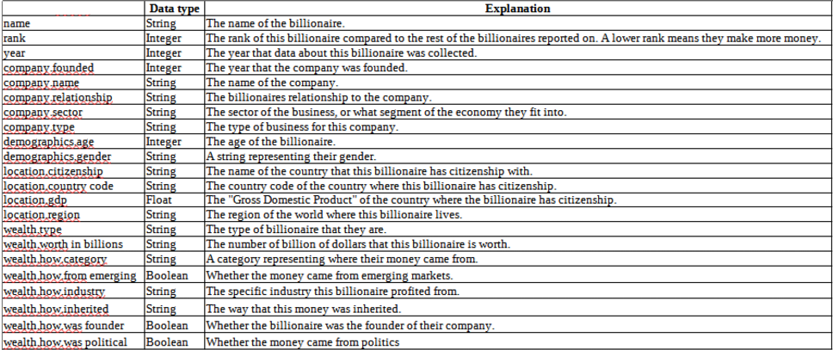

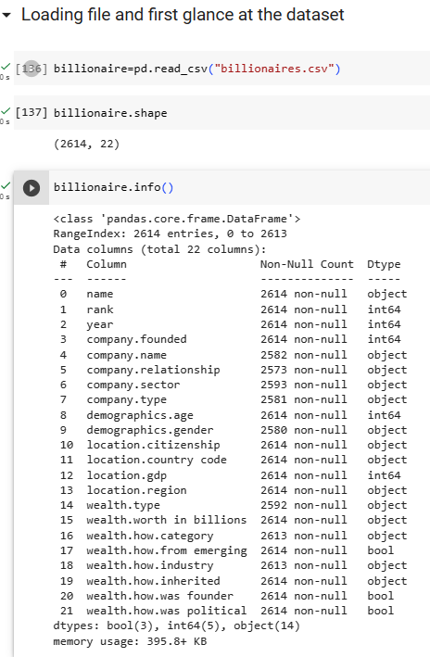

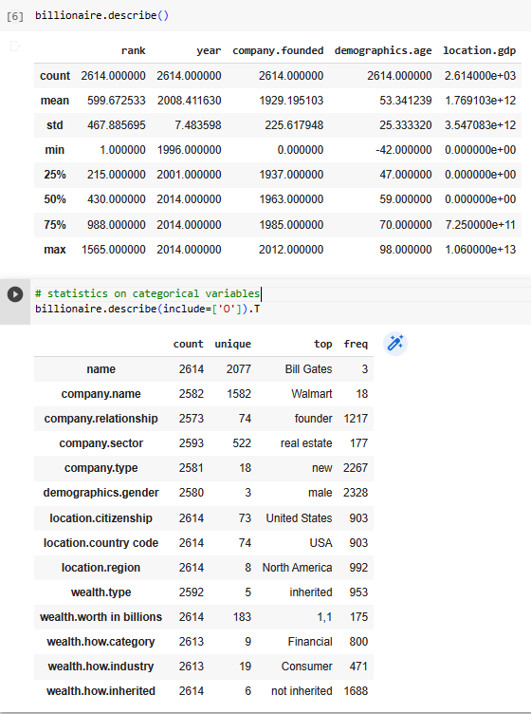

Before starting the research, small changes must be done in order to have a smoother process at later stage due to different conventions across different locations.

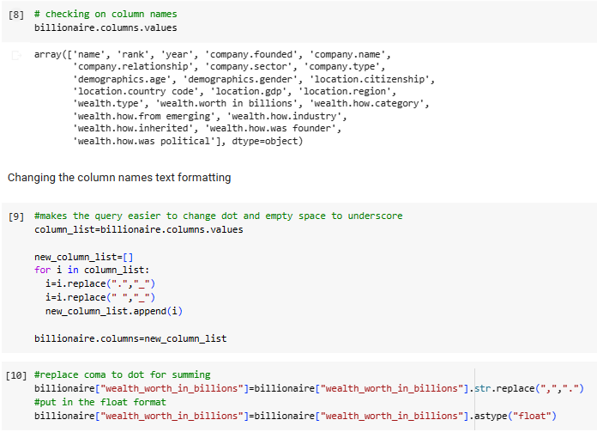

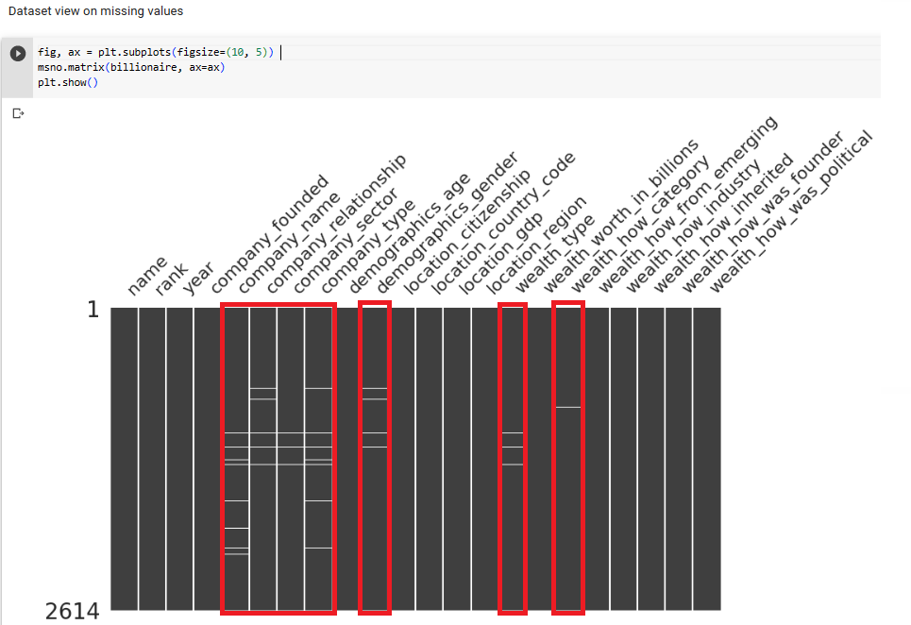

Finally, it can be seen that there are many missing data in the dataset which must be imputed in the next step in order to have a more accurate analysis on billionaire dataset.

The dataset of billionaire normally means a set of data about individuals with a net worth of at a minimum one billion US dollars. Mainly, this dataset is is applied in studies related to wealth and income inequality, philanthropy, and entrepreneurial activity.

There is widespread academic agreement that inequality of the wealth allocation is growing (Zucman, 2019). Different factors appear to have contributed to this enduring pattern. Karagiannaki (2015).discover that inheritances reduce wealth inequality. However, Salas-Rojo and Rodriguez (2022) recommend that inheritances are still the major contributing factor. Piketty and Zucman (2015) describe that how the yearly flow of inheritances and presents, as a proportion of revenue at national level, has considerably grown over the past period.

In order to clarify this question, the following research question is created:

**Is there any relationship between age or inheritance and the wealth worth?**

This dataset is useful for the fields of economics, finance and particularly analysis how wealth is distributed. The distribution of fortune is an essential topic of research for economic analysts and sociologists, because it gives better insights into the imbalanced wealth distribution, trends and social and economic advancement of people. Both scientists and economists are fascinated by the topic of how wealth is distributed (Gunawan and Riansah, 2021).

Prior research has utilised the Billionaire dataset for many reasons. Both Hurst et al. (1998) and Klevmarken et al. (2003), for instance, utilise information from Forbes along with the wealth distribution data provided by the Panel Study of Income Dynamics for America. Piketty (2014) describes patterns of wealth inequality utilising data in his book. Other research papers has utilised Forbes information to examine business trends in certain countries annually. Although the billionaire number is only a tiny percentage of the business society, data on these individuals might provide an understanding of how business is run in the profitable sectors, which are probably a reflection of the state of the economy for big business in general.

Gandhi and Walton(2012) analyise the connection among political ties and billionaire fortune in India using Forbes data between 1996 and 2012. Guriev and Rachinsky (2005) utilise Forbes data from 2004 to comprehend the function of oligarchs in Russia’s shift to capitalism as a whole. As an indicator of the overall health of evolving-market economies, Shama (2012) applies the turnover of a nation’s 10 richest people.

Bagchi and Svejnar (2013) utilise information from Forbes between 1987 and 2002 to see if the sort of fortune in a nation is related to development in its economy. The result show that politically-linked billionaires’ fortune affects the development in economy negatively, whereas independent billionaire’s fortune has correlation with the growth in GDP. The research paper that appears mostly similarly connected to this one is Kaplan and Rauh (2013), who apply World’s Billionaires data of 1987, 1992, 2001, and 2011 for comparing American super-rich people with ones from other nations. They evaluate American and non-American billionaires in the following categories: self-made against inherited fortune, the revenue level within billionaires’ families, and the sector in which they work. They claim, that the breakdown of American billionaires shows the significance of skill sets-biased advancements in technology and the consequent advancement of tech “heros” who are growingly probably to have created their own wealth as a cause to increasing wealth disparity in America. But, this occurrence does not exit elsewhere on Earth.

In addition, such datasets can be used by sociologists and political theories, because it gives an understanding of the relationship of power and financial situation, and also the means by which affluent people can affect political and social environments.

To sum up, billionaire datasets can be used to analyse and research on fortune allocation and inequality within the society.

### **1****.1.2 Null and alternative hypothesis**

The following hypothesis testing will be tested in this research:

First:

Null hypothesis (H0): there is no significant relationship between demographics age and wealth in any given year

Alternative hypothesis (Ha): there is significant relationship between demographics age and wealth in any given year

Second:

Null hypothesis (H0): there is no significant relationship between inheritance and wealth in any given year

Alternative hypothesis (Ha): there is significant relationship between inheritance and wealth in any given year

## 1.2. **Task 2: Solution exploration**

### **1****.2.1 Approaches and technologies**

The continuos development of business activities relies on the extensive analysis of enormous amounts of data. The big data analysis plays a significant role in the institution’s growth and decision-making process to reach economic success. In many cases, information evaluation with normal information technology equipments are unable to deliver useful outcomes. Consequently, many big data products have been created recently to assist businesses and data experts in making relevant data decisions in efficient and cost effective manner. Experts apply a variety of big data analytics tools for data storage, management, cleaning, extraction, prediction and evaluation (Abdalla, 2022).

The analysis of big data can not be reduced to a single technology or technique. This is a short summary of some of the most important members in big data domain below.

Hadoop is a freely available system that keeps and analyses large data on clusters of common hardware in an effective manner. This infrastructure is open and is capable of handling large quantity of structured and unstructured data, creating it a necessary component of any big data process.

NoSQL database systems are non-relational systems in the field information management that do not require a schema with fixed definition, which makes them a great solution for large amounts of raw, unstructured data. NoSQL refers to „not only SQL“, and these systems can handle many data formats.

MapReduce is an important element of the Hadoop system that has two roles. The initial step is localisation, which distributes data to different nodes in the cluster. The second operation is reduction, which orders and reduces the outcomes from each node in order to respond to a query.

YARN (Yet Another Resource Negotiator) is an another Hadoop element of second generation. The cluster management technique improves job allocation and resource control within a cluster.

Spark is a system with an open cluster computing that utilises implicit data processing and fault-tolerance to offer a programming environment for the whole clusters. Spark is capable of dealing with bulk and stream processing for rapid calculation.

Tableau is a tool which has end-to-end analytics that offers to prepare, evaluate, and share extraction of useful insights from large data. Tableau succeeds as a self-service analysis and visualisation tool, allowing consumers to raise new questions of managed large data and simply share these findings across the business. (Tableau, 2023)

The machine learning and data mining help the analysis of smaller to bigger data for the decision-making in business field. The machine learning methods and tools of data analytics can be generally classified as:

**a.) Clustering and segmentation:** Separates a big variety of entities into smaller categories that share common characteristics. Examining a bunch of customers to create smaller segments to narrow down for direct advertising is one good instance.

b**.) Classification:** It is the method of grouping the data into predefined set of categories according to the characteristics chosen by an expert or discovered by a clustering algorithm.

c**.) Regression:** It is applied to identify relationships between a dependent variable and one or more independent variables and to discover how the values of the dependent one vary with the respect to the variables that are independent. Utilising mobil money membership information, utilisation rate, payment form, and geographical location to forecast the future growth of online mobile money transfer is one instance.

d**.) Association:** It seeks to identify significant statistical connections between variables in big dataset. This could assist in directing digital banking agents to provide special rewards to online mobile app customers based on certain variables such as payment value, payment frequency, for instance.

e.) **Colleration**: It is based on similarity and correlation (Ajah and Nweke, 2019).

### **1****.2.2 Solutions and techniques**

Some similar options and techniques to analyse and gather meaningful insights from similar dataset:

1. Exploratory Data Analysis(EDA): EDA is largely utilised to identify what information could reveal over the traditional modeling or hypothesis testing, and it providers an in-depth comprehension of data features and their connections (IBM, n.d.).
2. Regression model: This can be used to identify the link between a dependent and other independent factors such as age, gender, location GDP etc.
3. Clustering models: Cluster analysis is the process of grouping data into a relevant or useful clusters. It has long been used in many fields, such as statistics, information gathering, machine learning, and data extraction (Gupta, Gupta and Mishra, 2011)
4. Natural Language Processing (NLP) and text mining: News, text mining and NLP techniques can be utilised to gain understanding of unstructured text. Its application have moved to sectors such data gathering, summary, spam messages, translation by machine etc. (Khurana *et al*. 2023).

### **1****.2.2 Methodological approach with justification**

The aim of any big data analysis is obtain reliable estimate from initial data. One of the most essential and frequently asked questions is whether there is a link statistically between dependent and independent variables (Alexopoulos, 2010). Multivariate linear regression is a statistical method applied for analysing the link among a target(dependent) variable (wealth.worth in billions) and a set of predictor (independent) variables (various demographic, company and wealth-related factors with numerical values). It is helpful for analysing how all of these independent factors affect the dependent one as a whole, and it can help determine which factors have an important effect on the dependent one. This regression model can be applied to this data to identify which predictors (such as age, gender, inheritance etc.) are connected to the changes in wealth in billions. EDA can be combined beside the regression model to comprehend additional patterns etc. in the data.

## 1.3. Task 3: Solution development

As it was displayed and stated initially, there are many missing data. Before completing the research those data must be imputed and pre-processed in the following way.

### **1****.3.1 Data pre-proccessing**

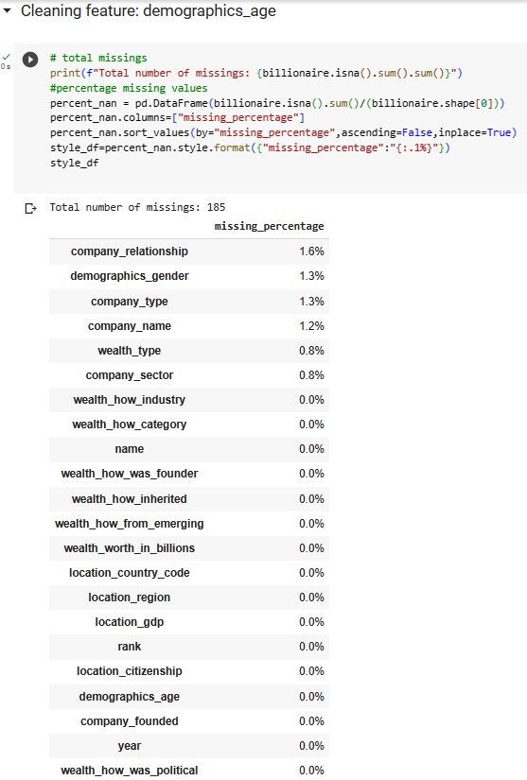The demographics age feature has 185 missing values at the first glimps.

However, it can be see that there are more missing values because many data points have null or even negative values.

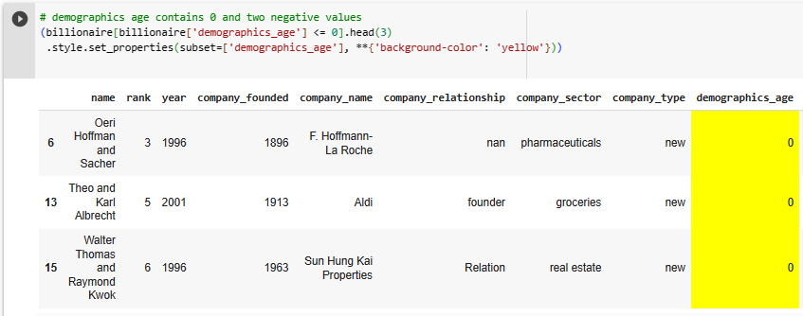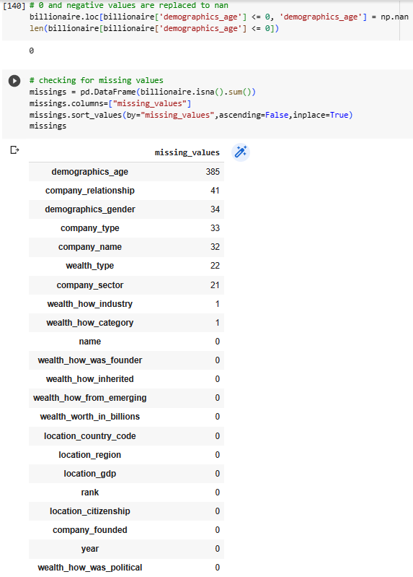

After replacing the null and negative values by na values, it can be see that there are now 385 missing data points which is a lot of data for 2614 entries of this dataset.

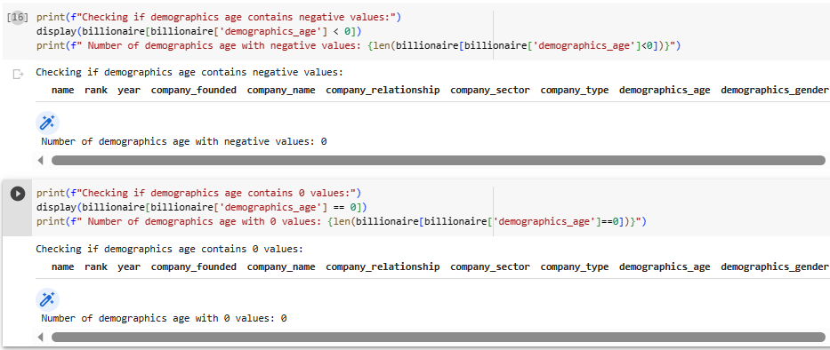

The company name column has missing values. The dataset is very small, therefore, it is not good to lose any data. The data imputation will be carried out manually in this case.

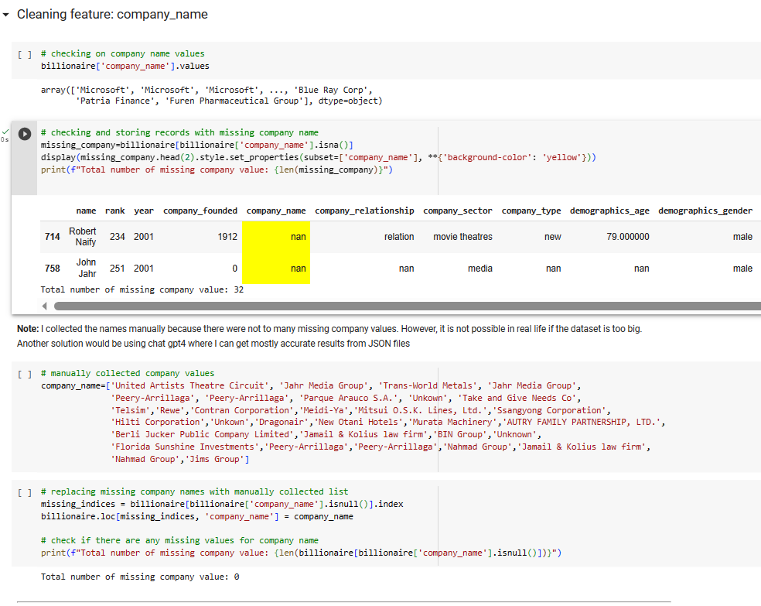

The company sector feature must have the same format in the following way.

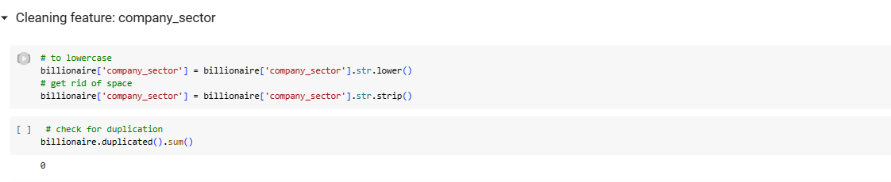

The demographics gender column has 3 categories initially. However, most of the families do not have assigned gender. As a result of this, family category was created extra and married couple is considered to be a family as well in order to get more accurate data imputation later on.

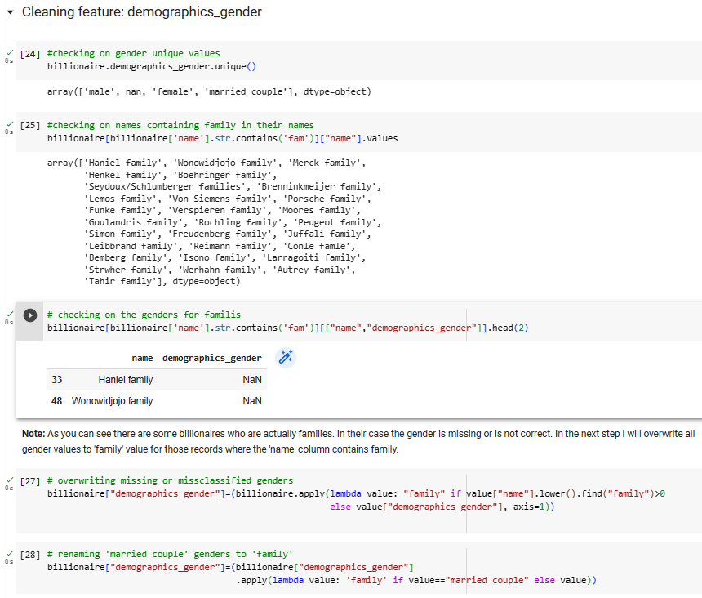

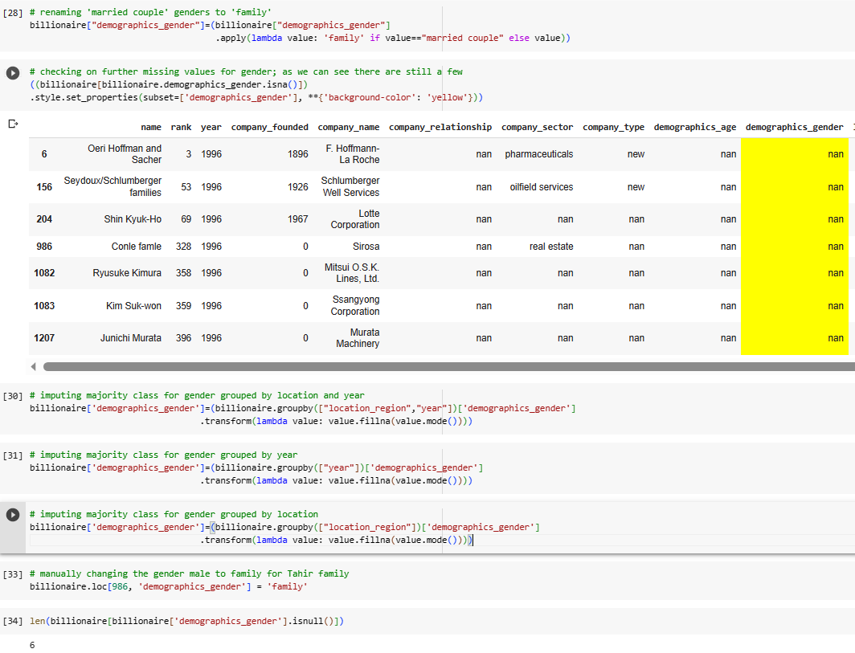

Demographics gender data imputation has been happened by getting the mode values for different features (clusters with similar traits) in order to be more precise. However, it was not possible to impute all data. Finally, the mode for the whole dataset was taken to impute the rest of the missing values.

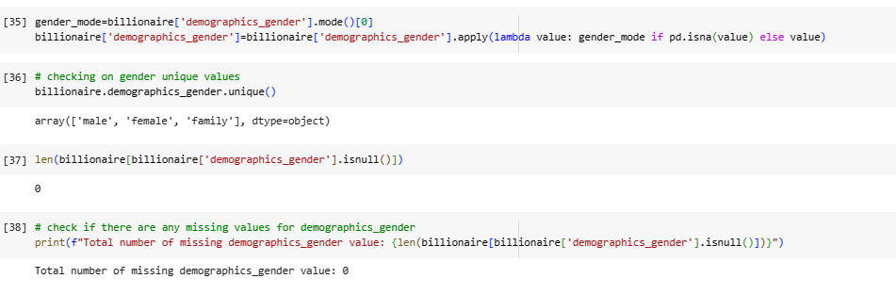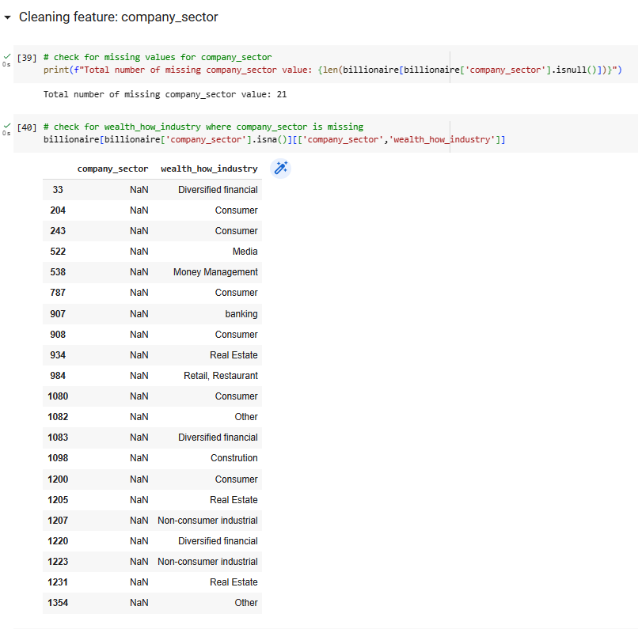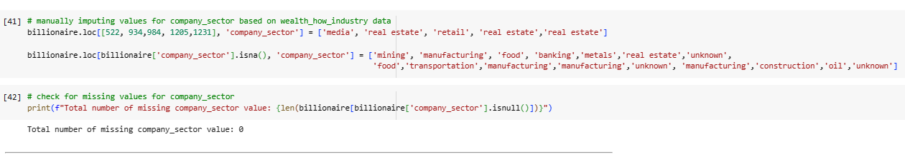

Company sector missing values have some overlapping with the wealth_how_industry

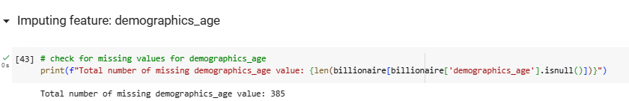column. Some data can be taken from there. Otherwise, the rest of the missing points were manually taken as well.

The missing values for demographics_age are imputed in the following way.

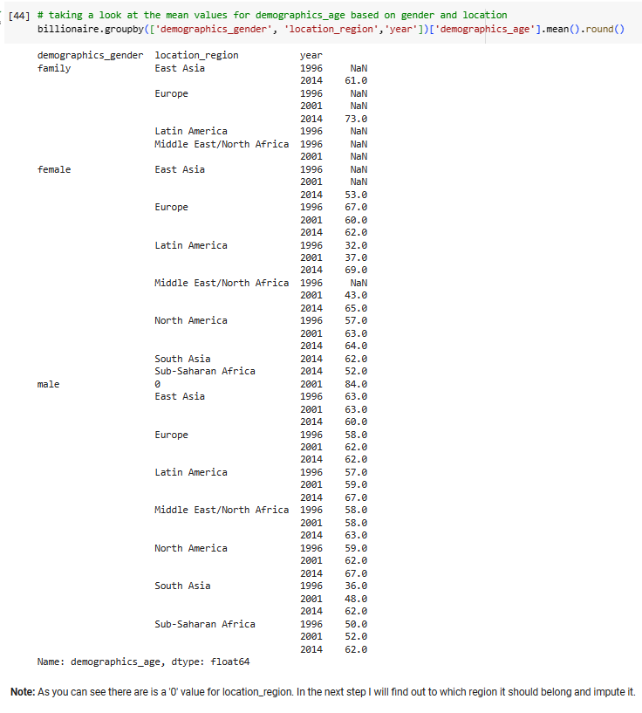

Zero location is Bermuda which belongs to North America.

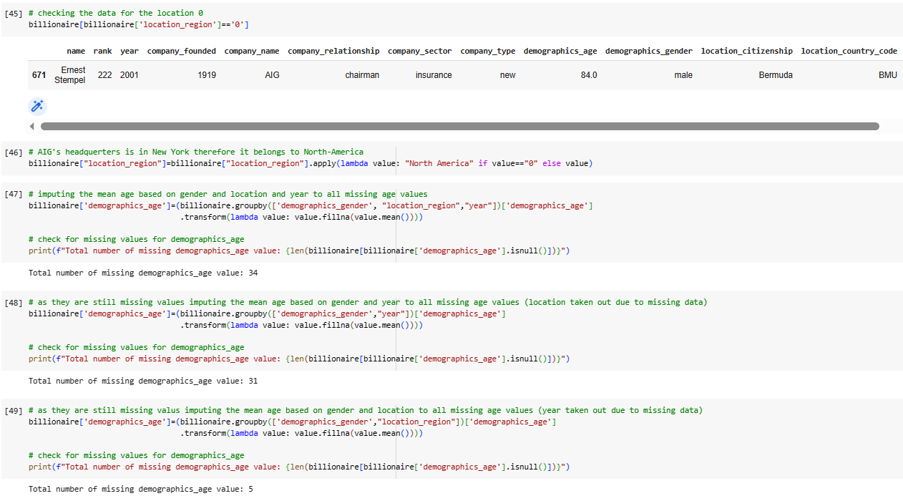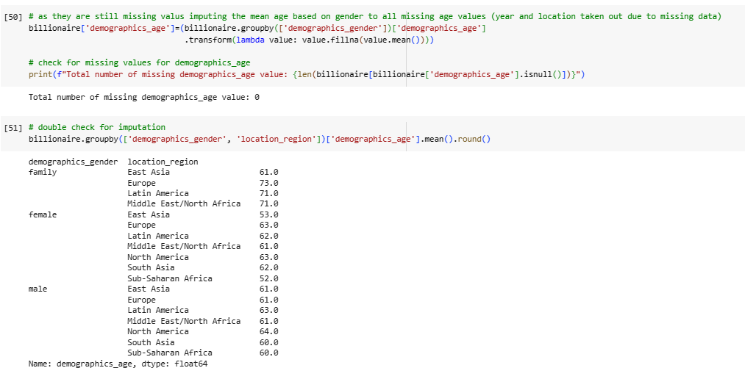

The demographics_age imputation has many steps because there are many missing values initially. Imputations are done by different features’ mean value.

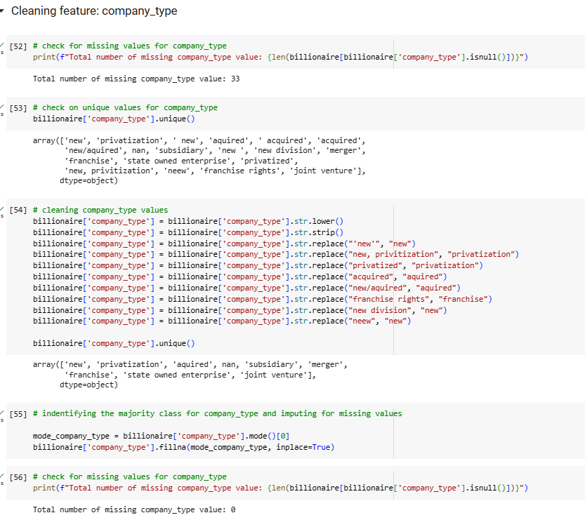

The company_type feature has many formatting issues (detailed steps are stated above). Mode imputation was used to fill up the missing values.

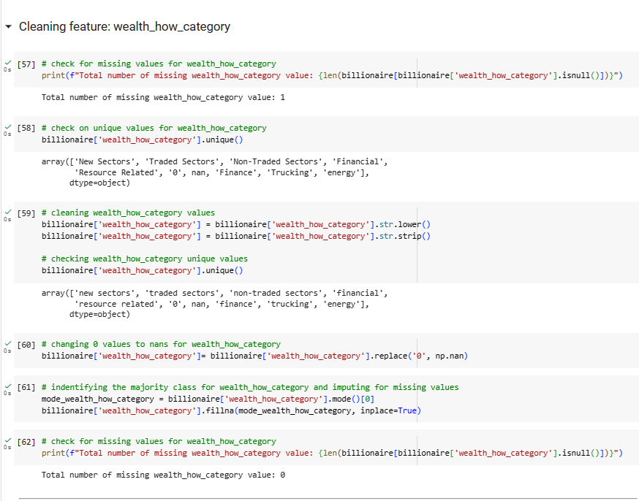

This feature has few missing values which was imputed by the mode value of the whole column.

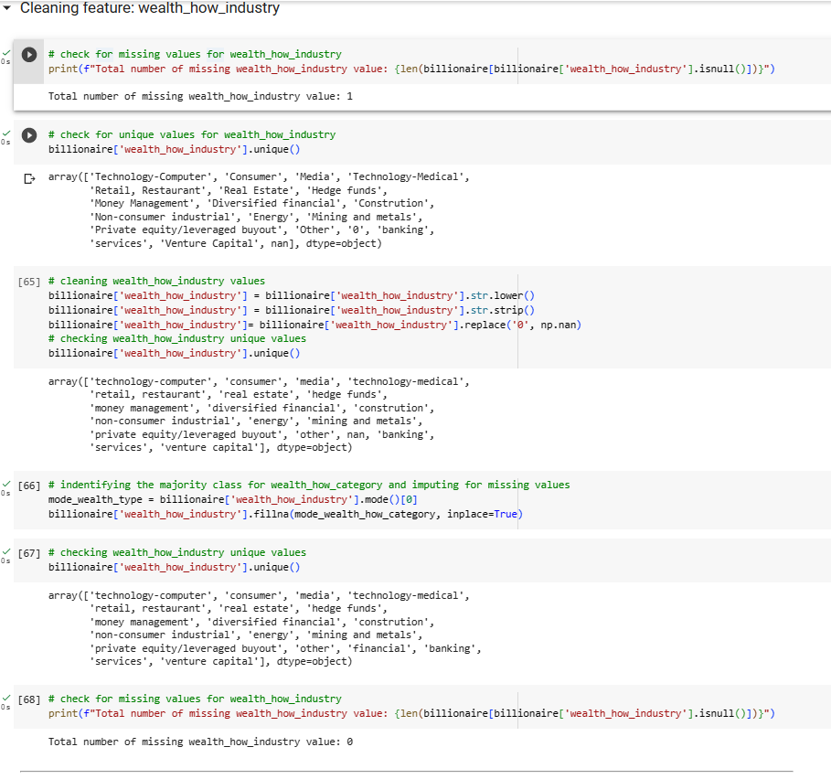

Mode imputation was used in this case as well.

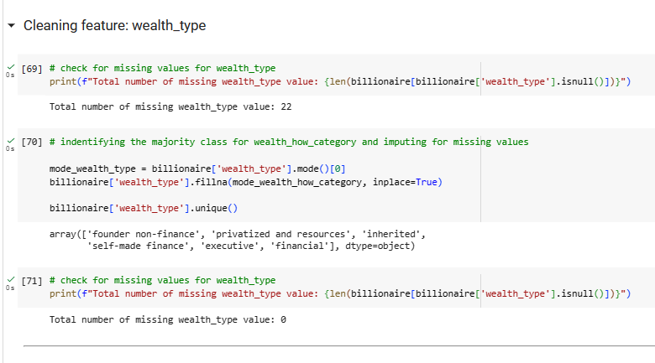

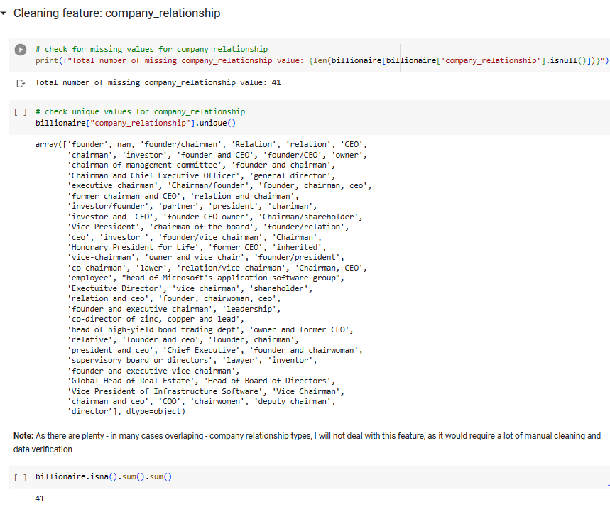 The company_relationship imputation is too complex, therefore, it will still contain missing values. However, it does not play any role in this research.

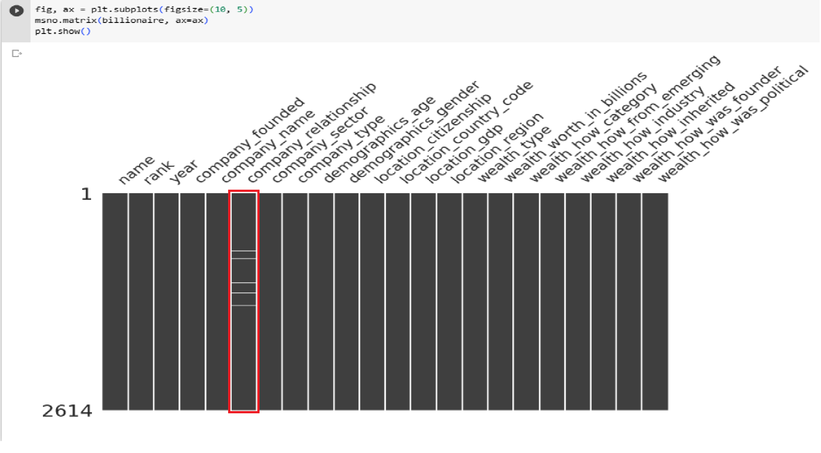

### **1****.3.2 General analysis, research questions and further visual representations**

In order to answer the research questions the following functions are created in order to have a smoother coding process with the answers. Many not necessary coding lines can be avoided in that way.

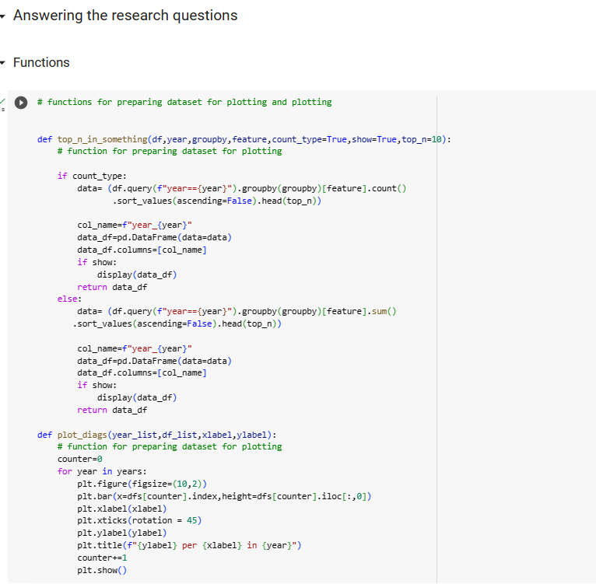

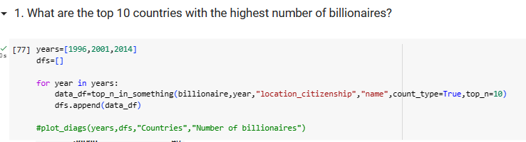

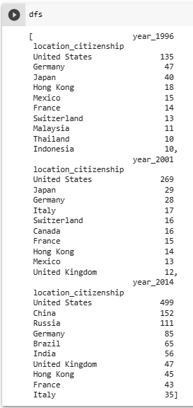

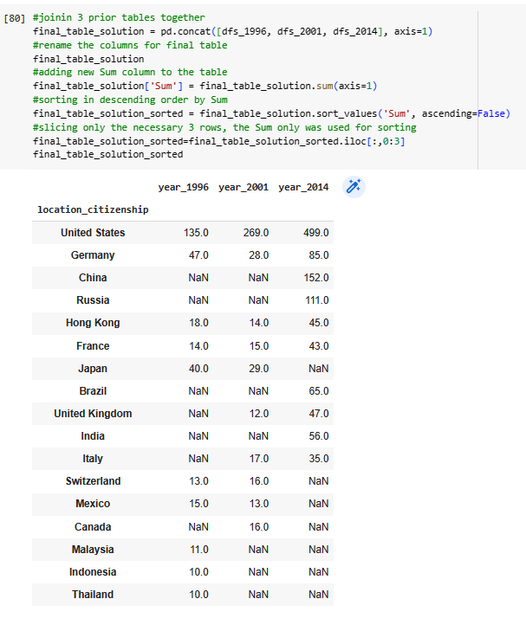

The following chart shows that United States has the highest number of growing billionaires in every given year. New countries such as China and Russian appeared on the list in 2014.

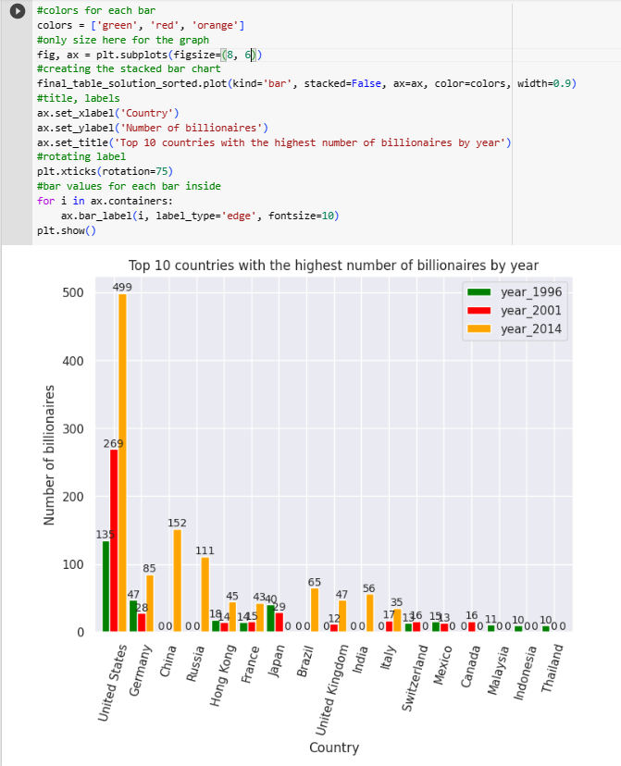

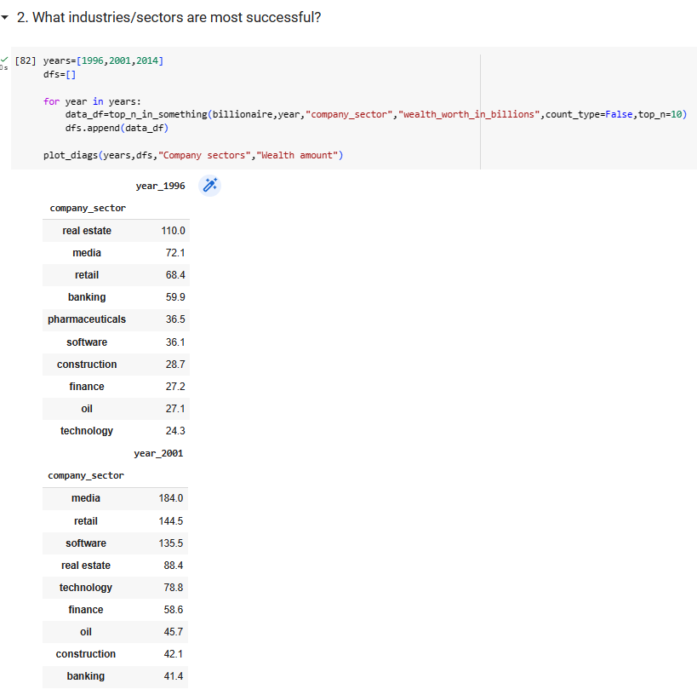

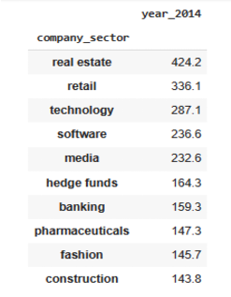

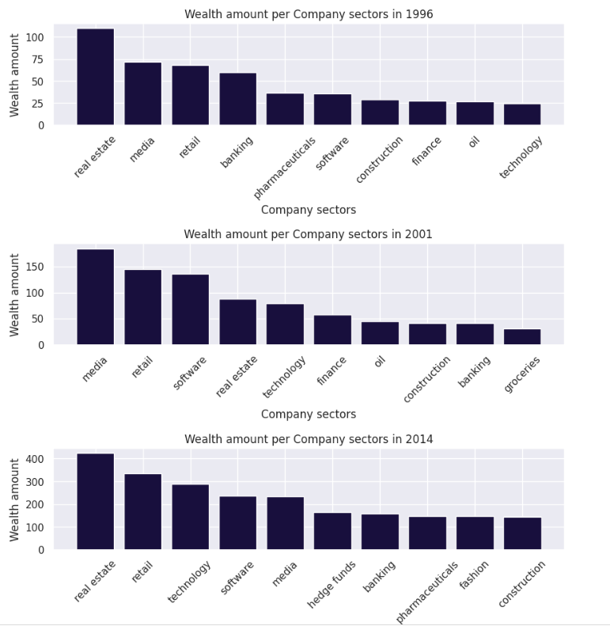

The company_sector among billionarie has changed during the period.

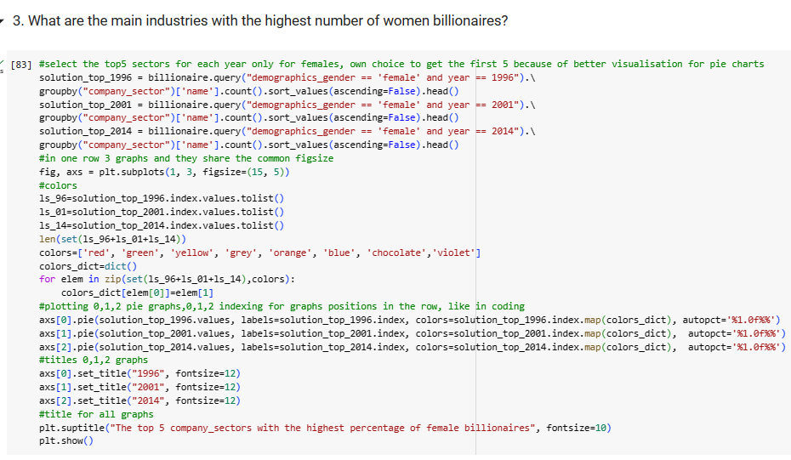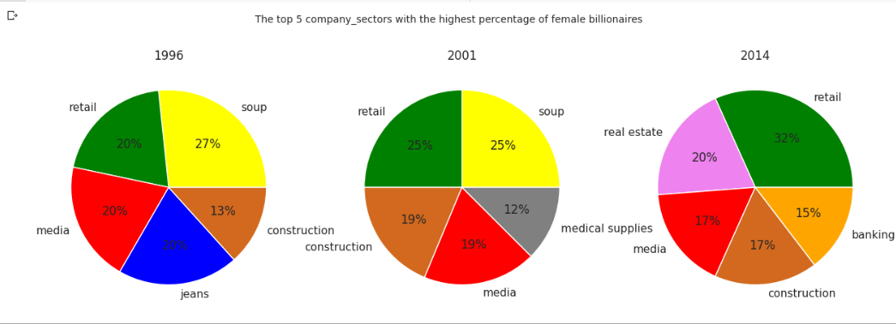

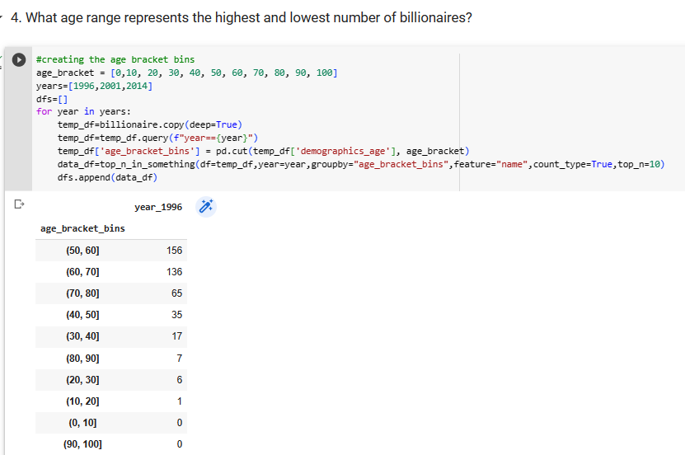 It can be seen that soup industry was the main source of fortune for females in 1996 and in 2001 which changed to retail in 2014 among female billionaires.

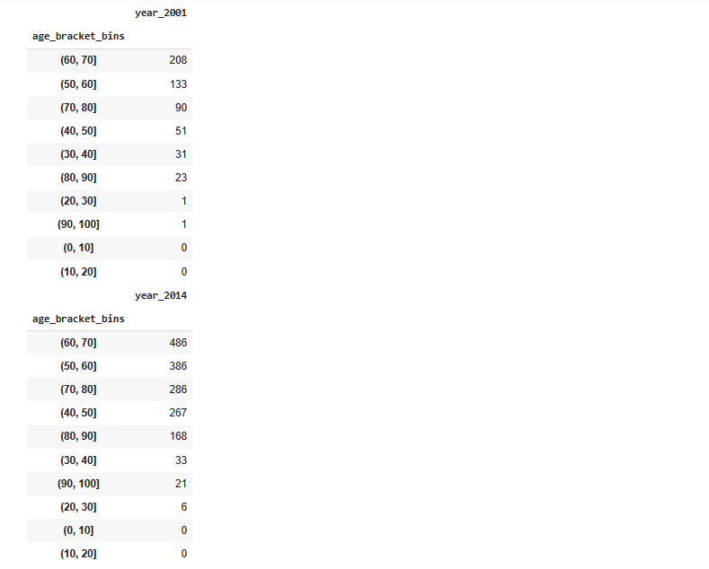

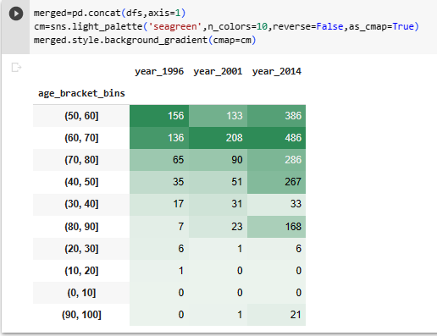

The most of the billionaire can be found in the age bracket of 60 and 70 versus the least amount of billionaire in the age bracket of 10 and 20.

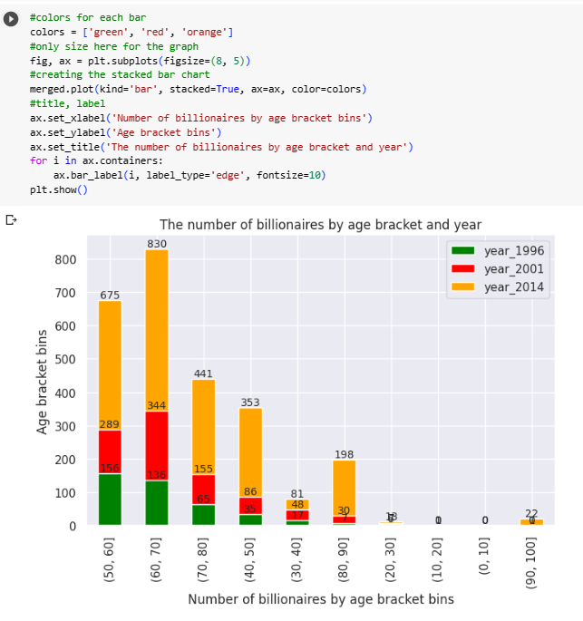

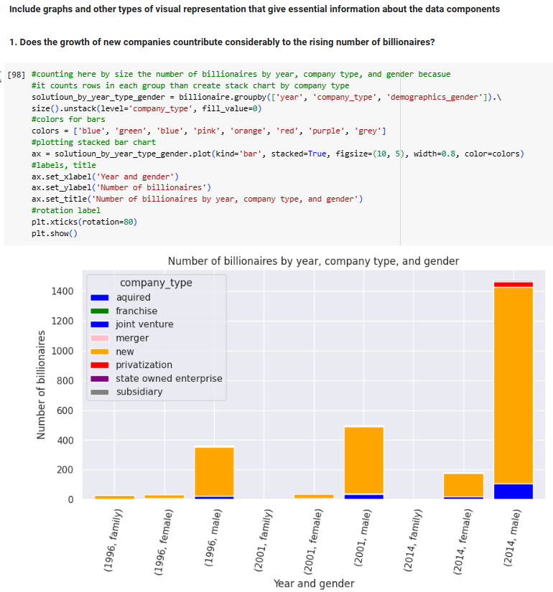

It can be see that there is upward sloping trend with male billionaire with new company_type.

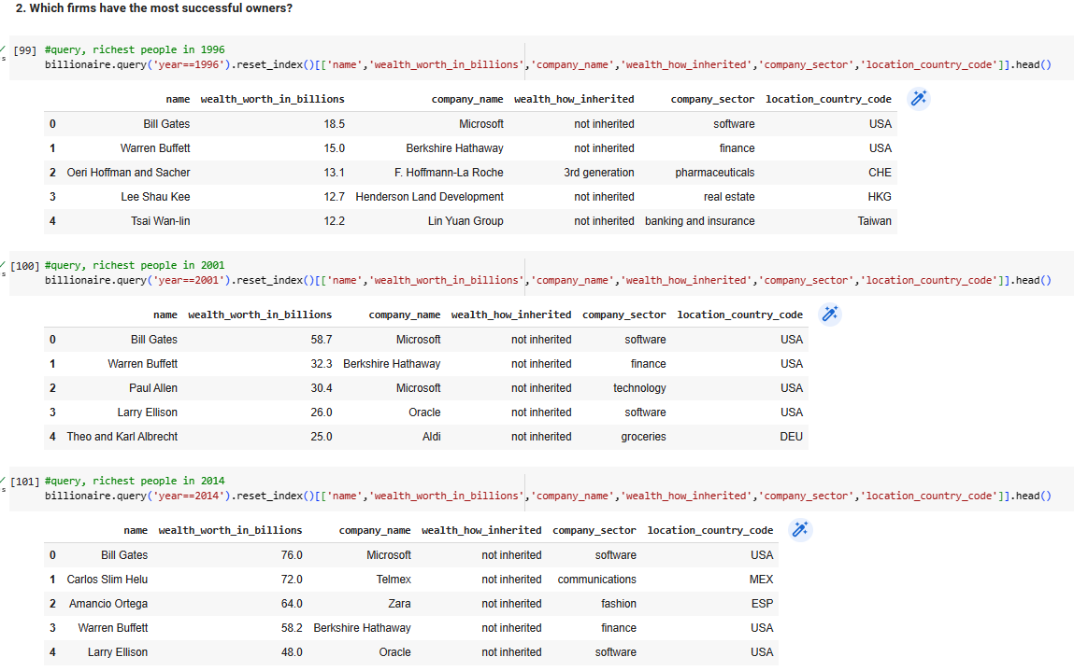

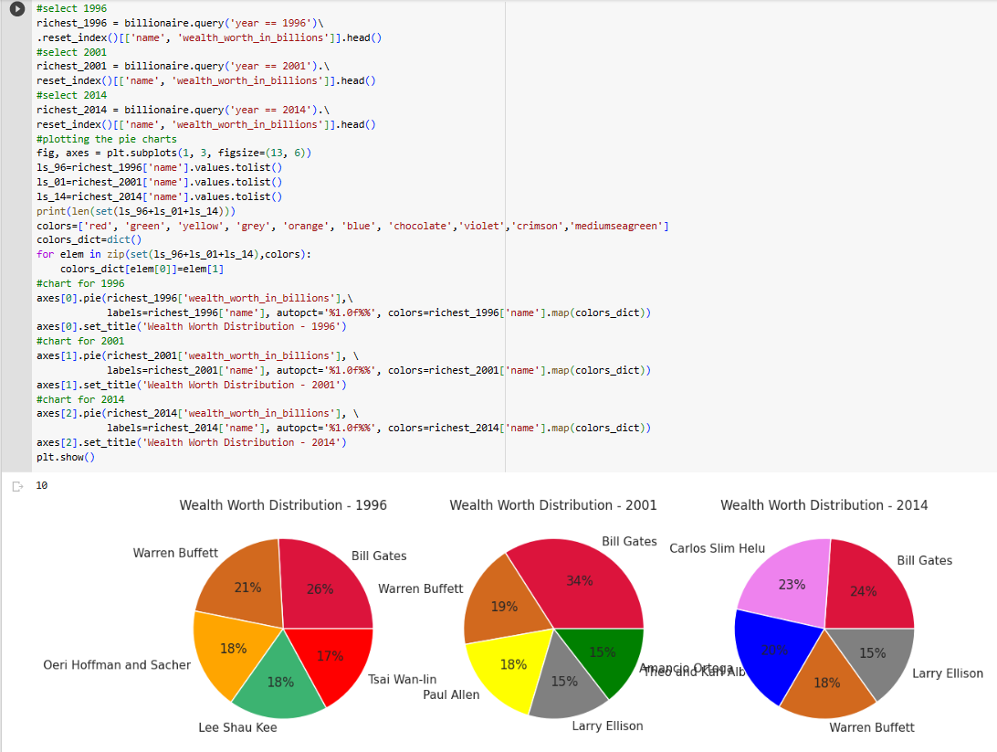 Bill Gates was able to maintain his position among billionaires between 1996 and 2014.

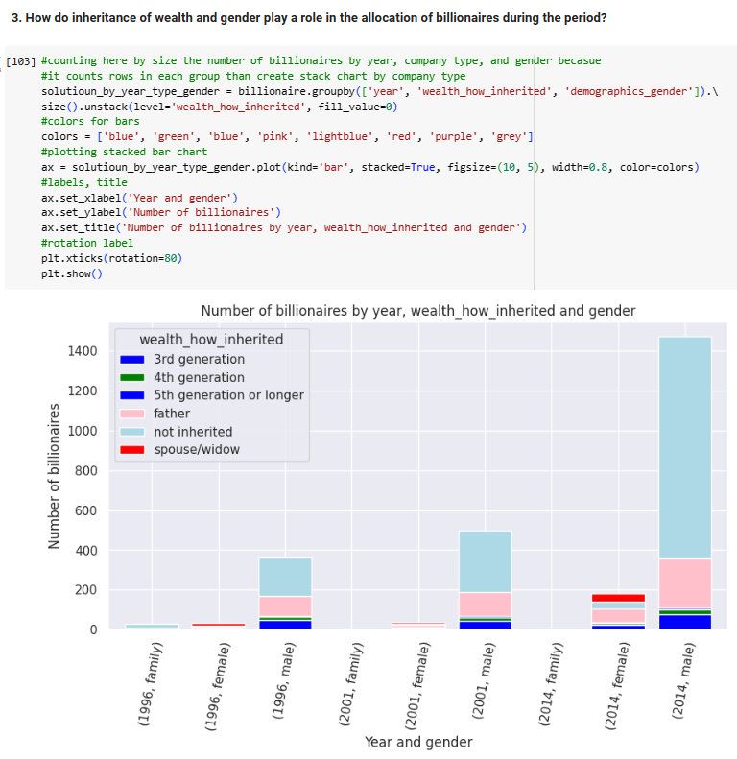

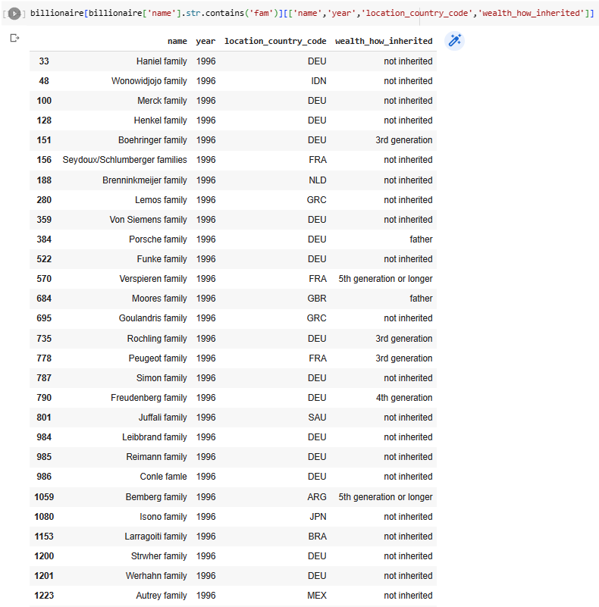 There is an upward sloping trend for male billionaire without inheritance over the period. Surprisingly, the most of the families do not have inherited fortune.

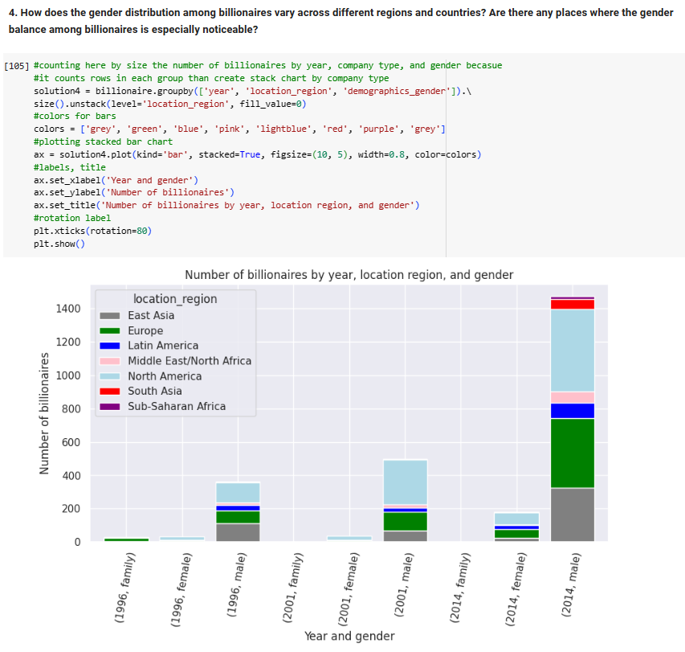

The number of billionaires has an upward sloping trend led by North America and Europe especially in the case of male.

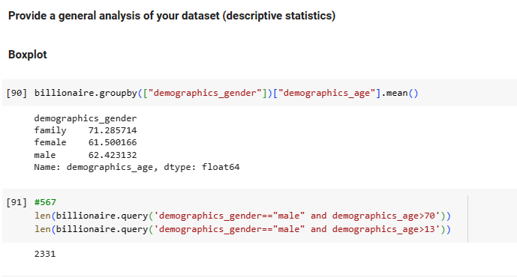

It can be seen that only male billionaires have extrem age values. The older and younger billionaires are male.

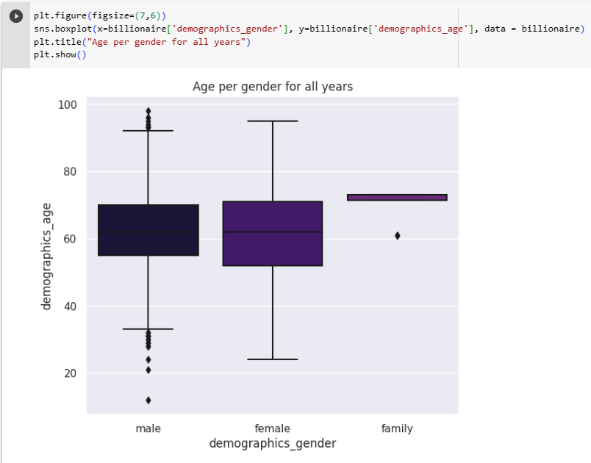

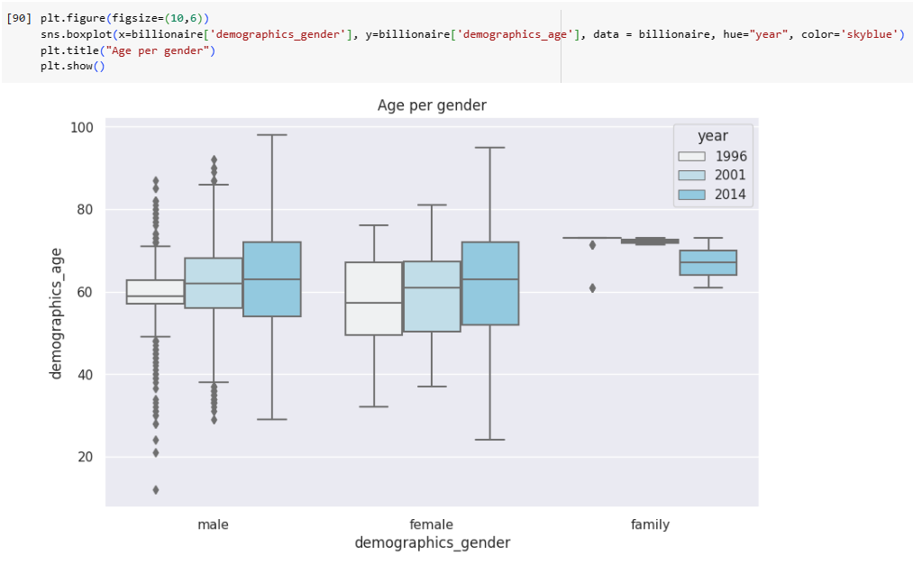

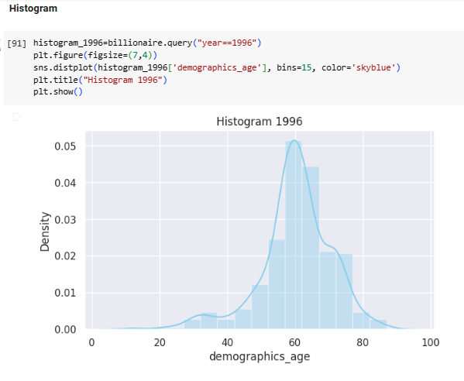

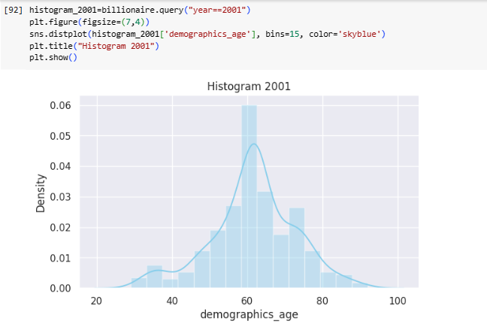

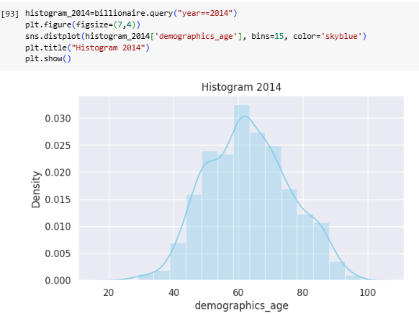

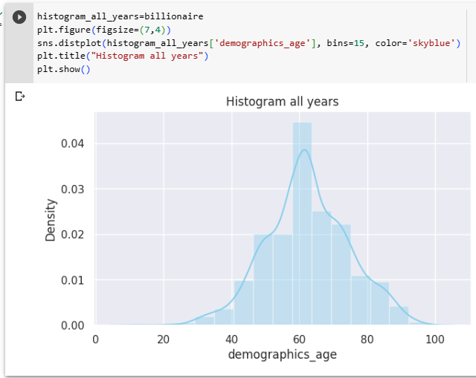

The histograms show all cases normal distribution with age mean close to 60.

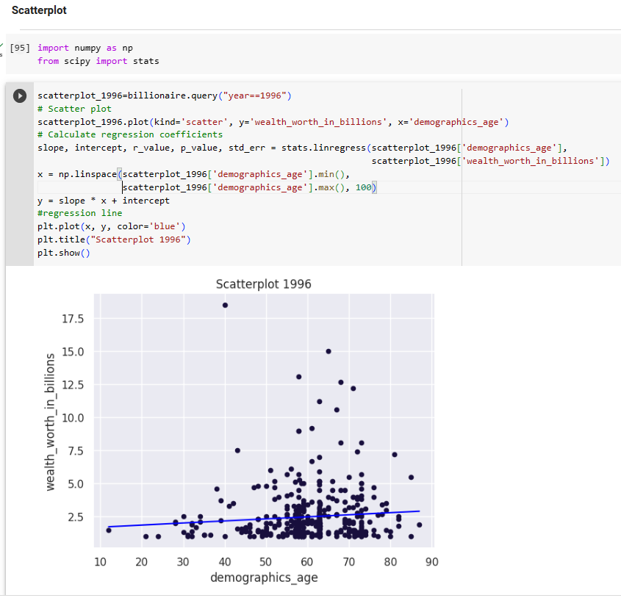

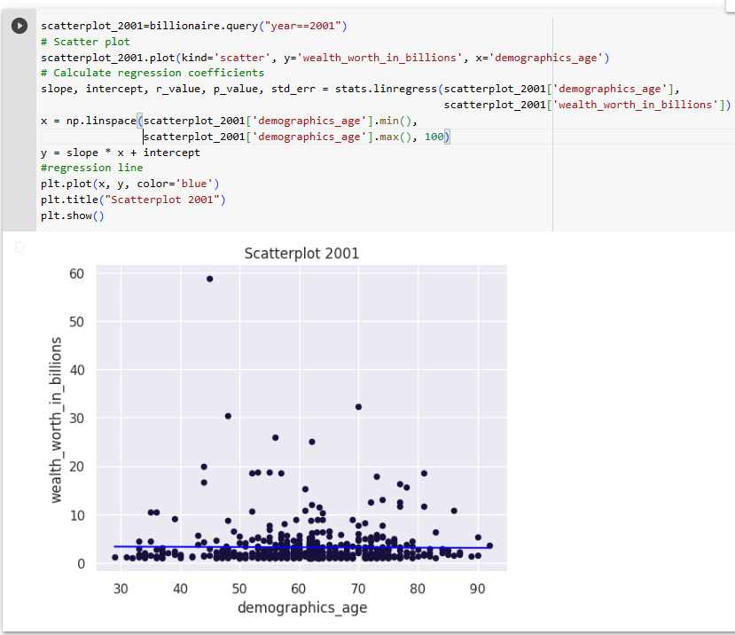

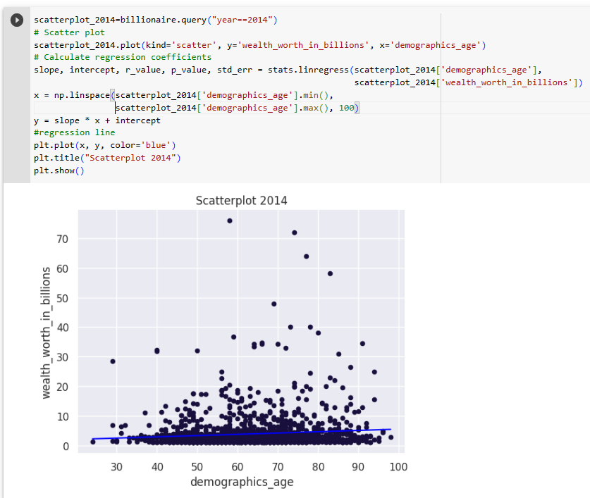

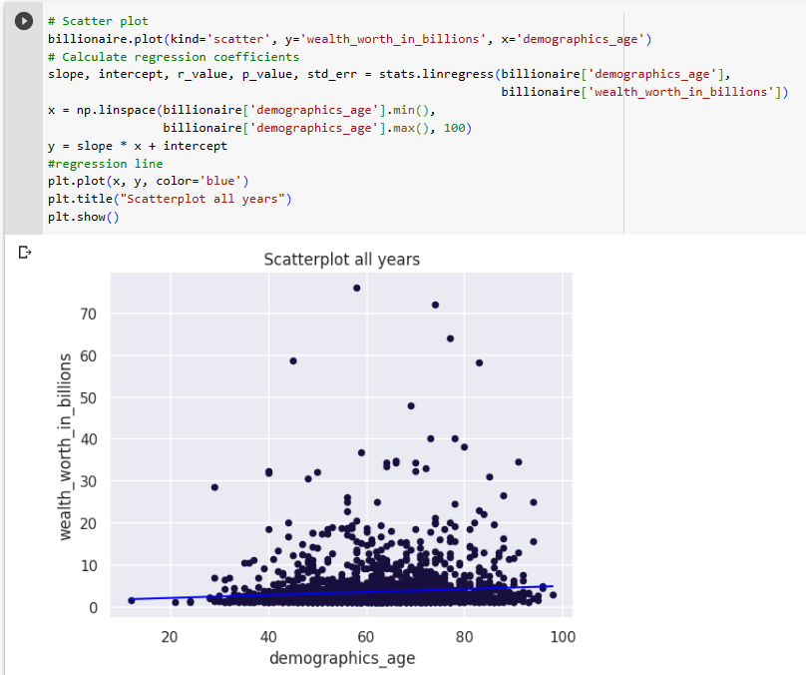 Linear line can be drawn in years and in the case of all years included.

### **1****.3.3 Statistical significance testing**

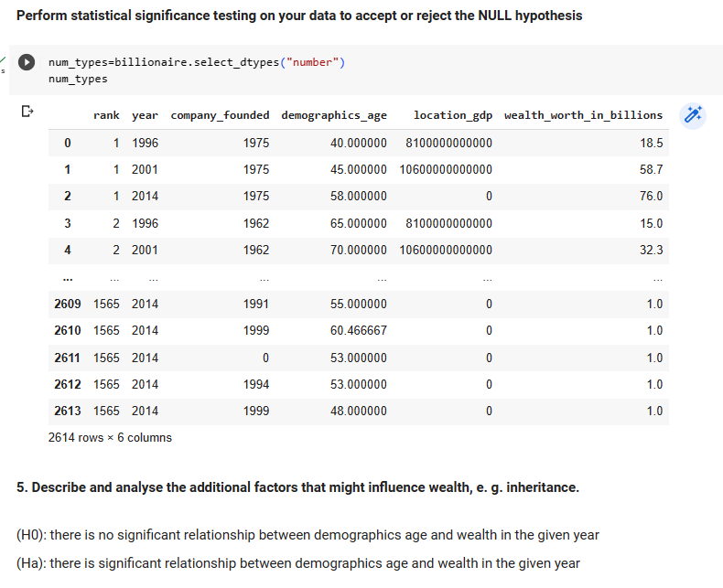

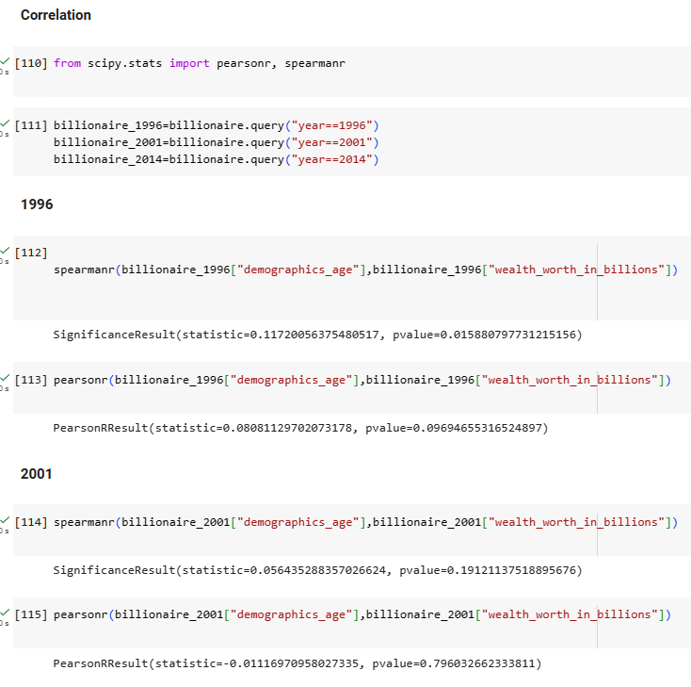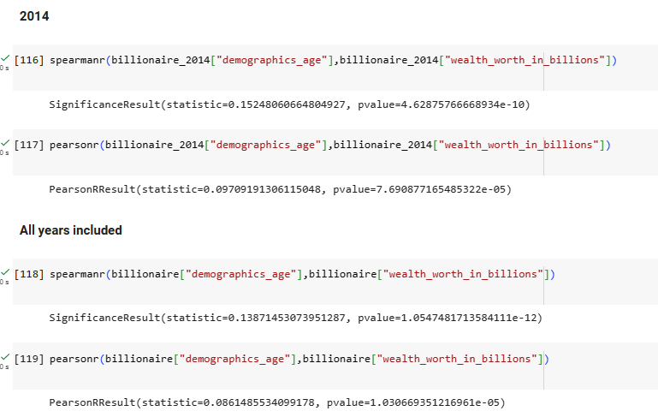

According to the correlation for all years, p value is lower than 0.05 (pearsonr is better because linear relationship is assumed. There is correlation among age and wealth. However, in 1996 and 2001, the p value is higher, which implies no relationship. In 2014, the p-values is lower than 0.05 which implies significant relationship.

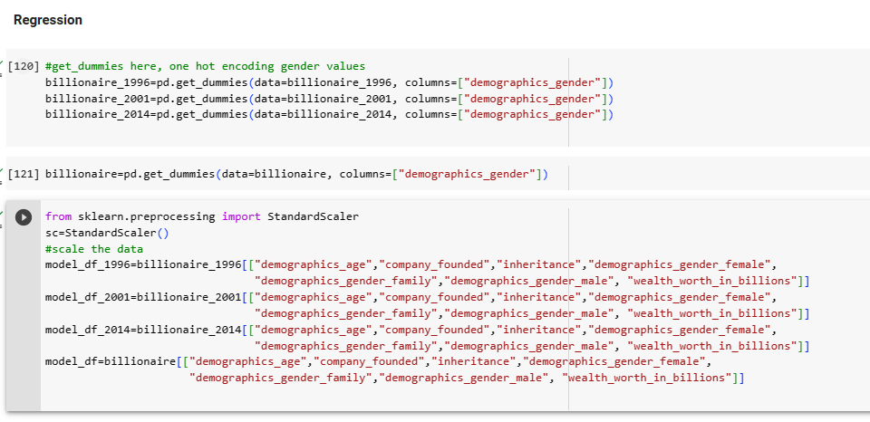

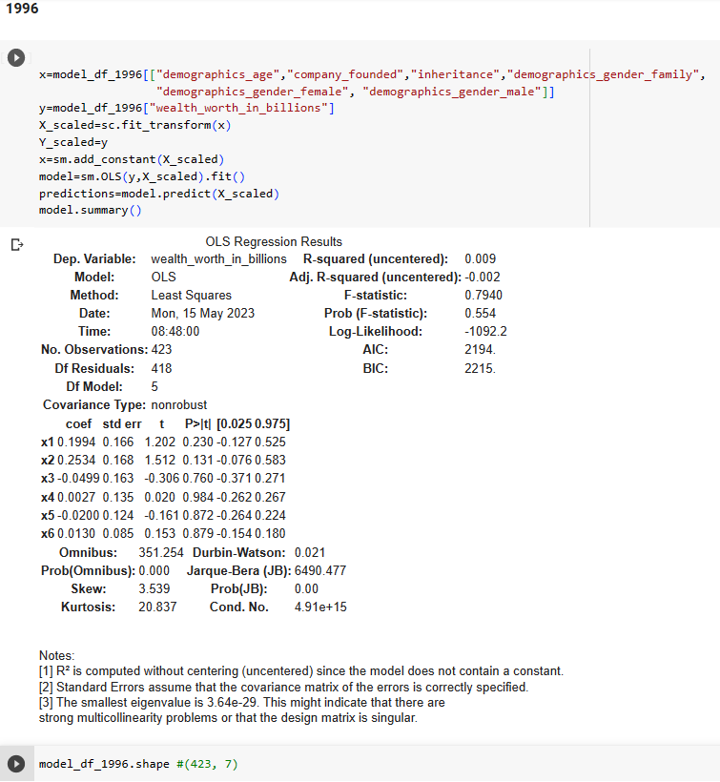

## 

## The model show only in 2014 significant relationship between age and wealth worth (p value=0.002 is lower than 0.05). However, the model has a very low explanatory power of 0.009. Many data were imputed which can affect the results as well.

## 

It can be seen that 4 models were created in order to answer the hypothesis testing questions.

The data was divided into 1996, 2001 and 2014 and models were build for all those years. Only the model containing all years and the model of 2014 show that age and wealth have a positive relationship. In both cases, the p values are lower than 0.05 (significance level).

The data of 1996 and 2001 represents only a few amount of data. However, the model shows that there is significant relationship among age and wealth and 2014 and in all year case. Accordingly, the Ha alternate hypothesis is accepted which implies relationship. In our models no train-test split was used because it was only a significance testing and not linear regression prediction. In such case, the train_test must be used. However, our data is very small to split.

The inheritance does not play any role in wealth creation in any year. In this case, the H0 is accepted that there is no significant relationship among wealth and inheritance.

## 1.4. Task 4: Evaluation and future development

### **1****.4.1 Potential impact of the results and its application within the domain**

The findings of this research can be utilised in many different areas like finance, economics, social science because the outcomes help to recognise trends, patterns and companies names, anomalities etc. in different locations by using advanced big data analytics tools.

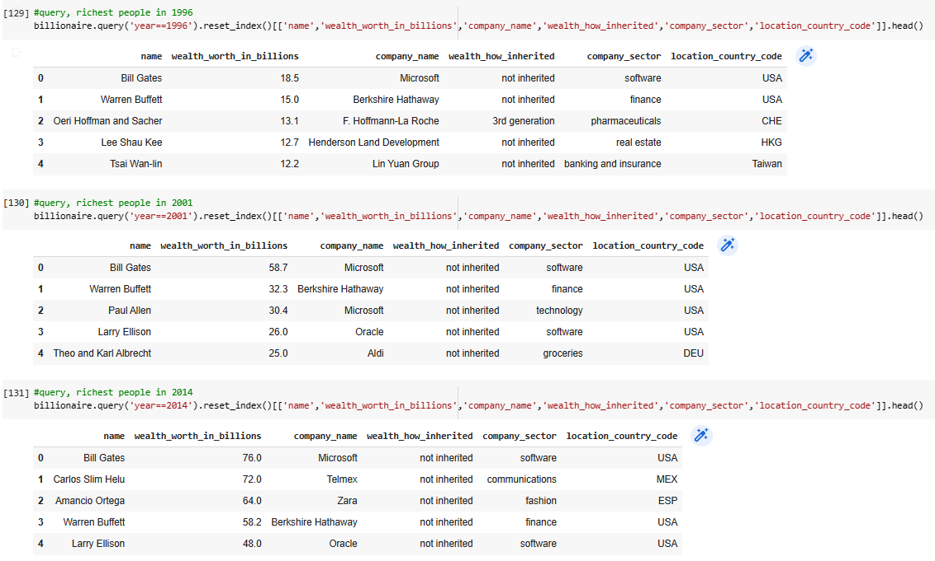

It can be seen that in the list of 1996, 2001, 2014 with the top rich people have same pattern such as Bill Gates and Warren Buffet are always included among the top 4 richest people in the planet, especially Bill Gates who has the first place between 1996 and 2014 all the time. The super rich people (except one in 1996 3rd generation inherited wealth in the table below) are self-made.

Mostly technology and finance-related company sectors contributed to the biggest wealth accumulation in the USA in the given years. By studying the data on the accumulation in wealth trends, company sectors, and locations of wealthy people, investors can make more precise decisions on portfolio management and asset allocation ideas.

Most likely the billionaire such are Warren Buffet and Bill Gates are interested in maintaining their long-term success in the future. Their long-term past performance with their managerial style can provide trust to the investors regarding creation of shareholders’value which make them more rich as well. Microsoft or Berkshire Hathaway shares must be included in any long-term investment portfolio.

The dataset can be utilised to discover trends in the traits and habits of wealthy business people, or to investigate the link the generation of wealth and elements linked to society or environment. Leckelt *et al.* (2022) suggest that distinctive personality traits can help in the creation of wealth. According to their data, self-made high-net-worth individuals closely matched the behavioural profile of the rich, and the more so, the richer they got.

Analysis of statistics demonstrates that the super rich people in the USA are more innovative than in Europe (Freund and Oliver, 2016). These results can help social science to understand wealth difference, the main drivers and economic environment in different countries.

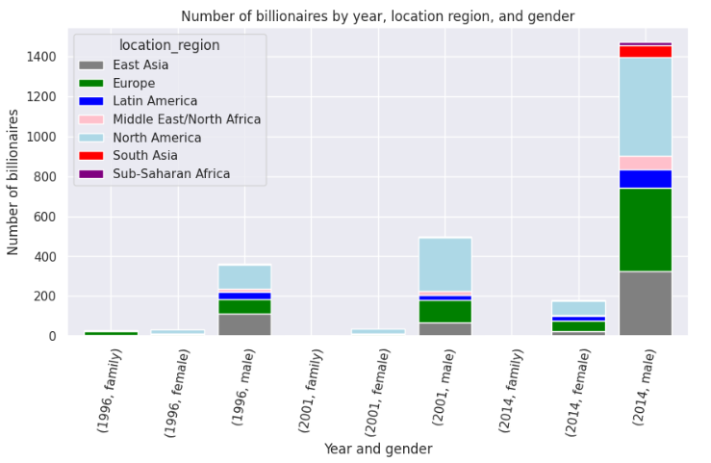

### **1****.4.2 Limitations**

Some limitations of this research must be considered, containing the follows:

1. Quality of the data: The quality of the dataset can vary depending on data source, resulting in possible biases and missing data.
2. The dataset is limited only to data in 1996, 2001, 2014. Lack of current data: The data does not contain the current data about billionaires. The wealth worth, location, or other features may have changed considerably since then (between 2014 and 2023)
3. Size of data sample: The samples are small based on the amount of data every year, that can influence the robustness and generalisability of the models.
4. Limited number of features: The dataset does not contain features such as education etc. This can influence the comprehension of dataset and affecting wealth creation too.
5. The explanatory powers of the models in every year are very low. Many data were imputed and not too many relevant and appropriate features for independent variables.

### **1****.4.3 Further solution development in terms of the latest technologies**

The investigation of the billionaire dataset is a challenging and complex job containing the collection, preprocessing, and analysis of the data. The extraction of appropriate data from text in a format that can be integrated into algorithmic trading is recently one of the natural language processing (NLP)’s main challenges (Soni and Selot, 2020). NLP methods to evaluate articles provided by news, posts from social media, text data everywhere which is publicly available could make it possible to gather a more complex comprehension of the behaviours and views particular rich people.

The steady rise in the accessibility of data, processing power, and storage-particularly in the cloud-and the growing complexity of the instruments utilised for analysing large amounts of data have resulted in the sudden growth of artificial intelligence in financial services and investment industry. With the development of artificial intelligence (AI), and machine learning methods can be utilised wisely to detect fraudulent transactions by analysing large amount of financial data (Ali *et al.,* 2022).

Data is considered to be the new currency, and new data continue to be produced by applications, company outcomes, social networking sites, the web etc. 90 percent of the data in the financial sector is most likely to be unstructured, which has been always challenging to analyse, but because of advances regarding how data is processed by companies and the accessibility of information processing resources, this can be utilised to generate a competitive edge.

It is generally believed that cloud computing is the best method for storing, organising, and analysing big data (Berisha, Mëziu and Shabani 2022). The development of cloud-based computing and computing power has significantly decreased the expense of massive data processing and storing, which has decreased the entrance requirements for those seeking to operate as a supplier or user of AI and data applications.

# **Section 2** **– Business Intelligence (Tableau)**

**What is business Intelligence etc. some sentences here for introduction**

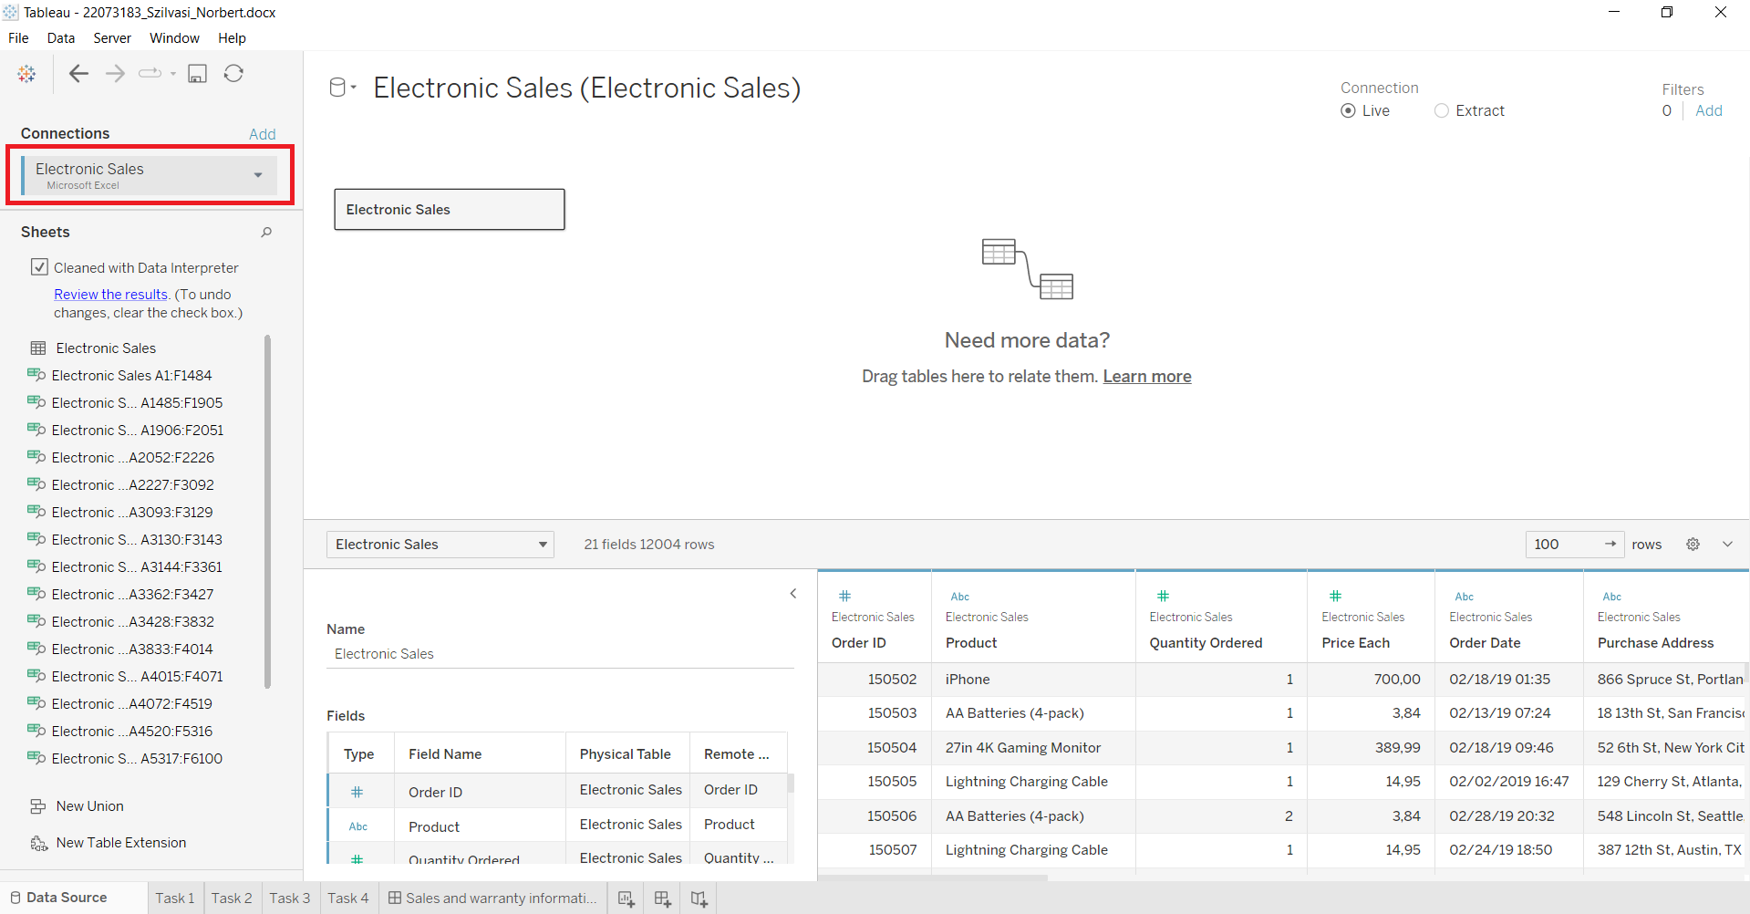

## **2****.1. Task 1**

Available here:

[22073183_Szilvasi_Norbert.docx | Tableau Public](https://public.tableau.com/app/profile/norbert.szilv.si/viz/22073183_Szilvasi_Norbert_docx/Task1?publish=yes)

1. step: After creating the basic chart with Quantity Ordered and Product features, null values needed to be excluded from the dataset.

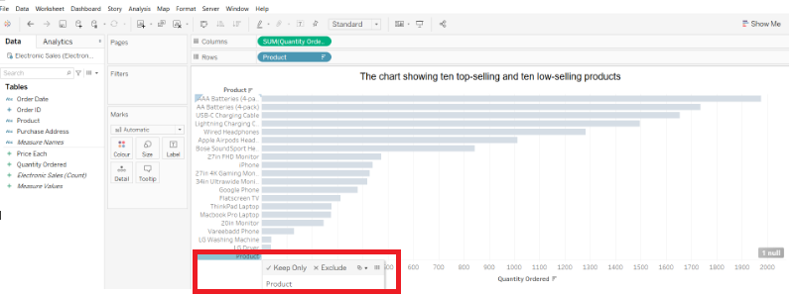

2. step: In order to be more transparent, the bars are divided by different colors using calculated field with the following basic calculation.

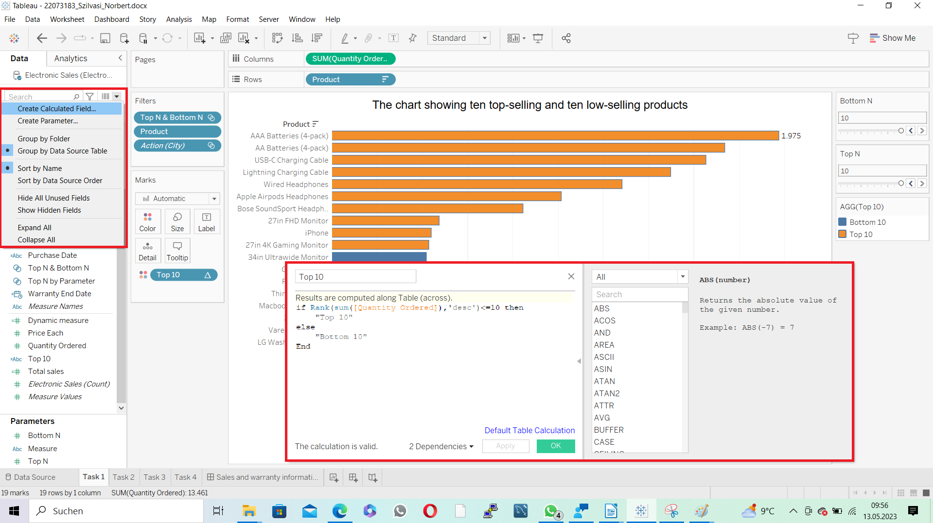

3. step: Then the parameters of top and bottom N values were created by clicking on the following button on the picture. The sliders for top and bottom N on the right side will be visible only creating the parameters

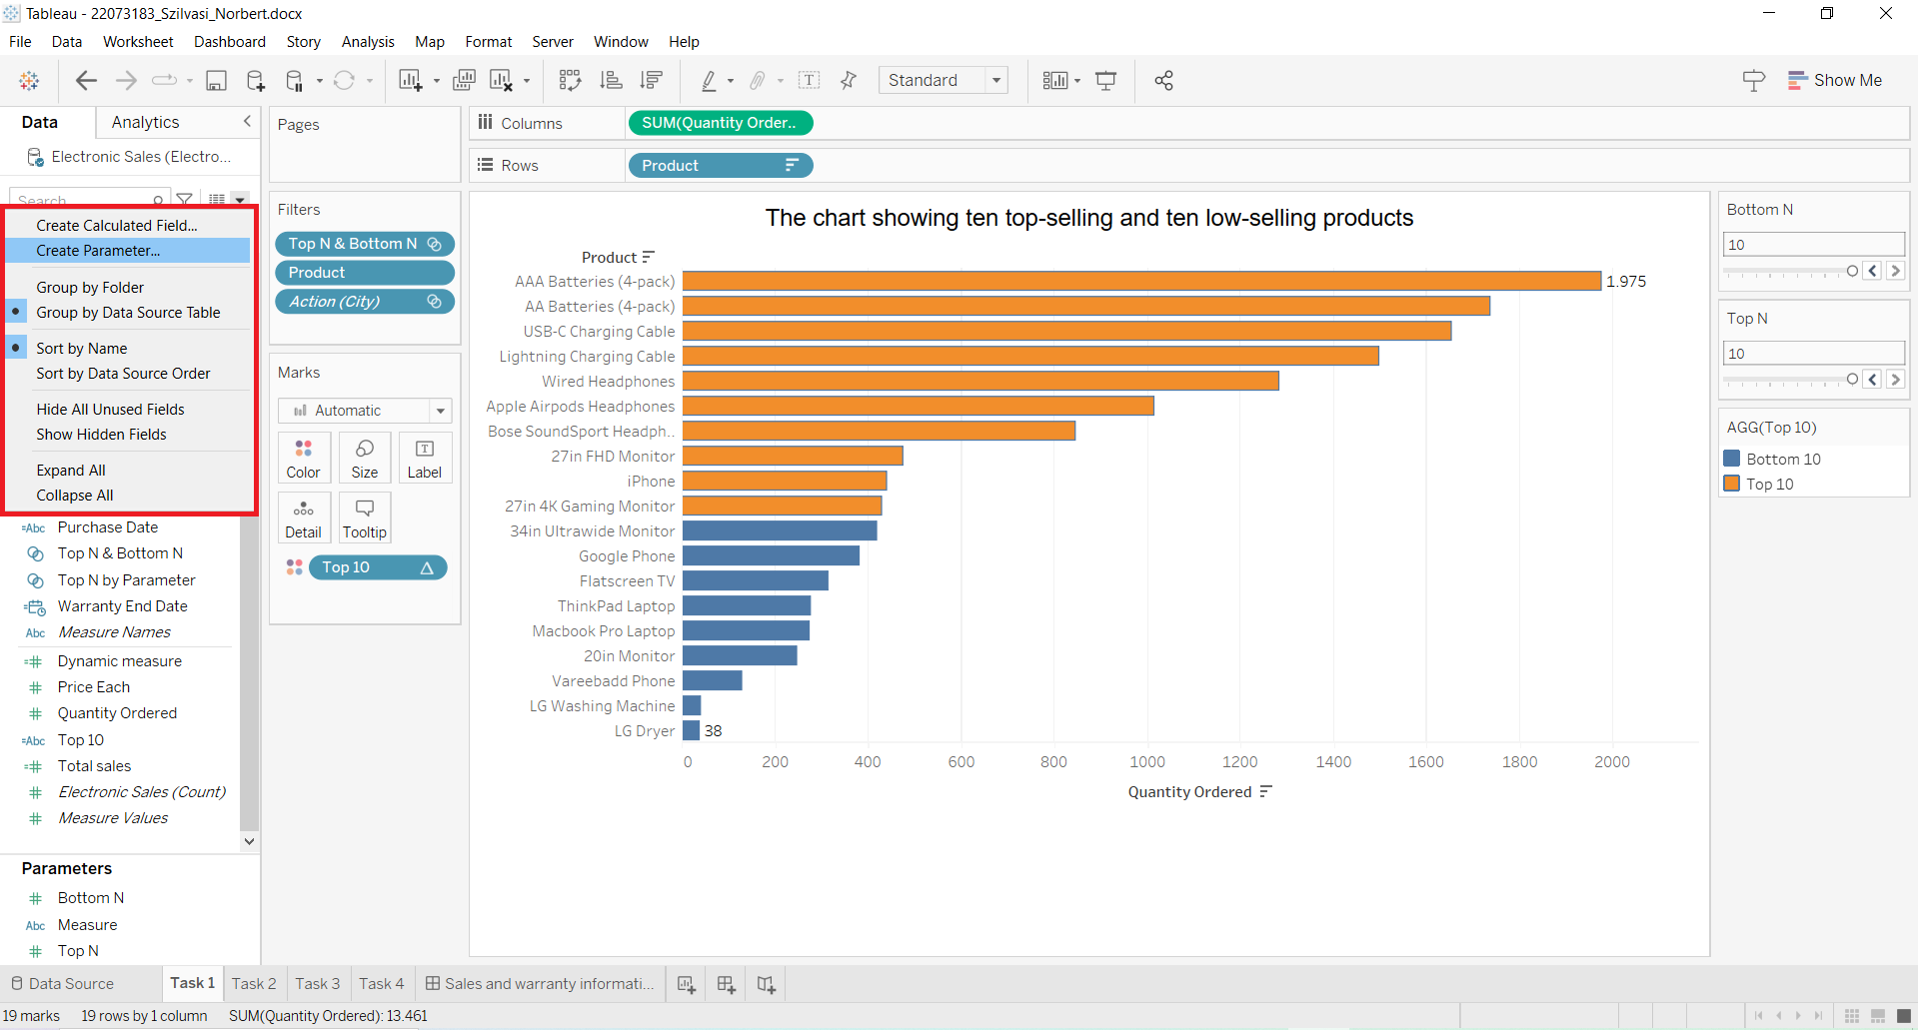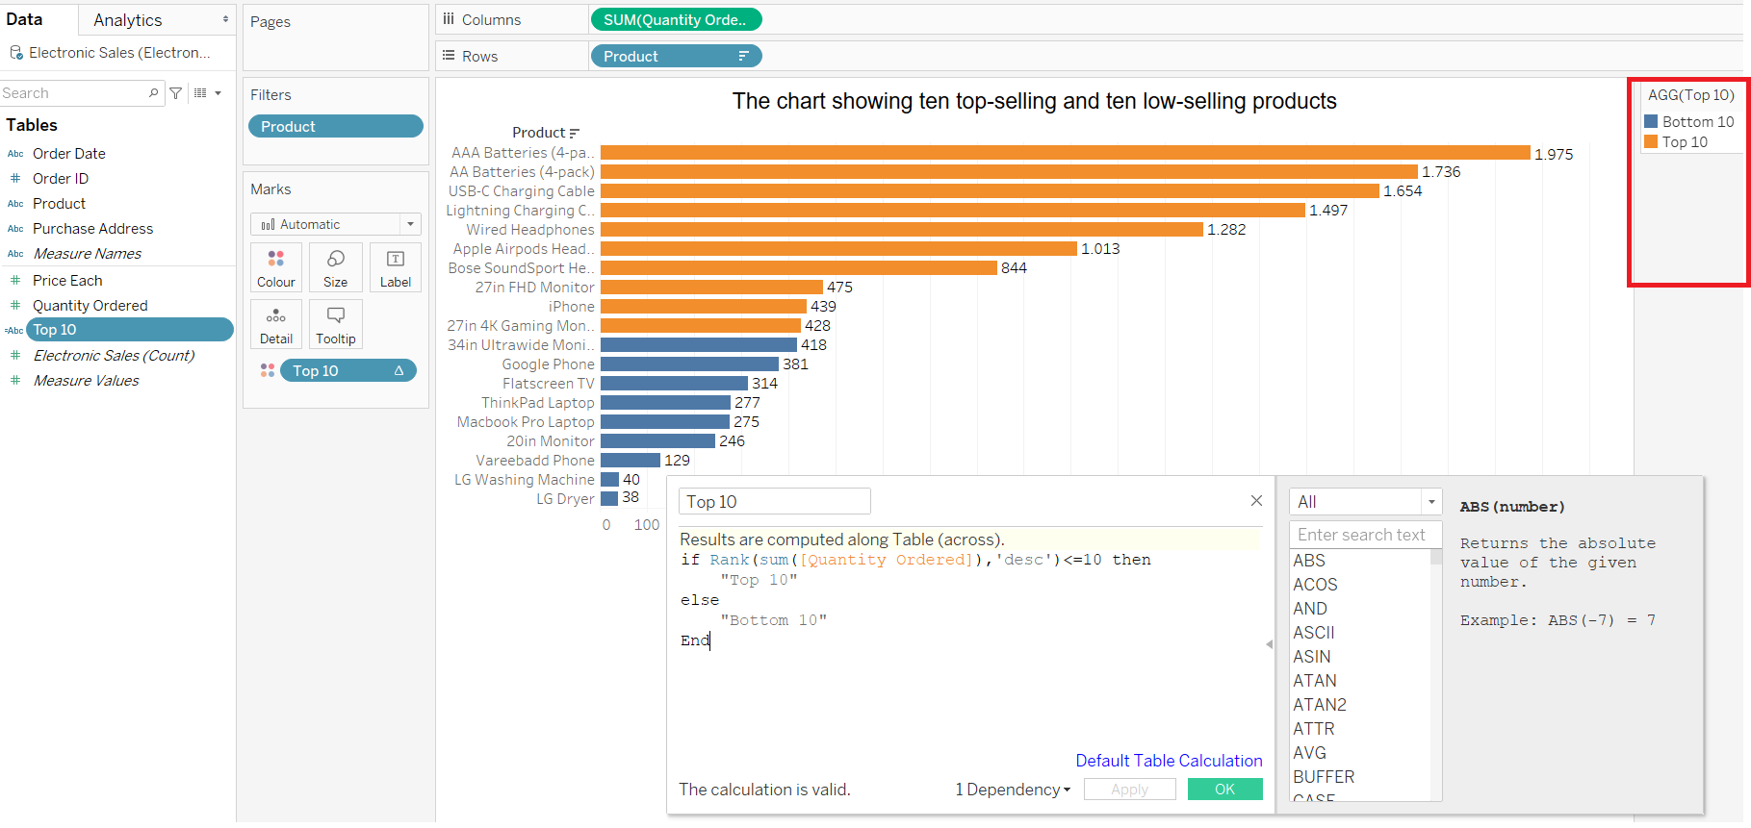

4. step: Creating the parameters with maximum value of 10 and minimum value of 1 and step size of 1 for bottom and top N. In order to do that, the bottom N parameter was created first, then top N was created by duplication of the bottom N.

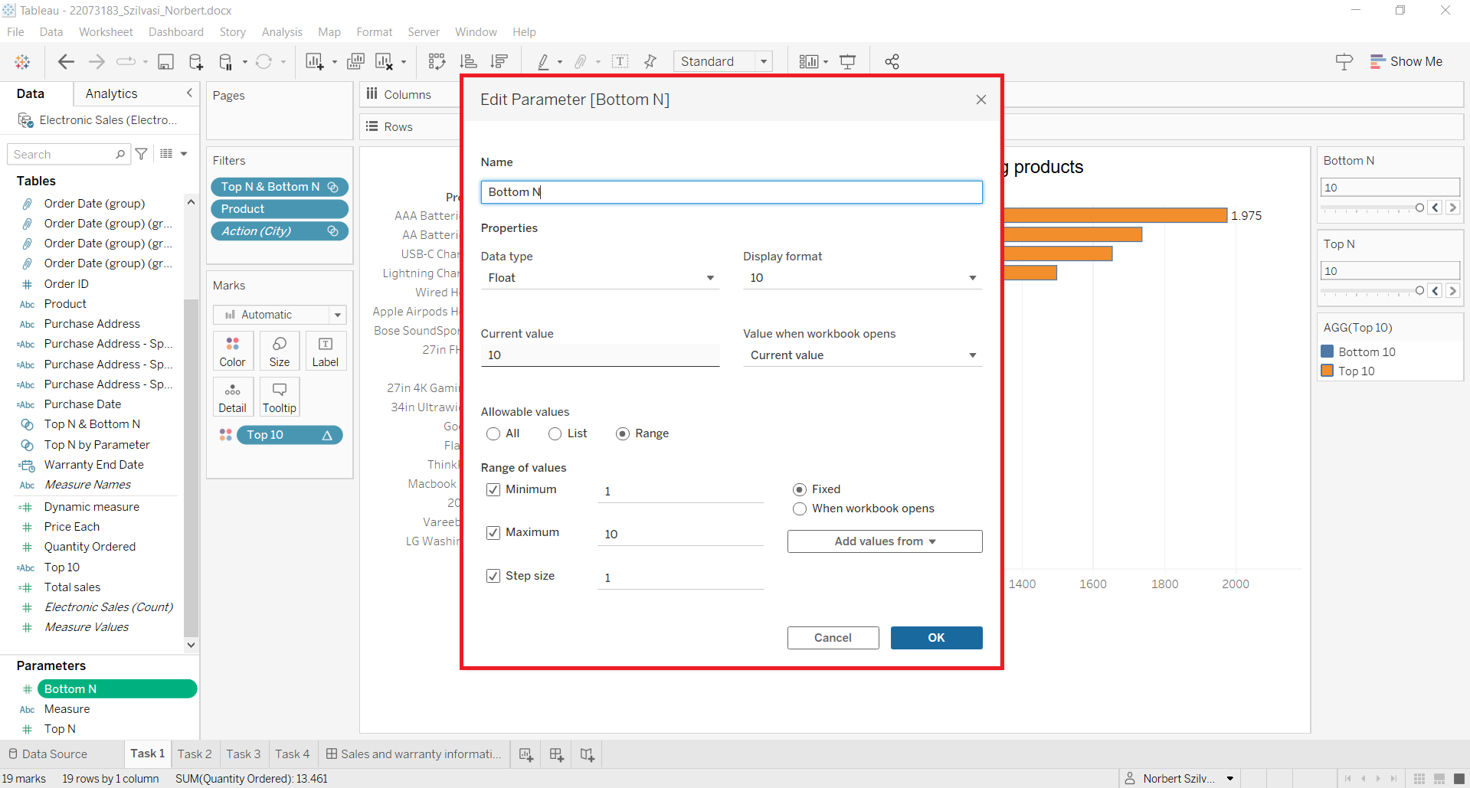

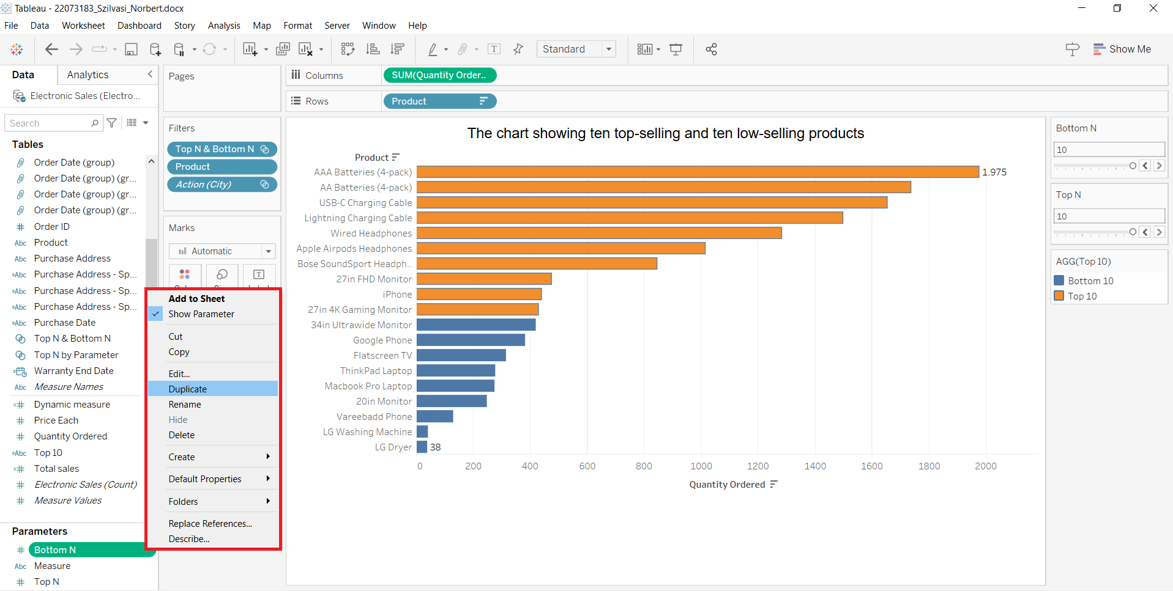

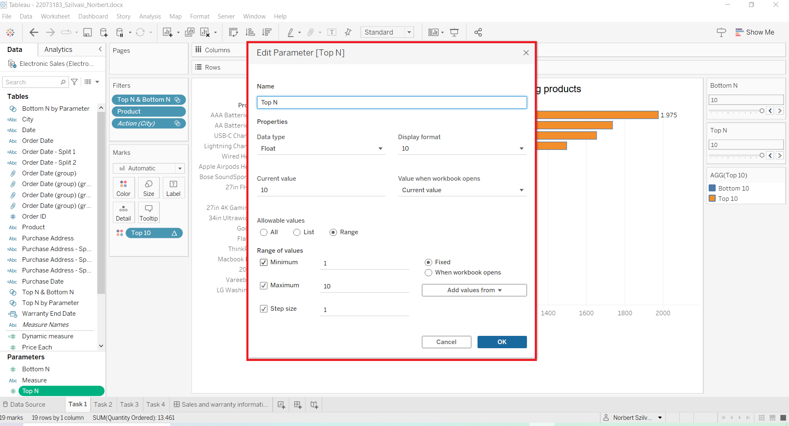

5. step: Then the parameters were set in order to be visible on the right part, but it is not possible to change the numbers without creating a set

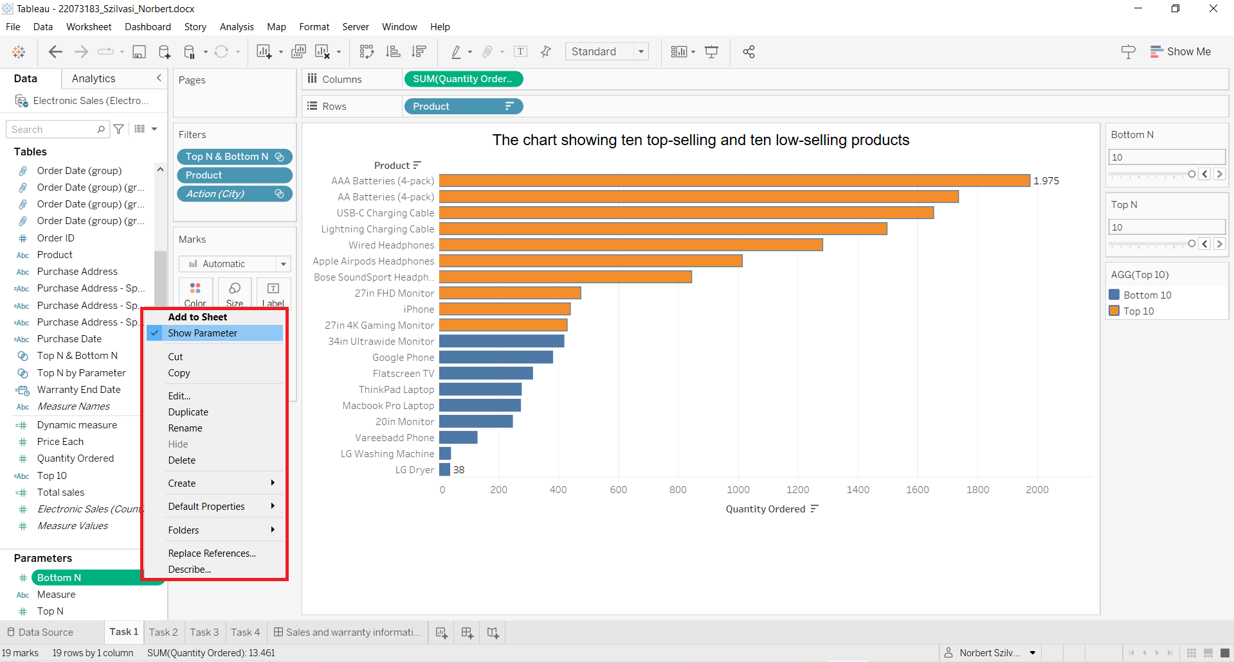6. step:In order to create an interactive chart with parameters, sets must be added as well in order to be able to set how many products must be visible by changing the top and bottom N parameters

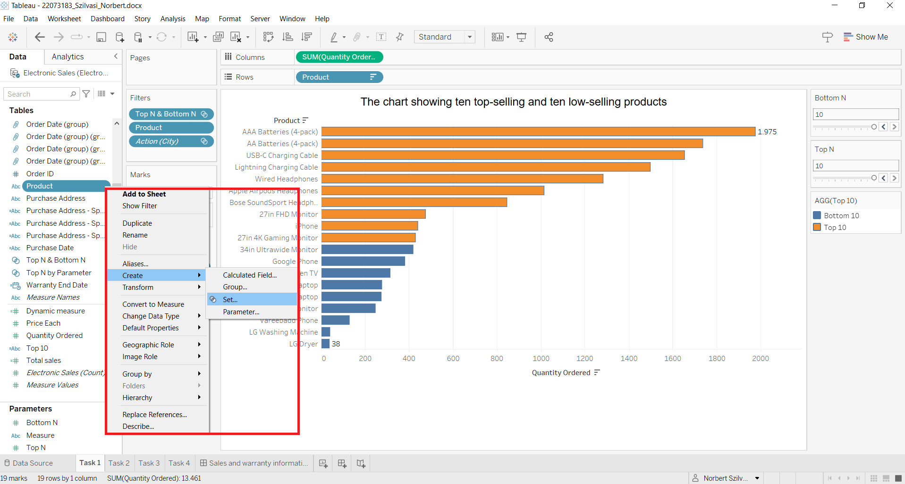7. step:Creating a set for top N (same way for bottom N with duplication then just rename the button and adjust to bottom N in the edit set top section)

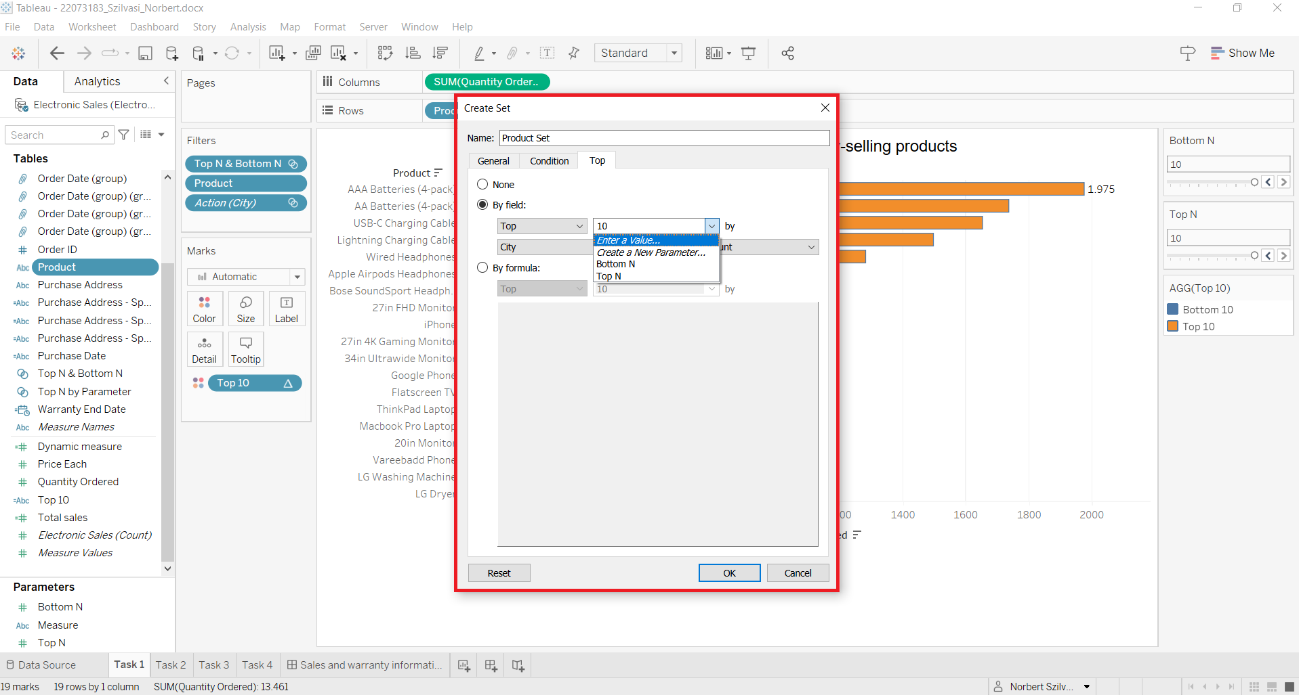

## 

## 

## 

8. step: In order to build up connections with top N and bottom N parameters, combined set mu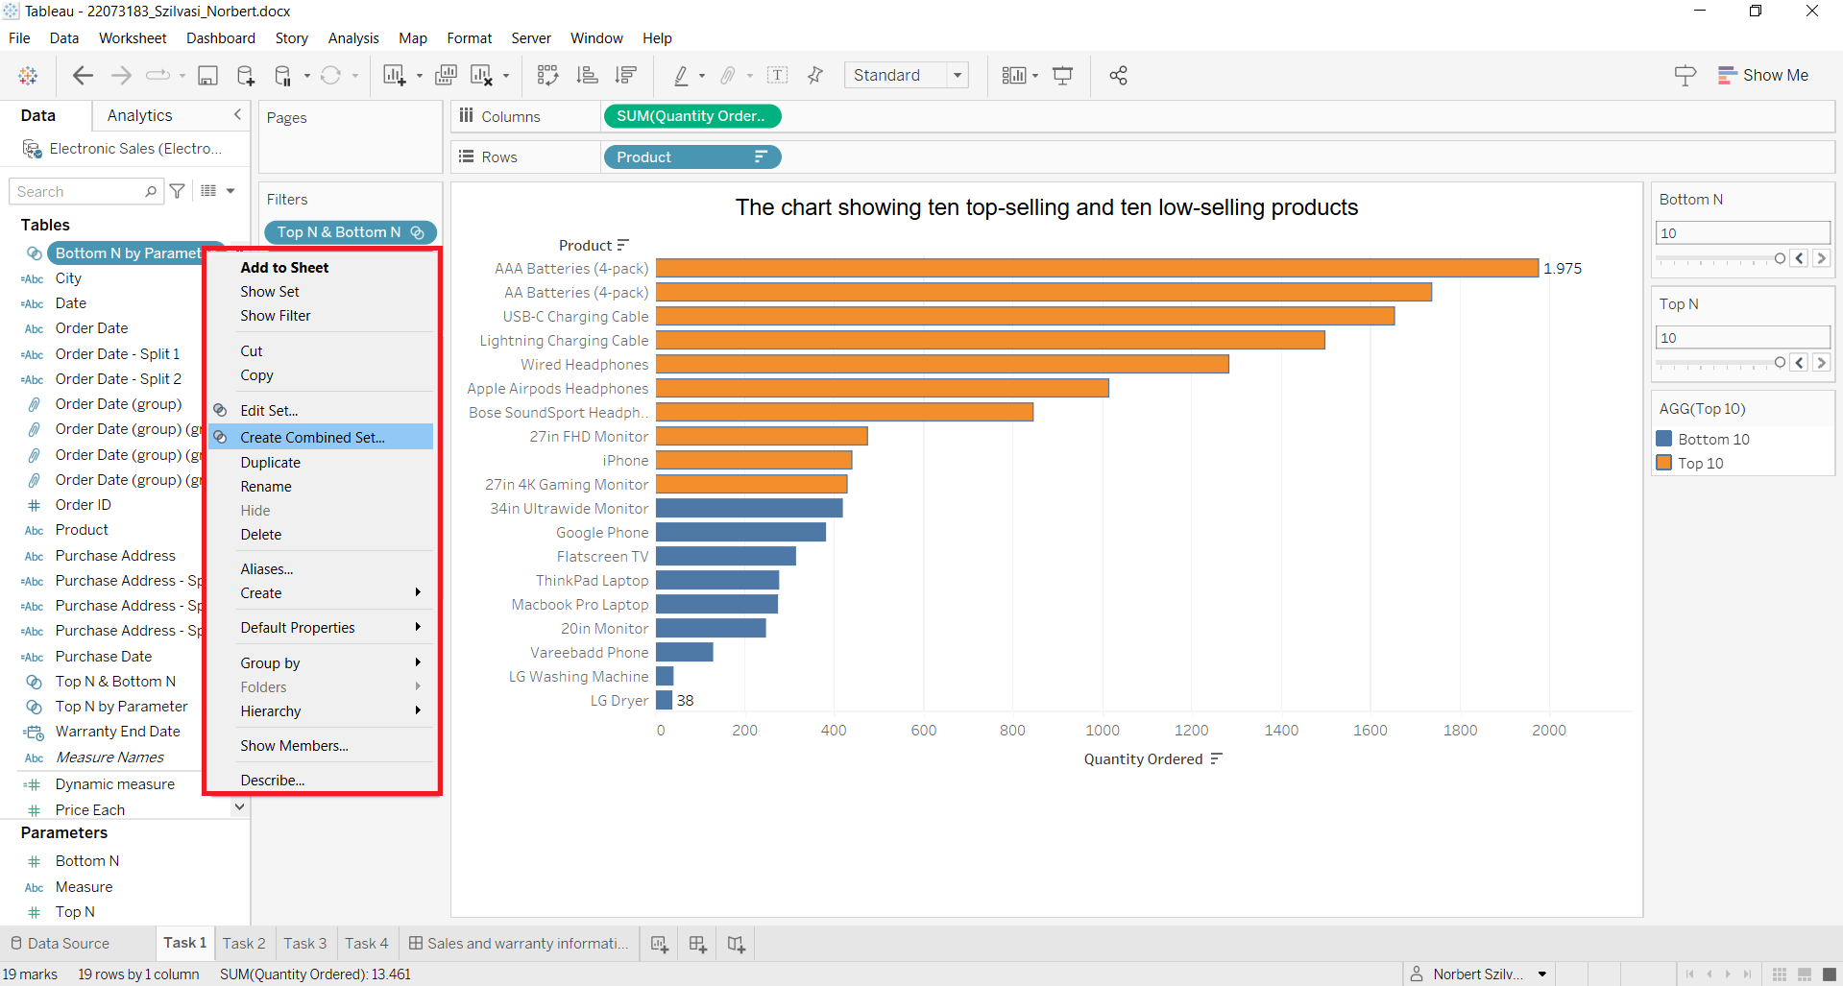st be created. Then selection of N is possible for top and boom products by sliders

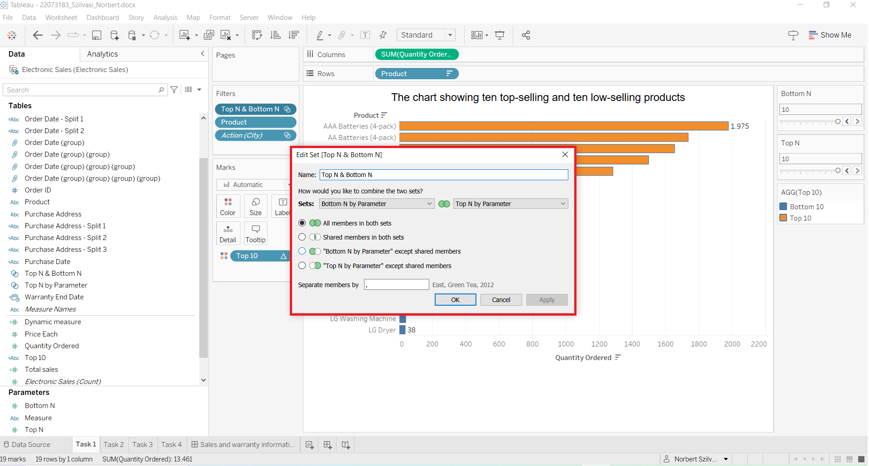9. step: The sliders on the right side can be seen with an interactivity. Bottom N and top N products can be set to display on the chart the required number of top and bottom products in descending order. It is not possible to set the slider values to 0, because error message appears.

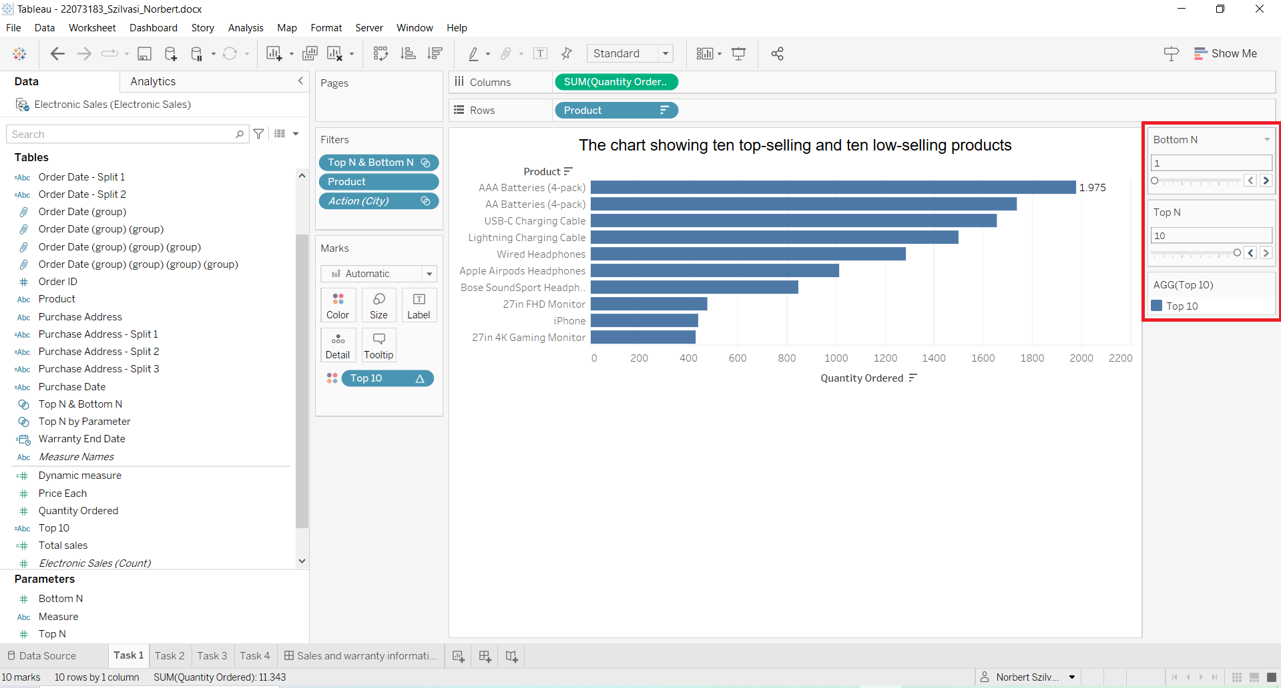

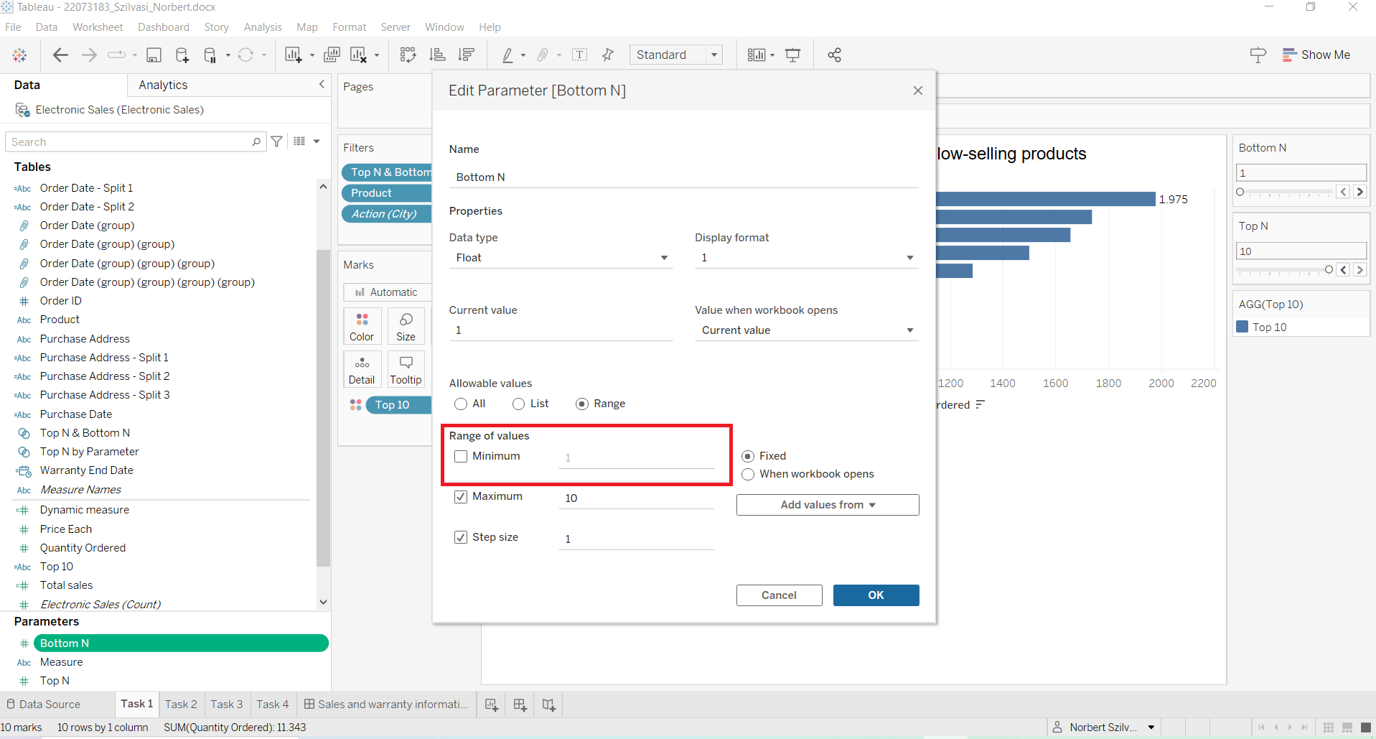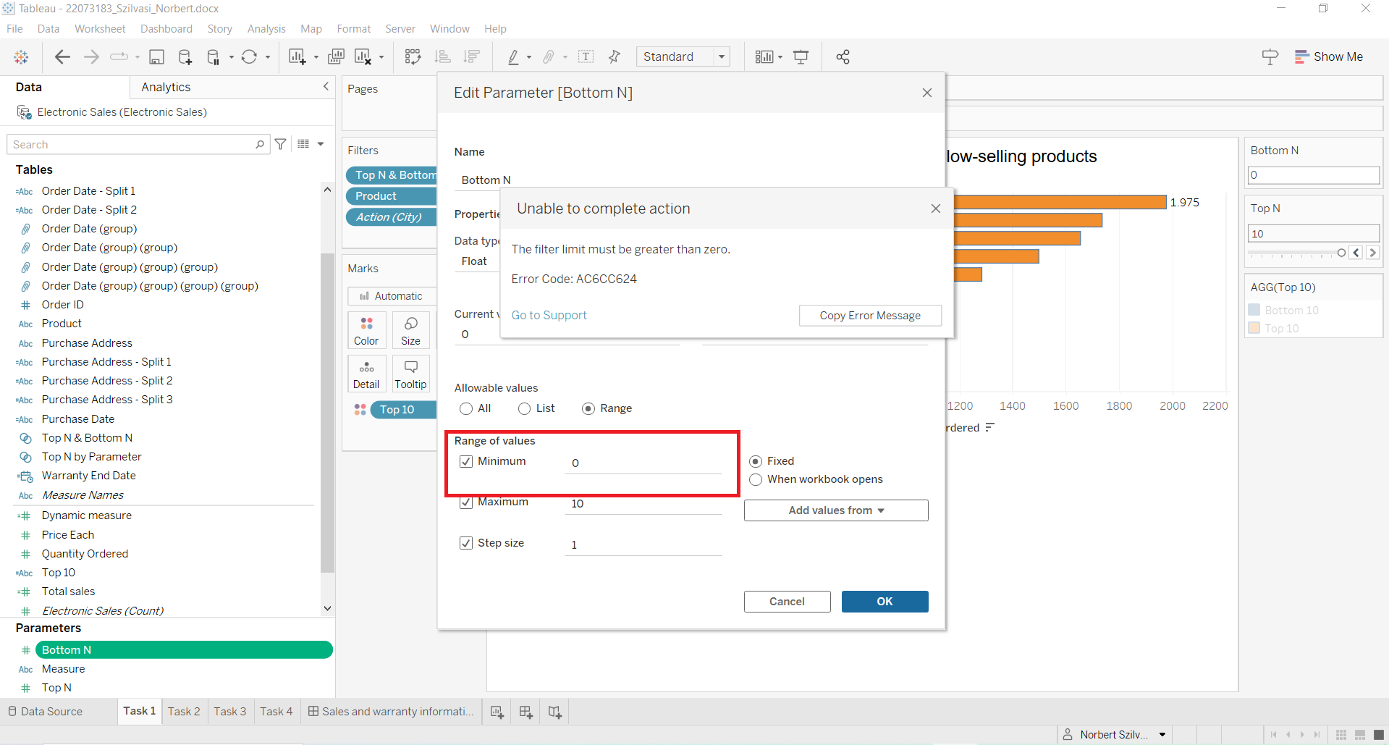

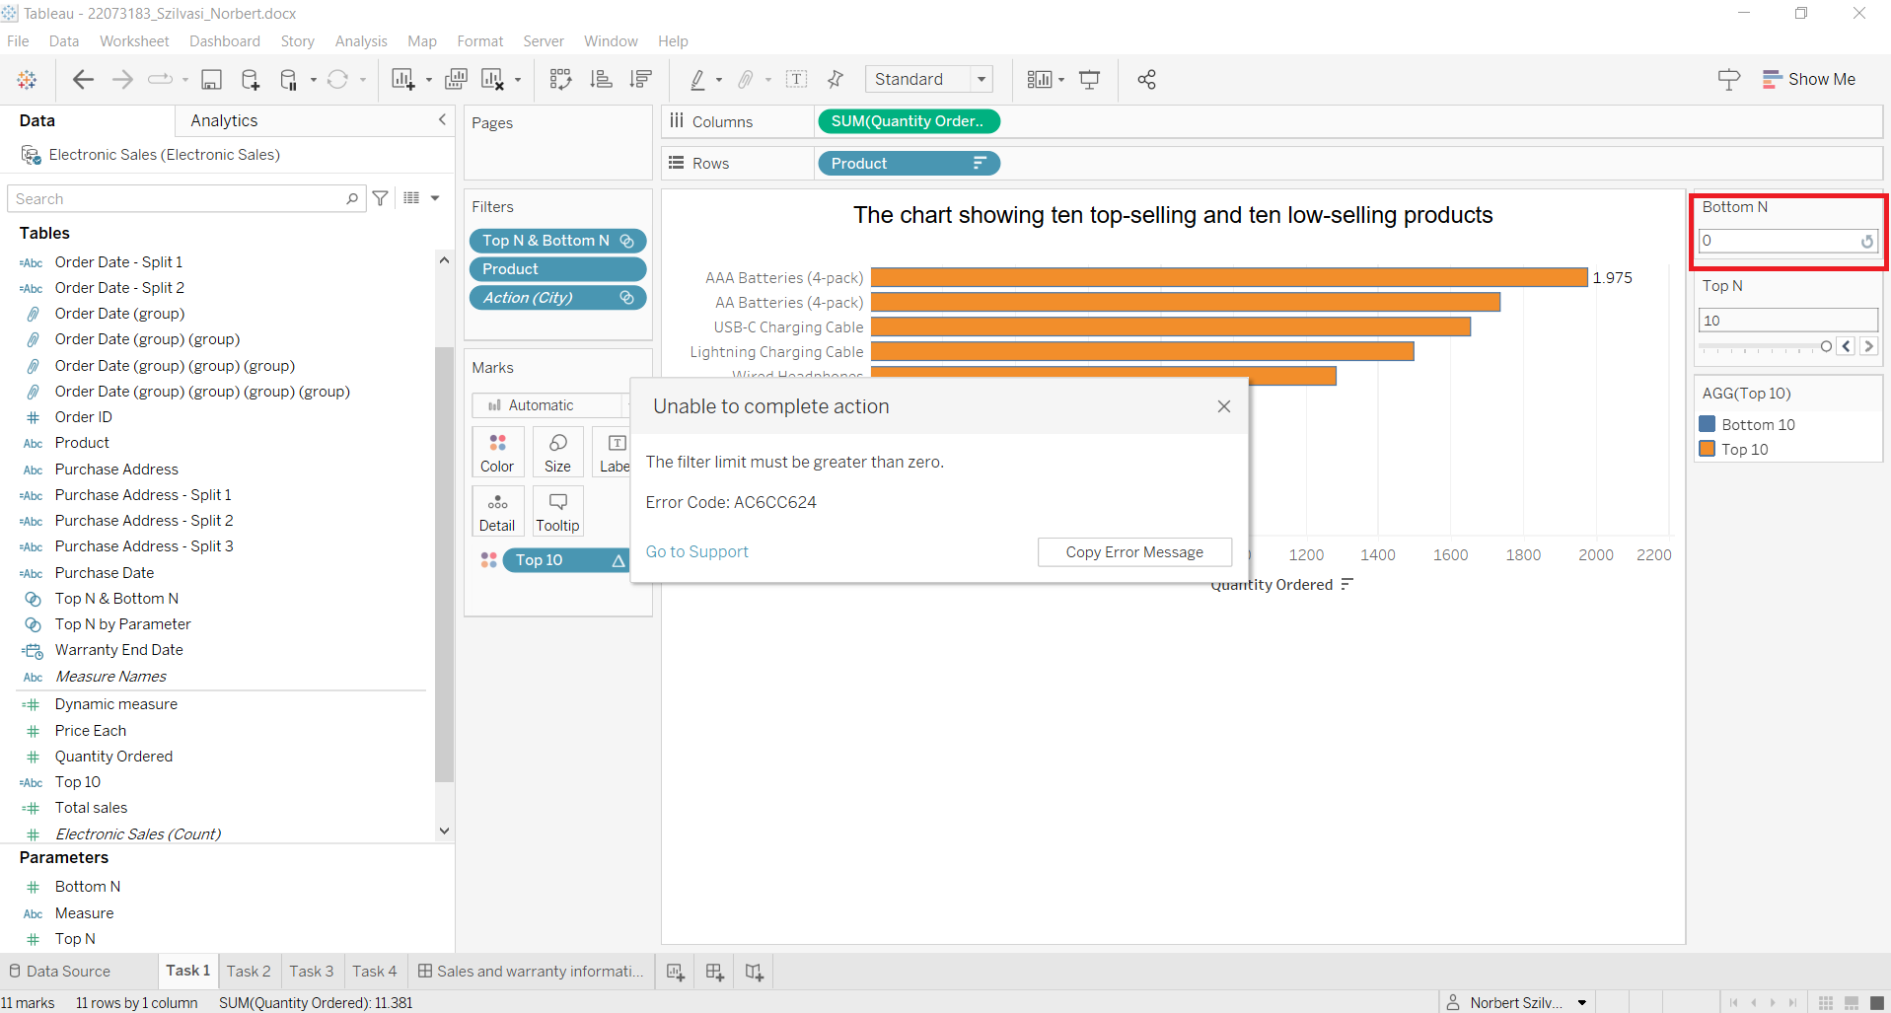10. step: Finally, border color and opacity can be set for the desired design. All bar values can be set by using show mark labels

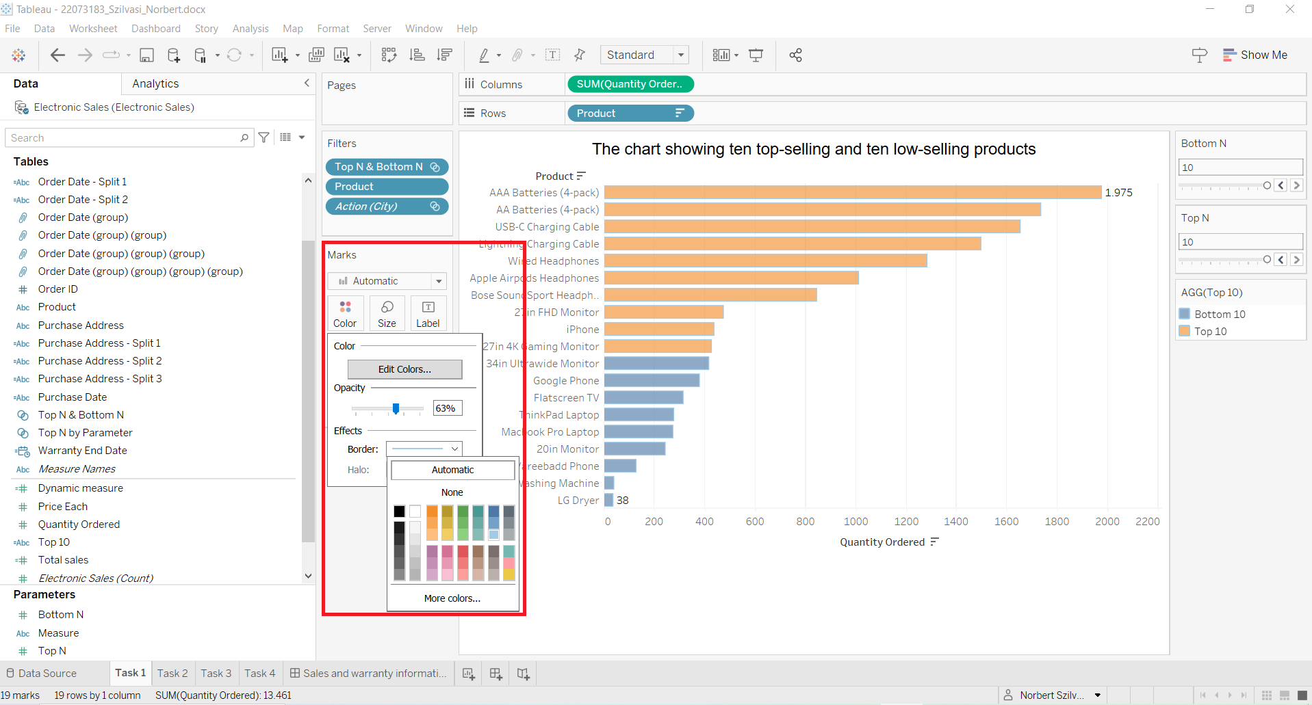

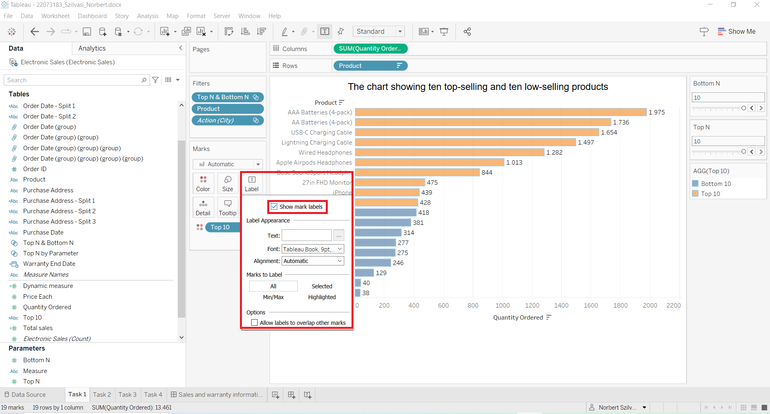

## **2****.2. Task 2**

Available here:

[**22073183_Szilvasi_Norbert2.docx | Tableau Public**](https://public.tableau.com/app/profile/norbert.szilv.si/viz/22073183_Szilvasi_Norbert2_docx/Task2?publish=yes)

1. step: Looking at Purchase Address feature, city name is included in the middle part of the string value with comma separation

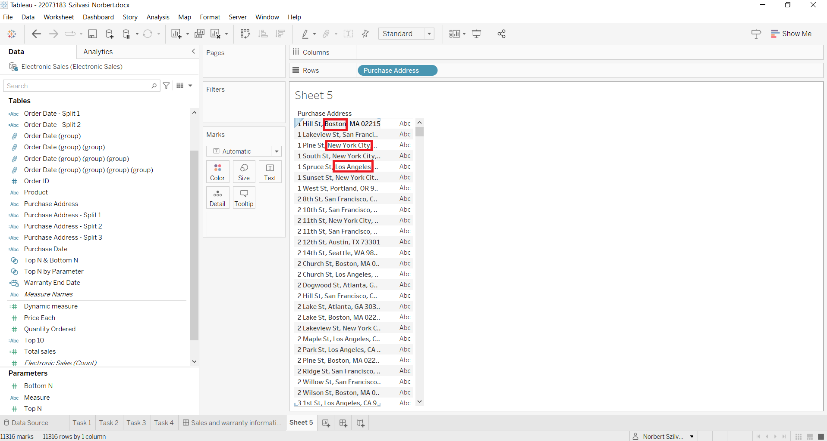2. step: In order to be able to separate the city name, split was used. Split 1,2,3 features were created

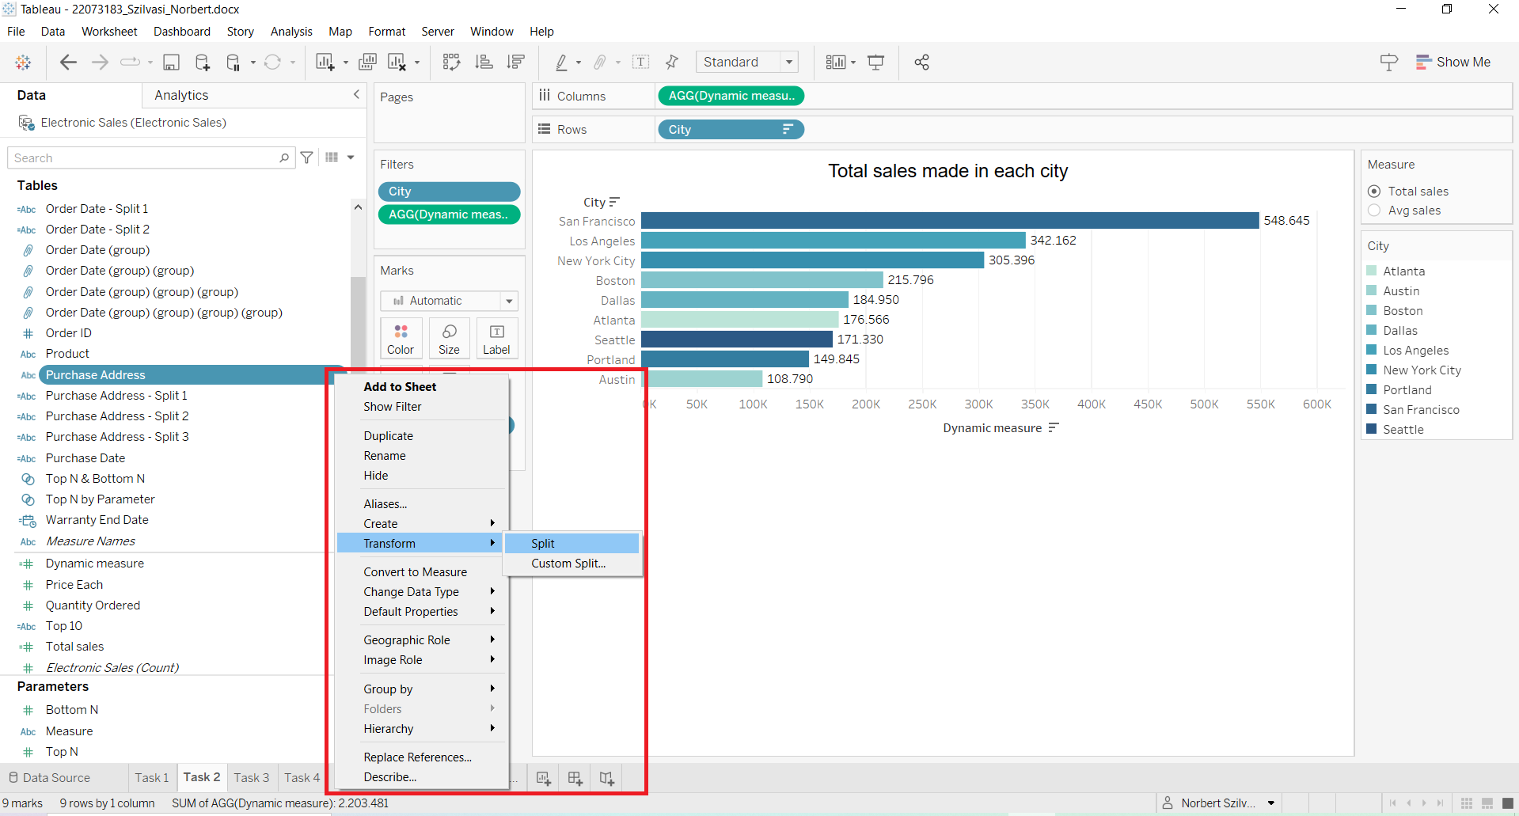

3. step: Split 2 code refers to city name in the Purchase Address and by clicking on it the code can be seen

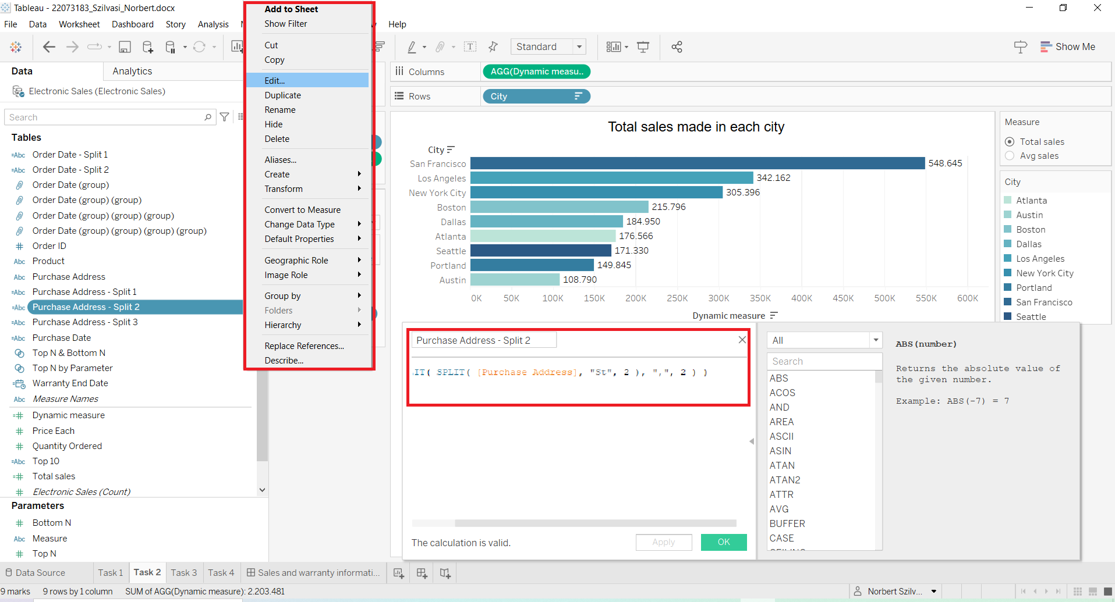

4. step: City feature was created by using the same code (from Split2) to extract city name from the Purchase Address field

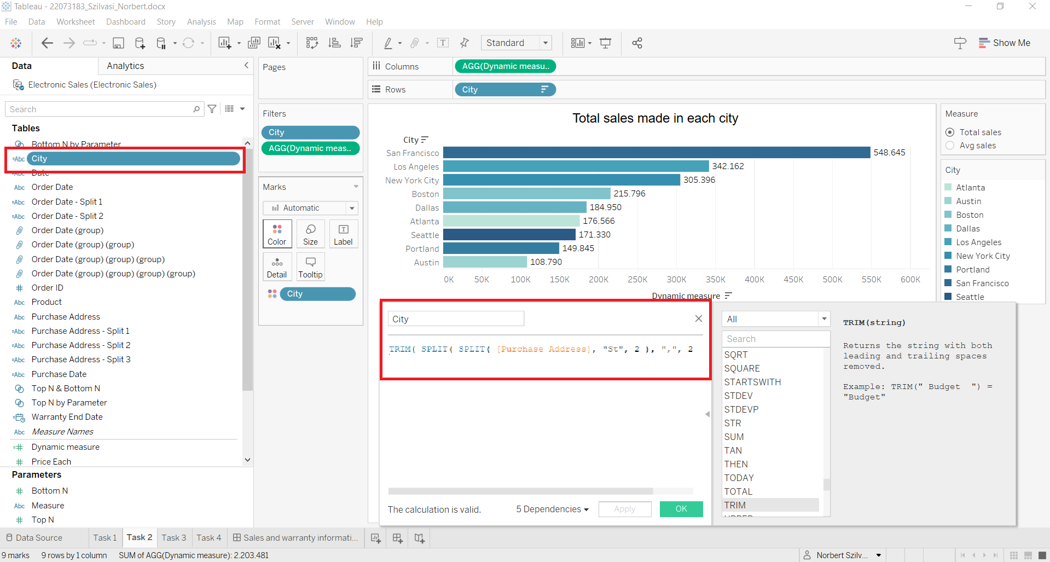

5. step: Measure parameter was created in order to be able to switch between total and average values

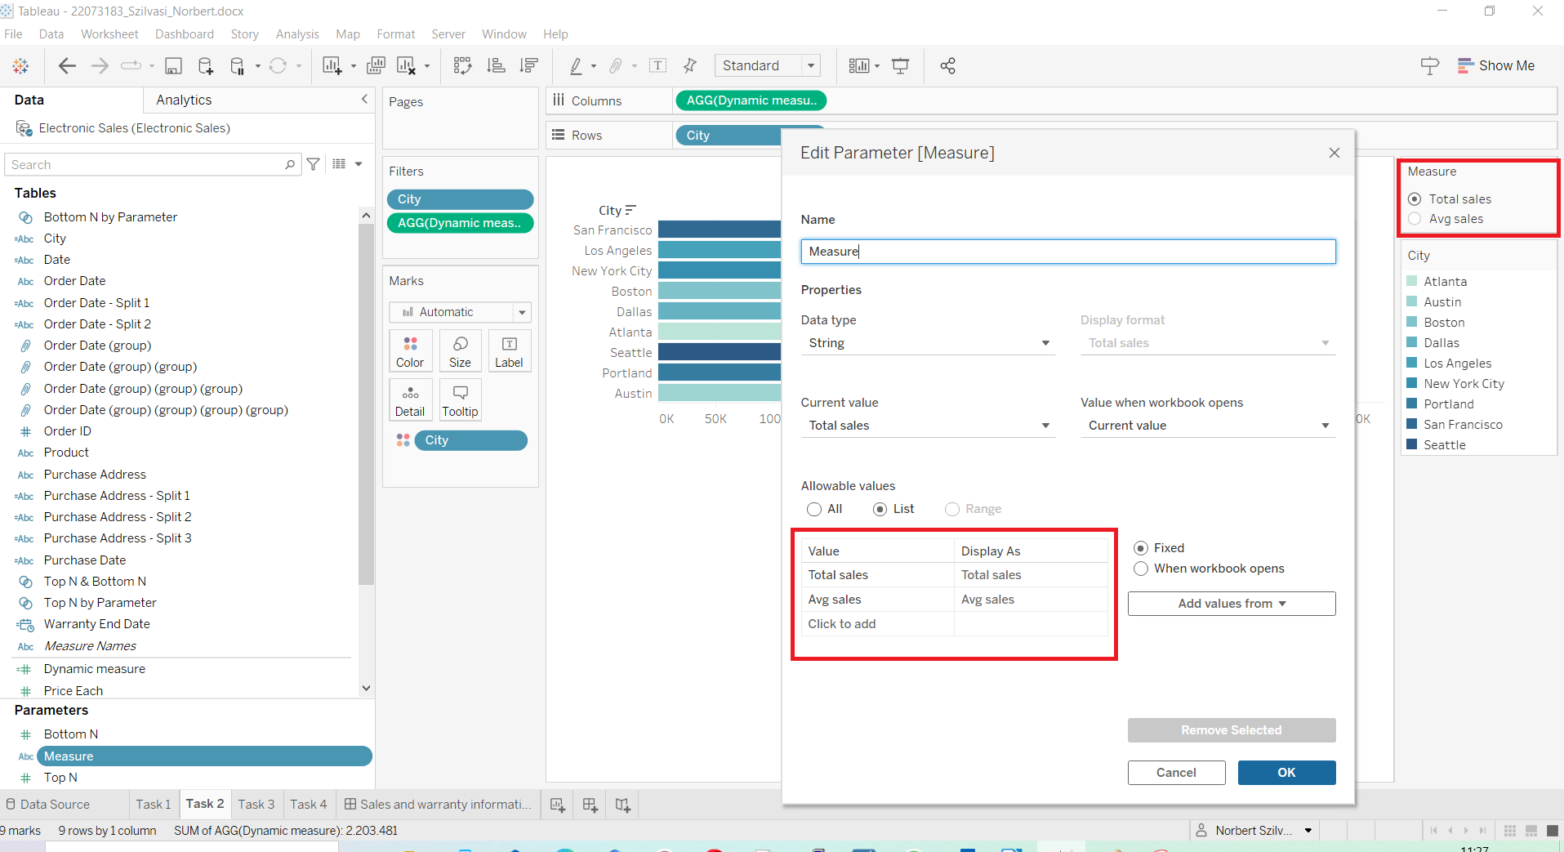

6. step: Dynamic measure calculated field was created in the following way in order to be able to display total and average sales in order to be able to switch between them

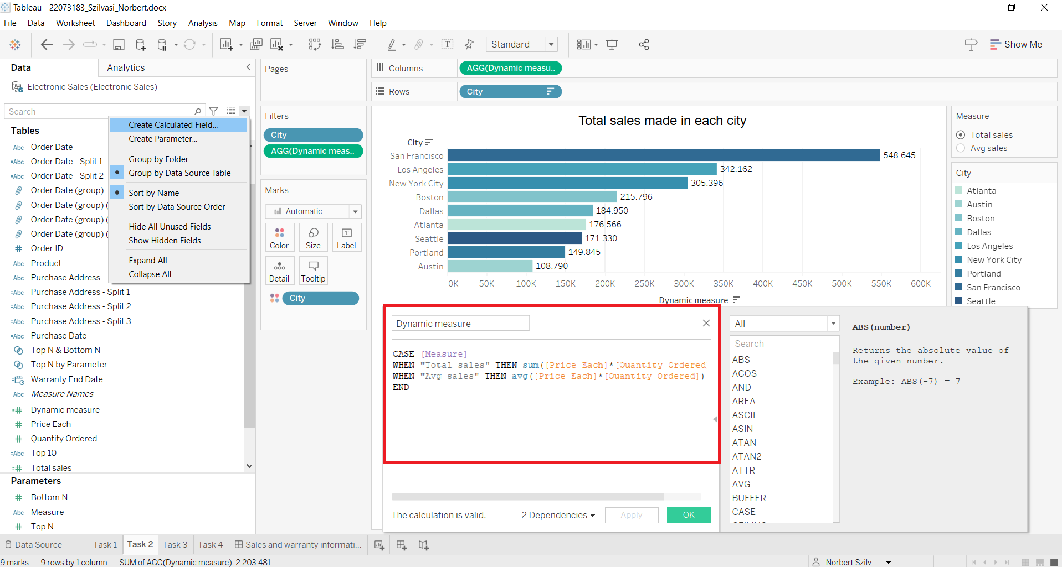

7. step: Dynamic measure was dropped to Filters field, then total and average sales can be changed on the right side

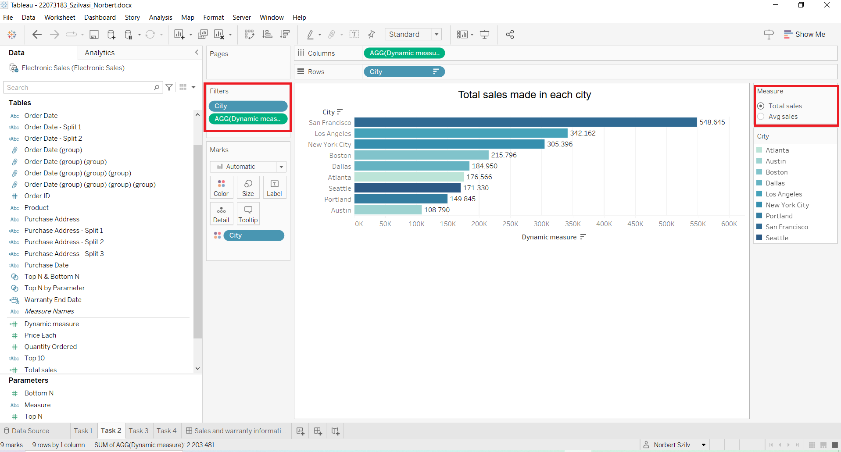

8. step: In order to create a dynamic title, parameter measure must be added beside the title in the edit title field

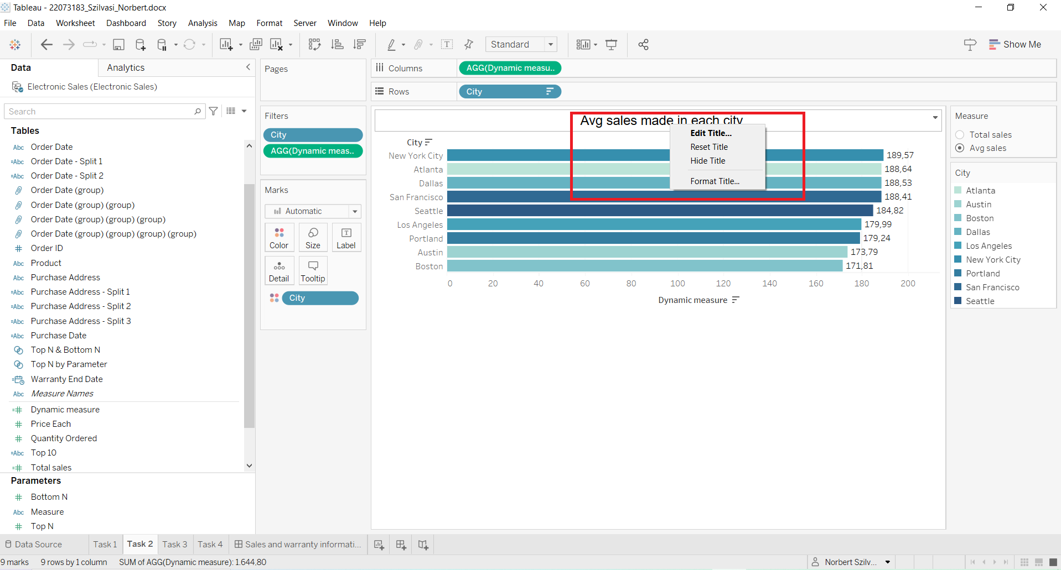

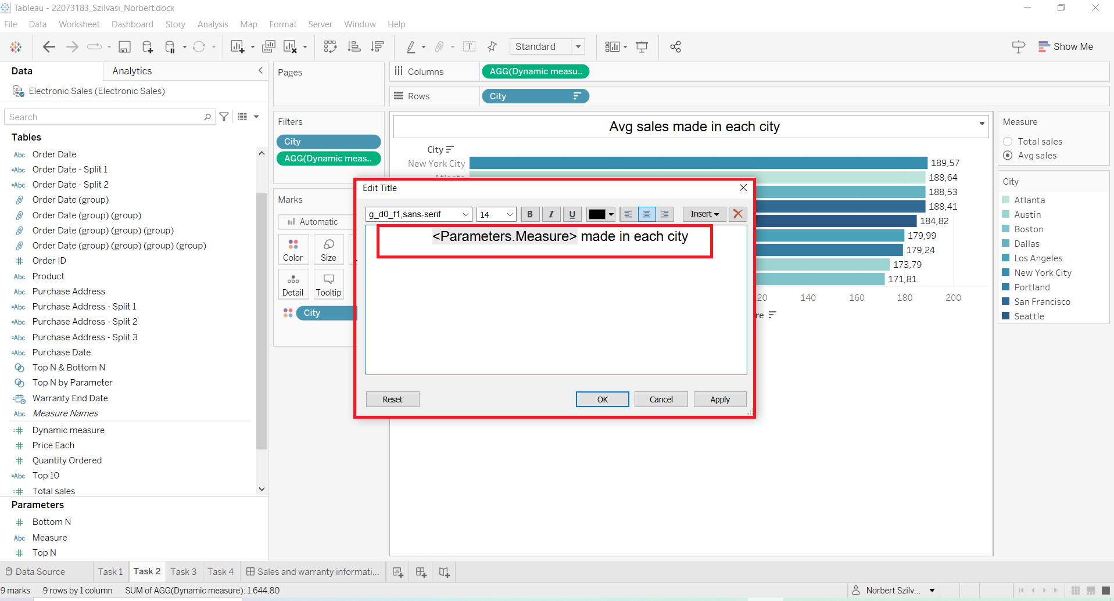

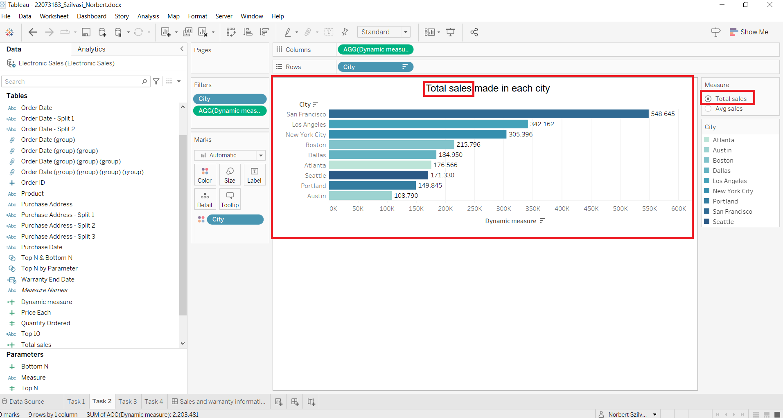

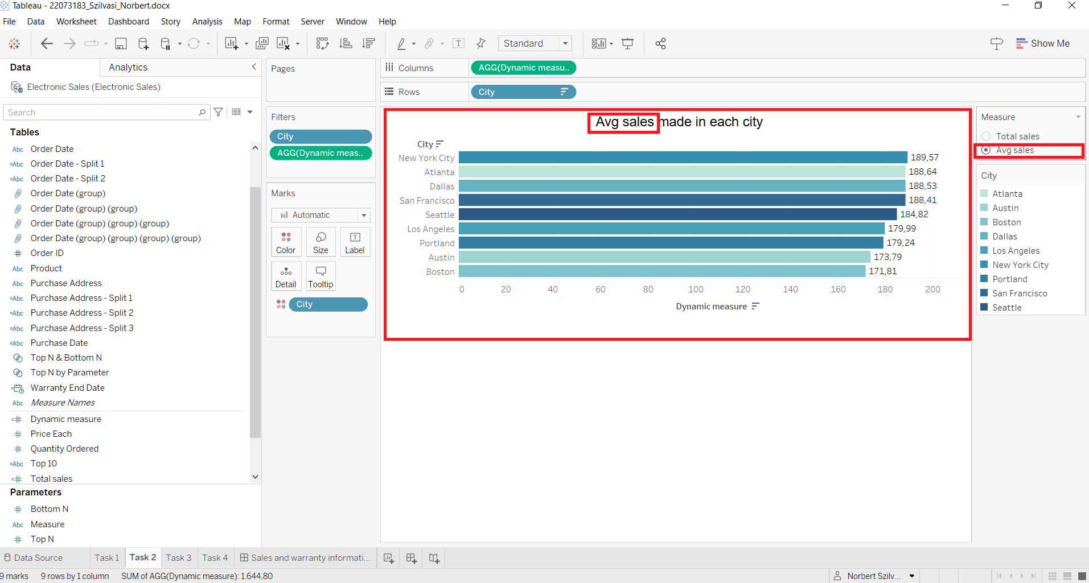

## **2****.3. Task 3**

Available here:

[22073183_Szilvasi_Norbert3.docx | Tableau Public](https://public.tableau.com/app/profile/norbert.szilv.si/viz/22073183_Szilvasi_Norbert3_docx/Task3?publish=yes)

1. step: Order Date feature must be grouped to get weekly results for sales

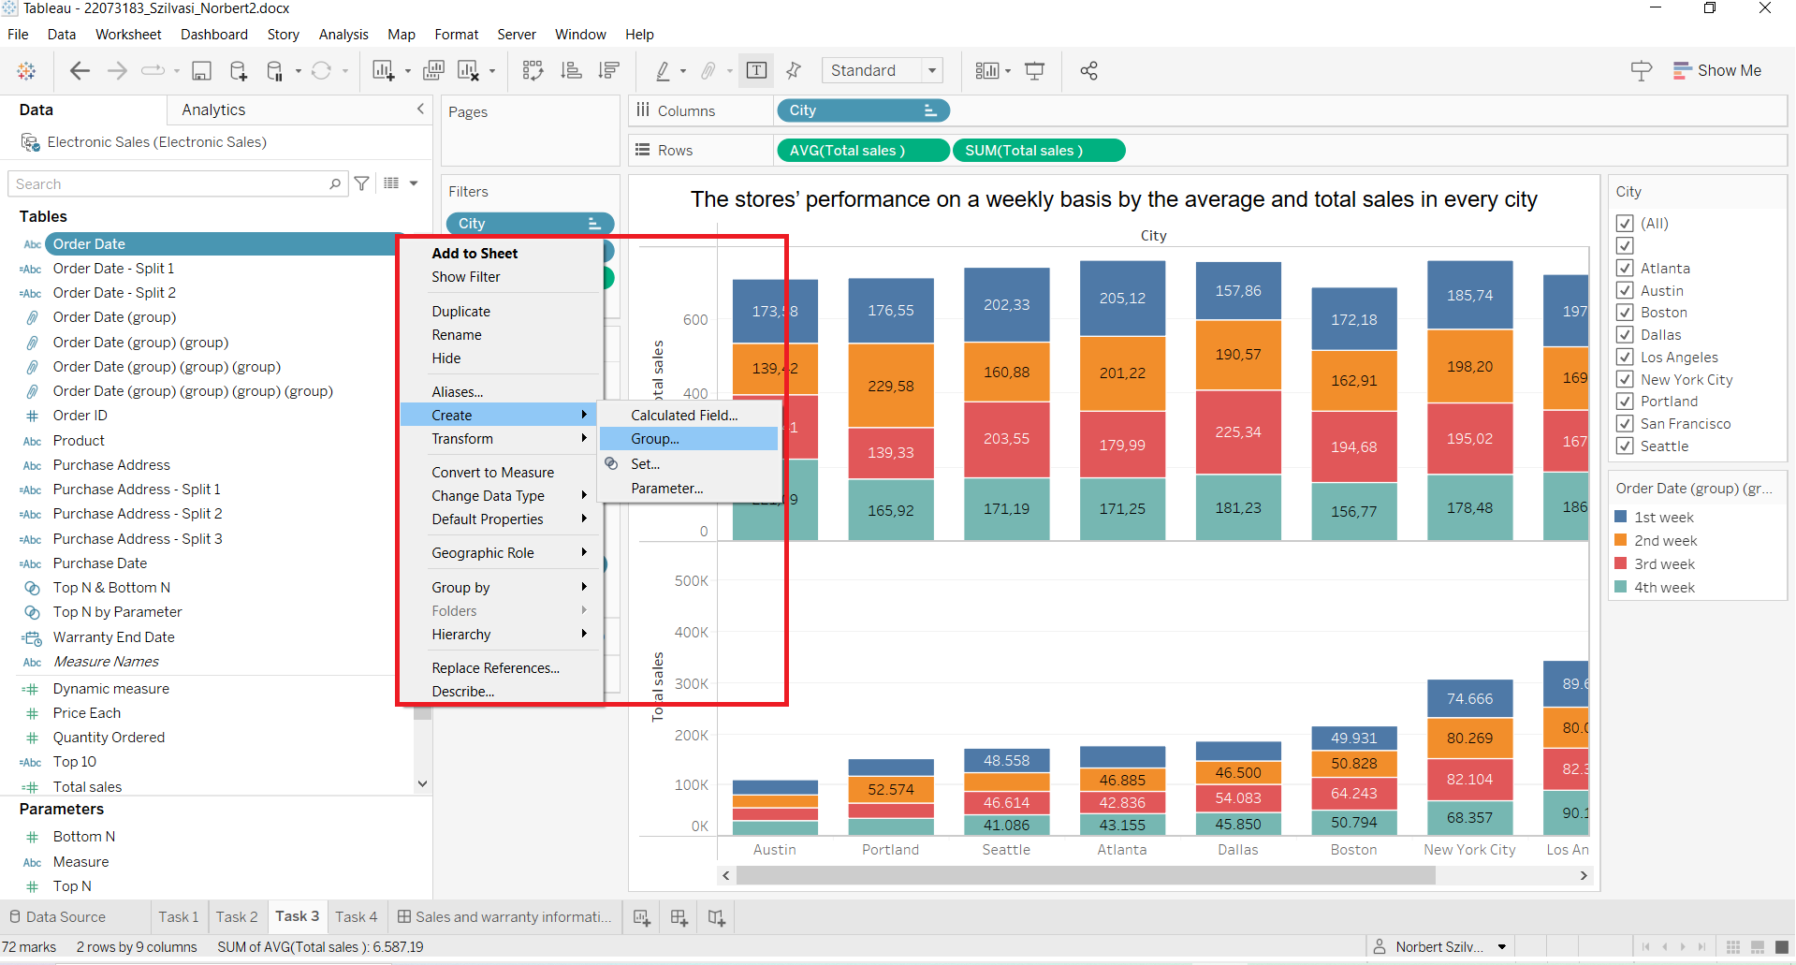

2. step: After selecting the values (7 days for a week), by clicking on the group button the weeks can be calculated

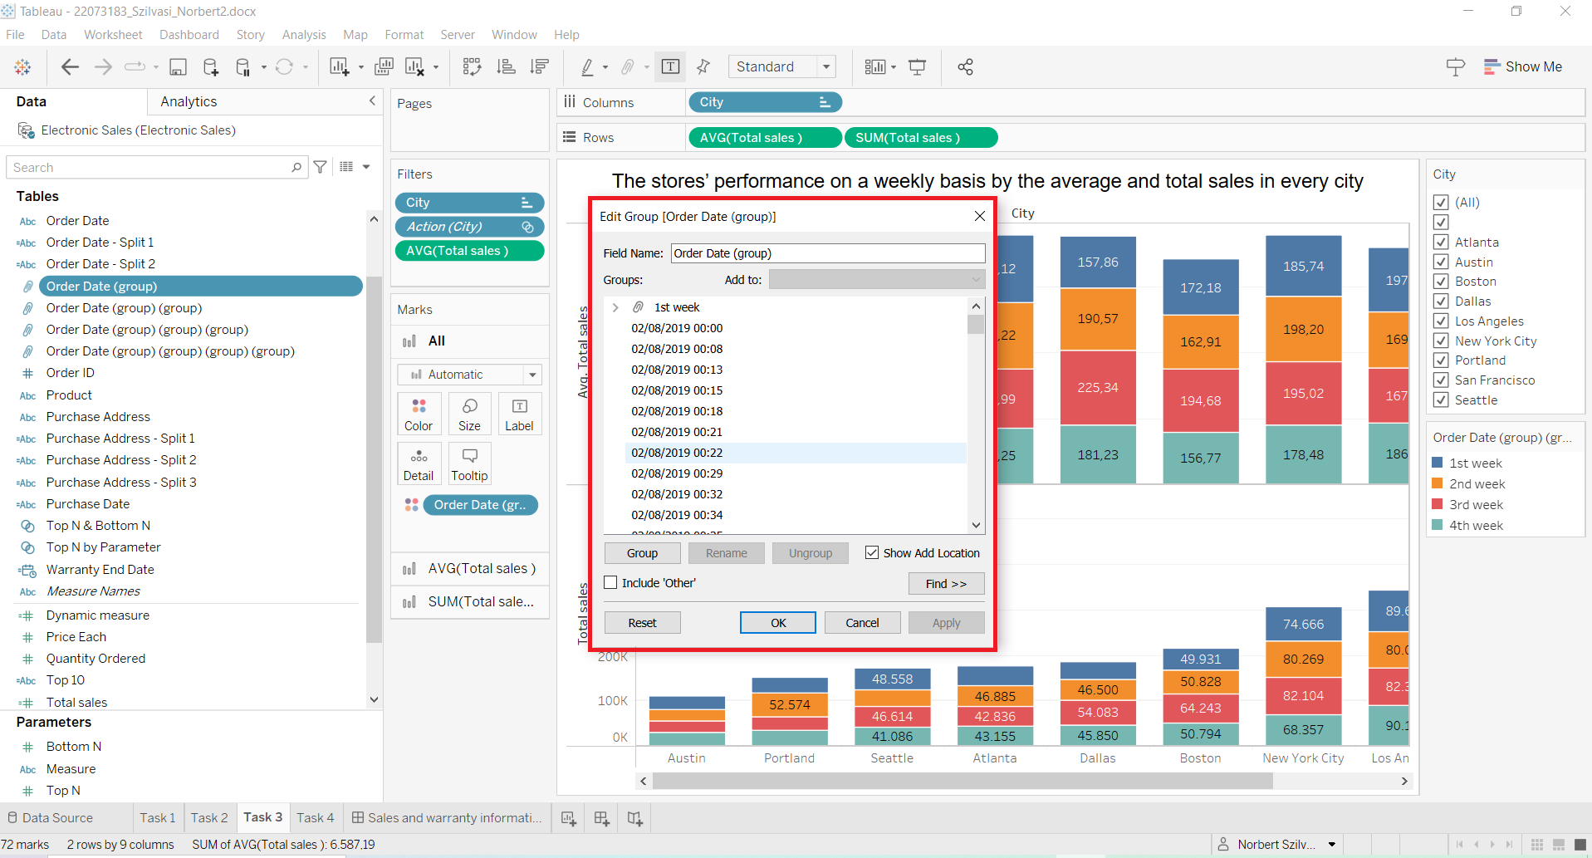

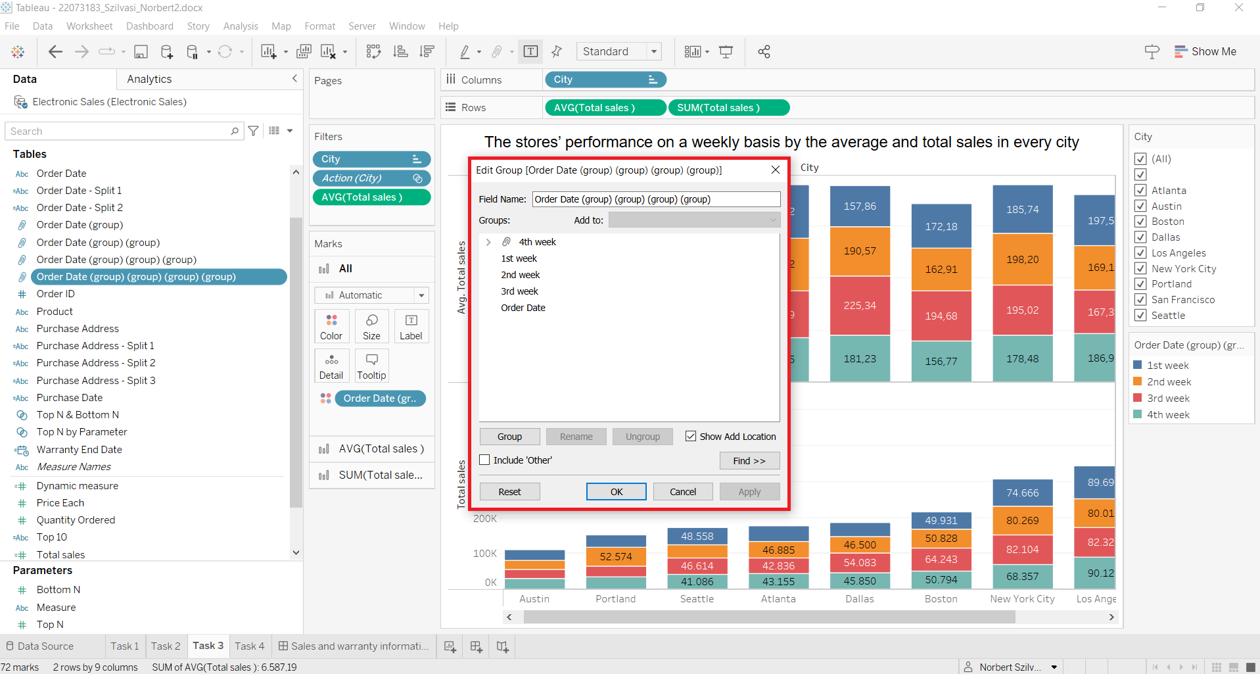

3. step: City, Avg sales and Total sales features were used to create the chart, after creating Total sale calculated field

## 

4. step: Filters are on the right side to select the required week or city information

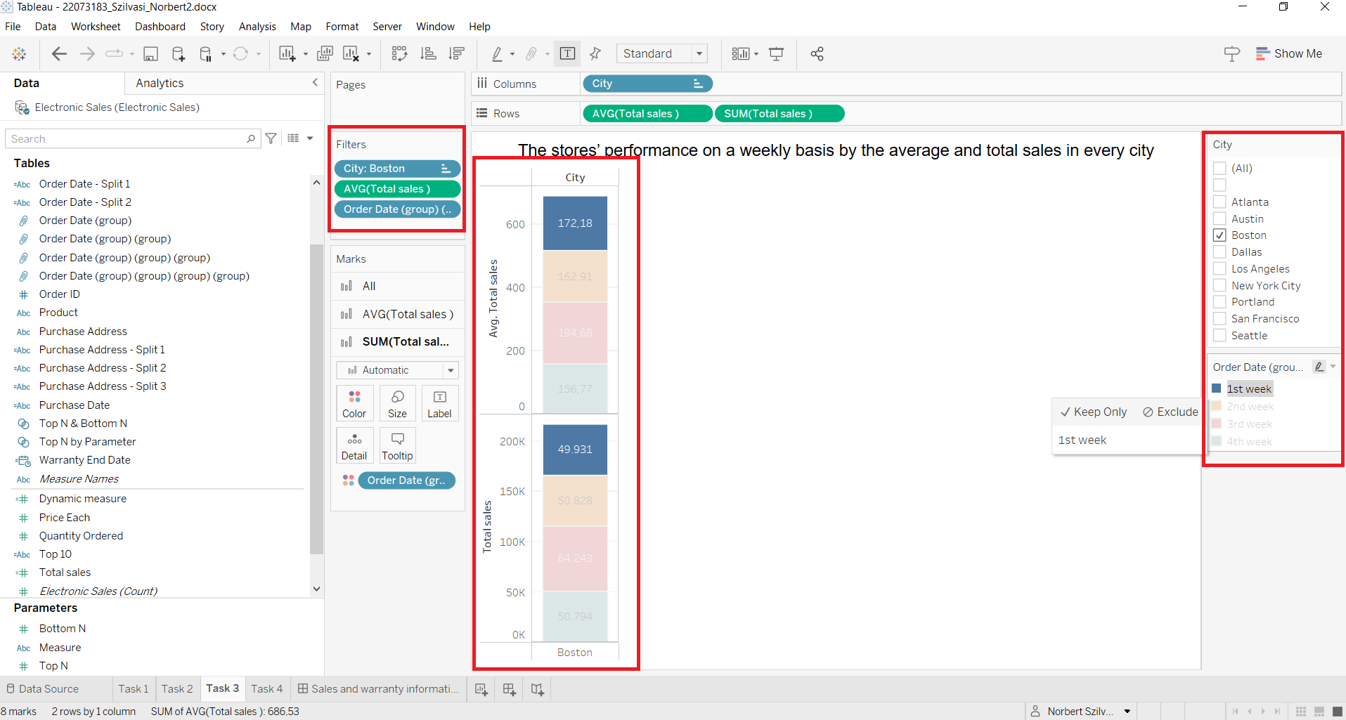

## **2****.4. Task 4**

Available here:

[22073183_Szilvasi_Norbert4.docx | Tableau Public](https://public.tableau.com/app/profile/norbert.szilv.si/viz/22073183_Szilvasi_Norbert4_docx/Task4?publish=yes)

1. step: Order Date must be divided to get the date without the time part

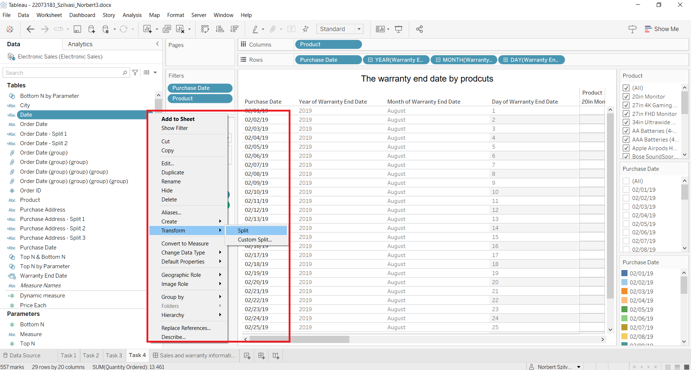

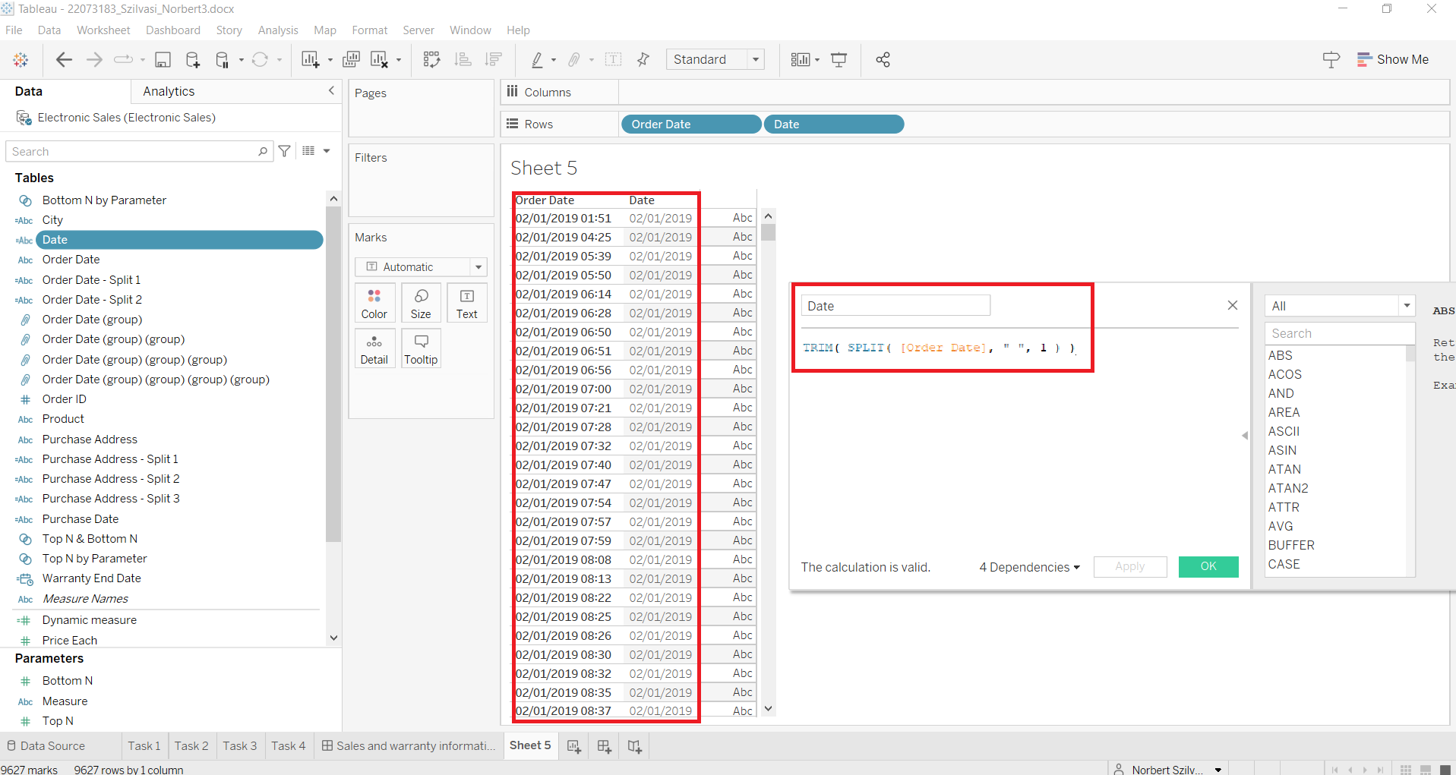

2. step: Order Date feature has to different form with 2019 and 19 which must be replaced

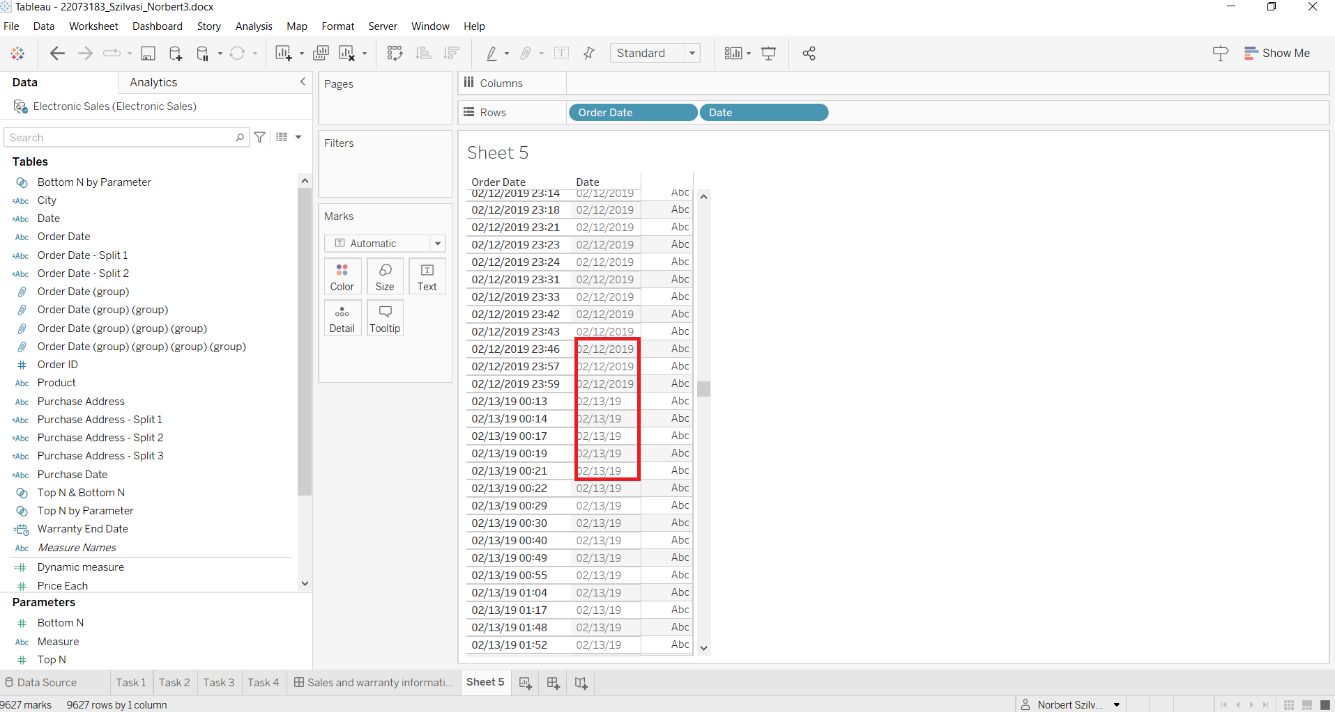

3. step: 2019 was replaced by 19 in Date and Purchase Date was created by using the calculated field

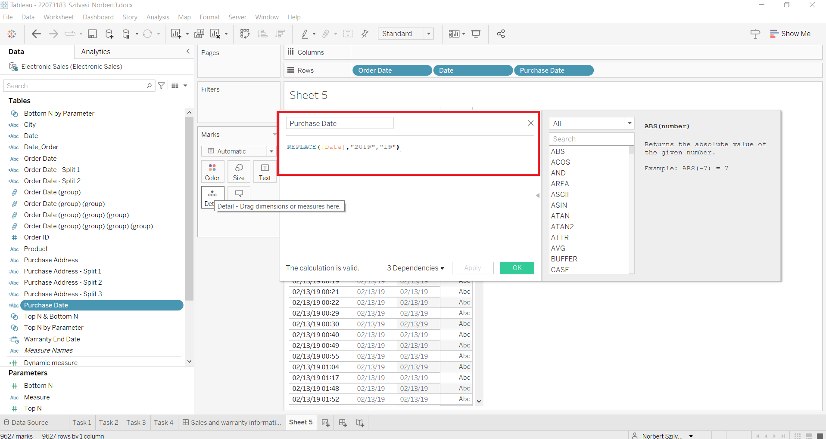

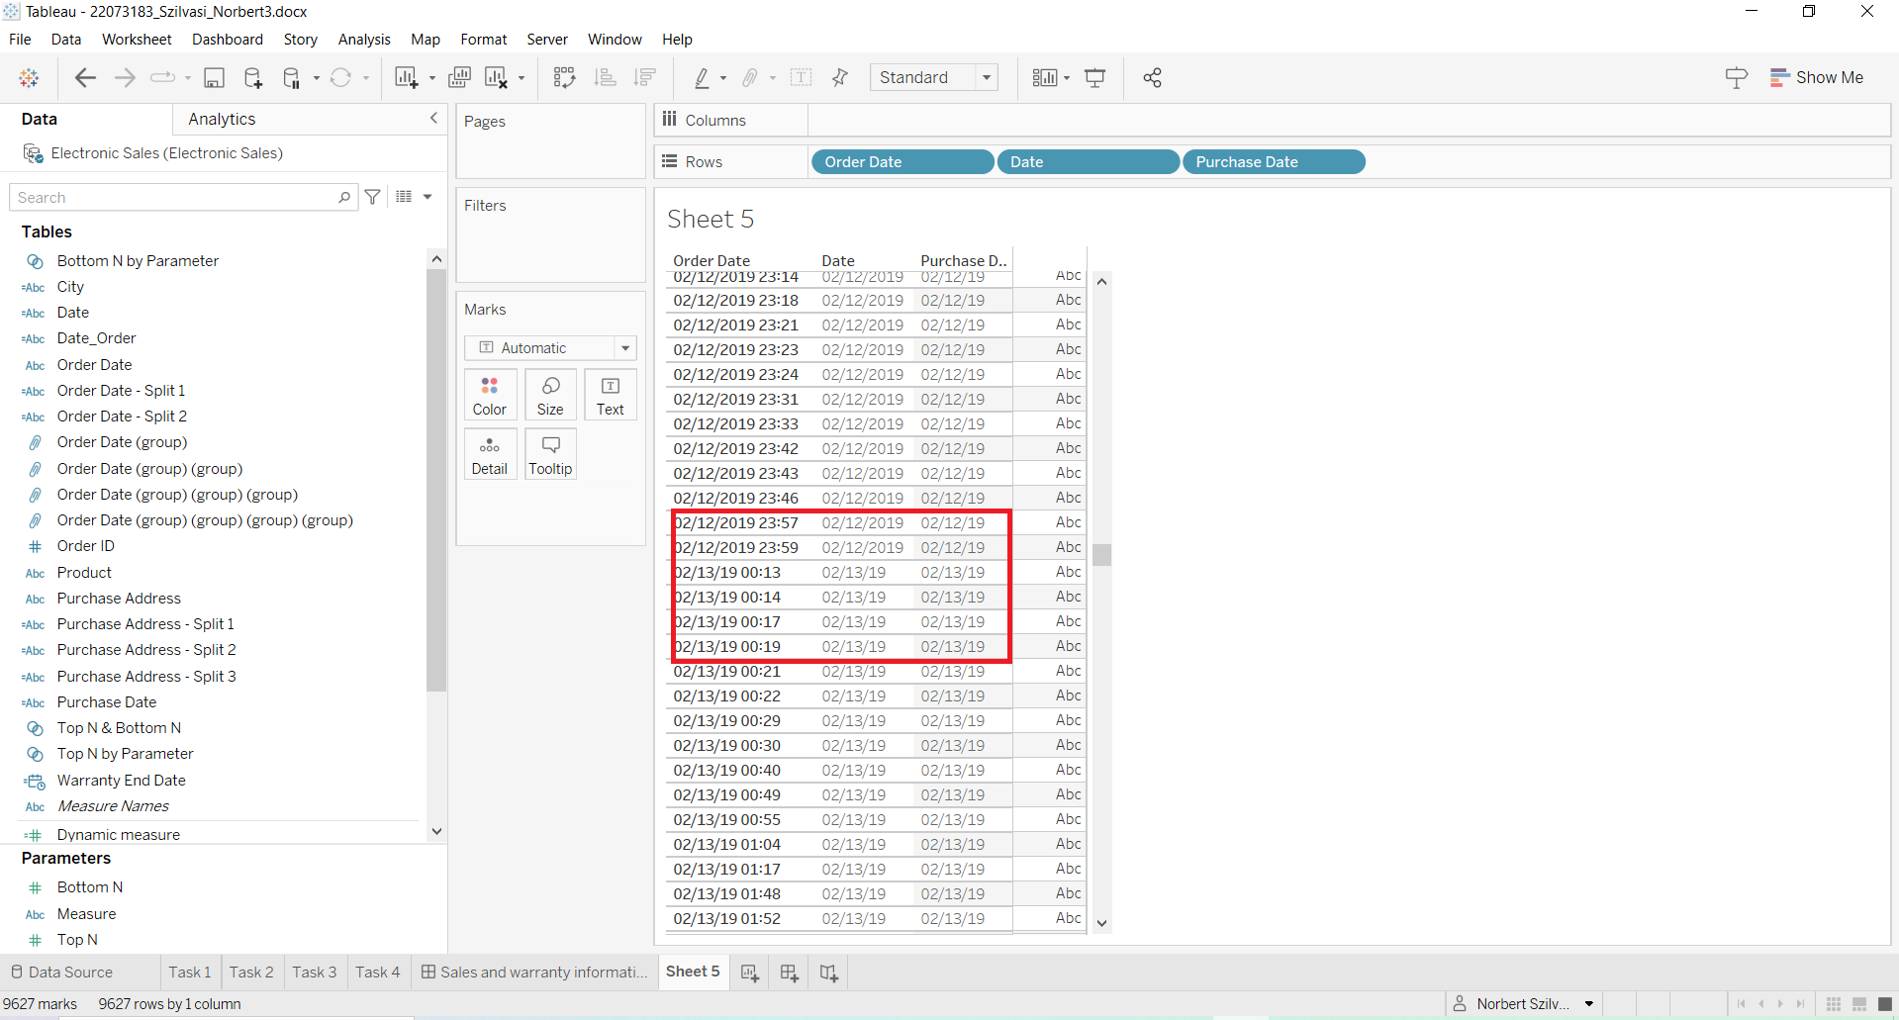

4. step: Warranty was calculated by using the dateadd function in the calculated field

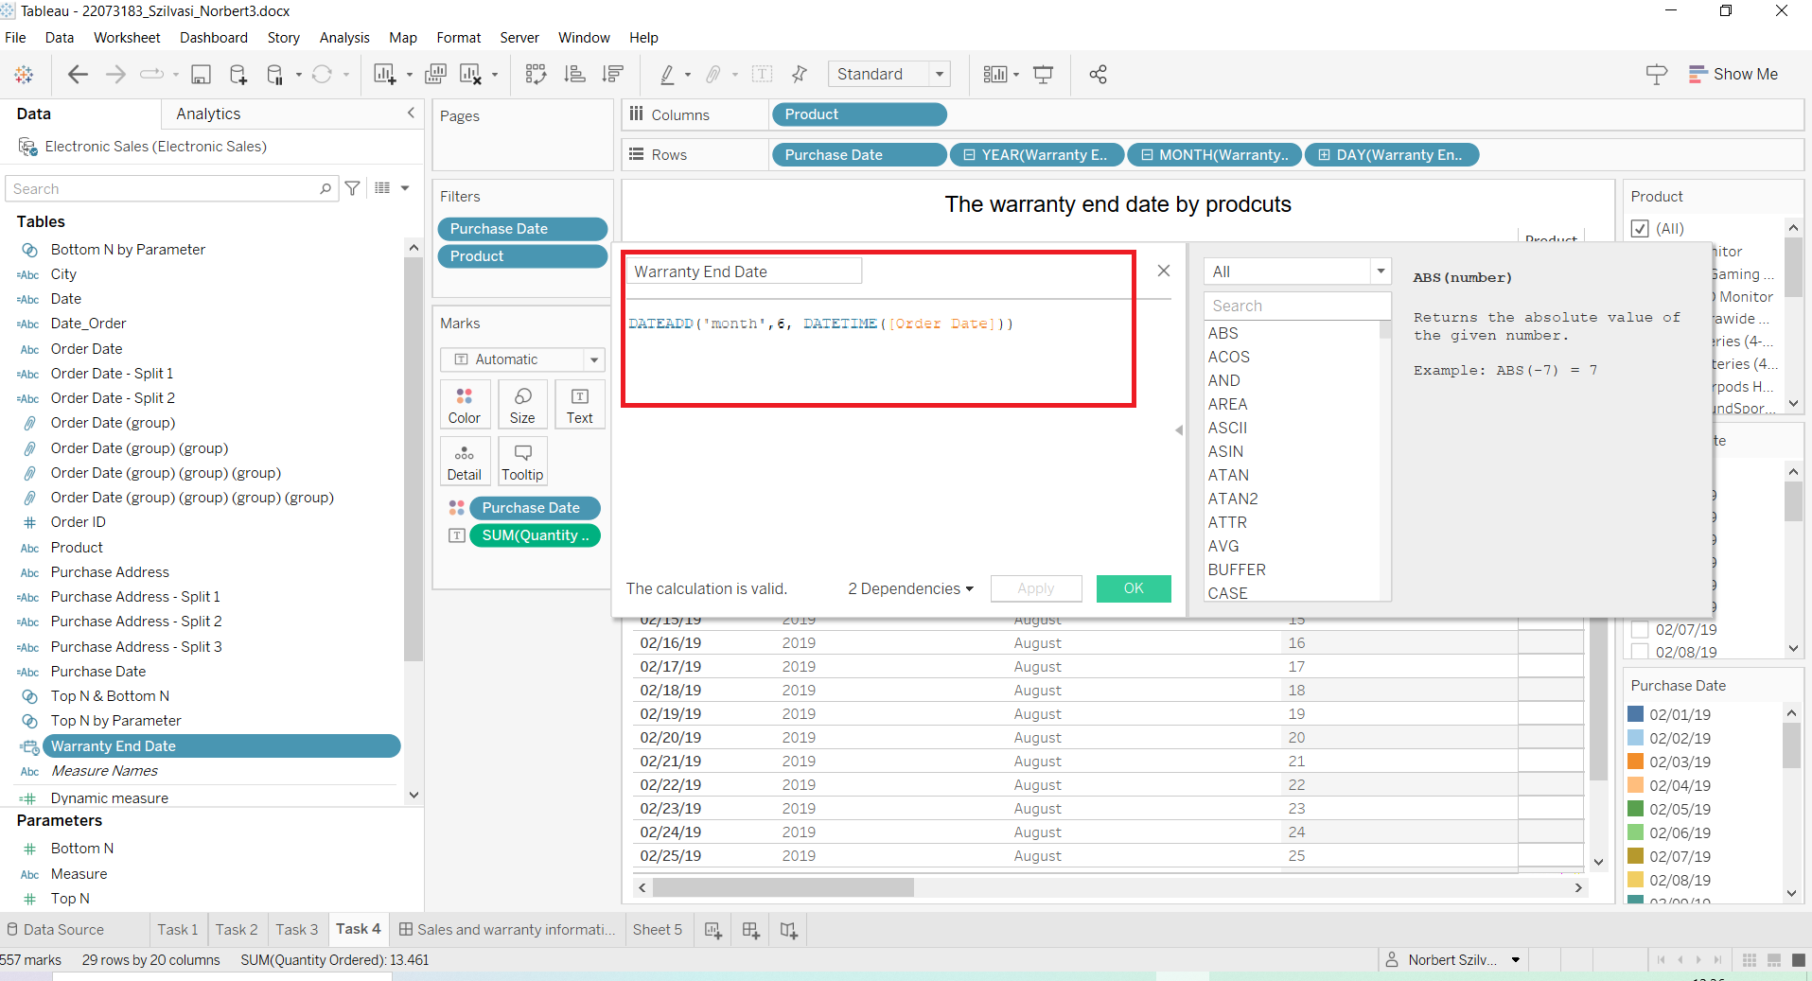

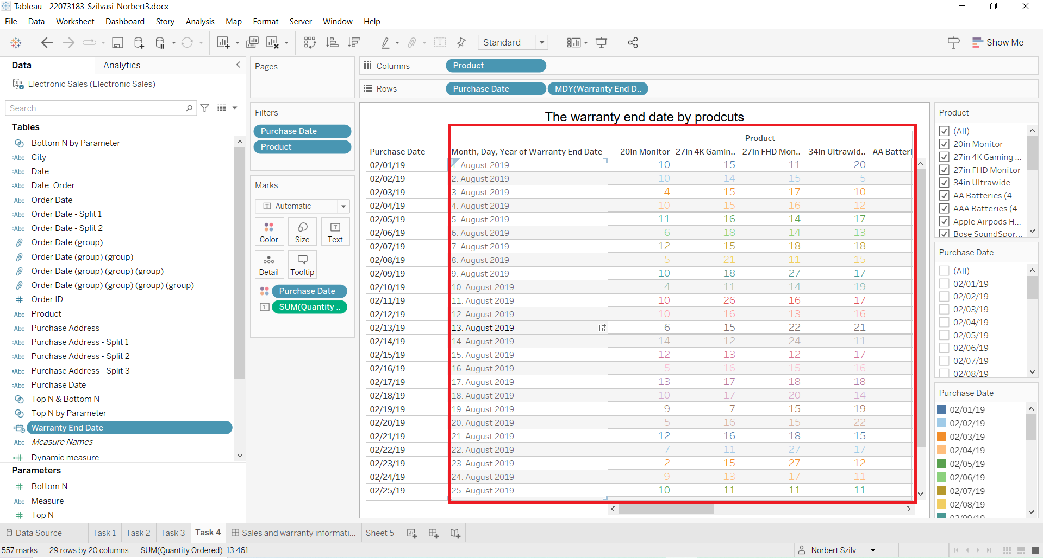5. step: Purchase Date Type must be changed in order to get a good and correct visualization on Tableau Public because if the format 02/19/2019 month/day/year will not be changed to day/month/year order on Tableau Public null values will be displayed:

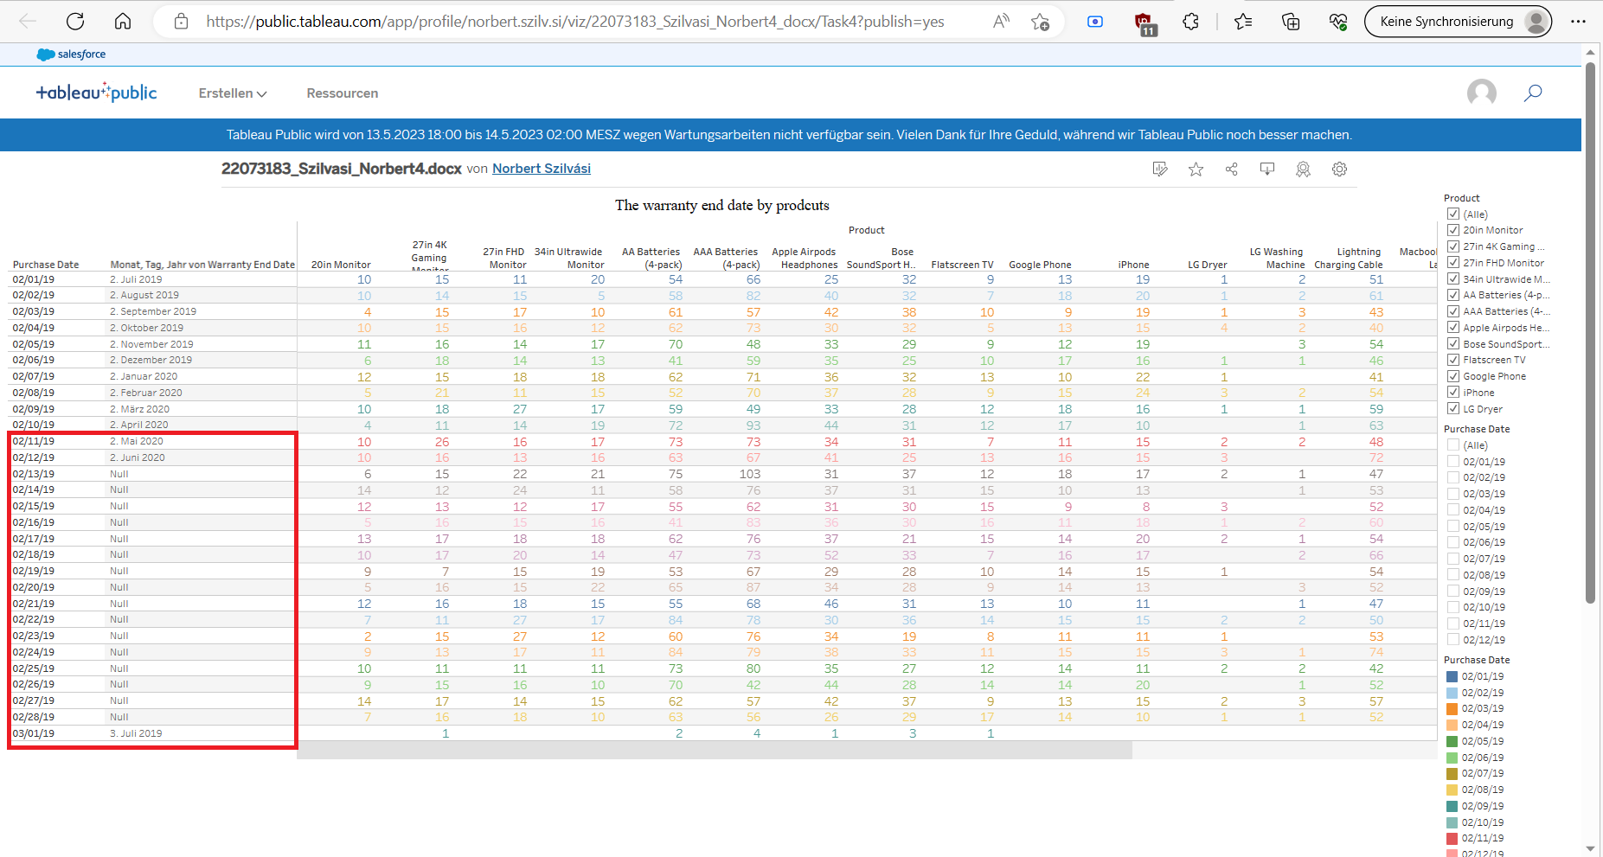

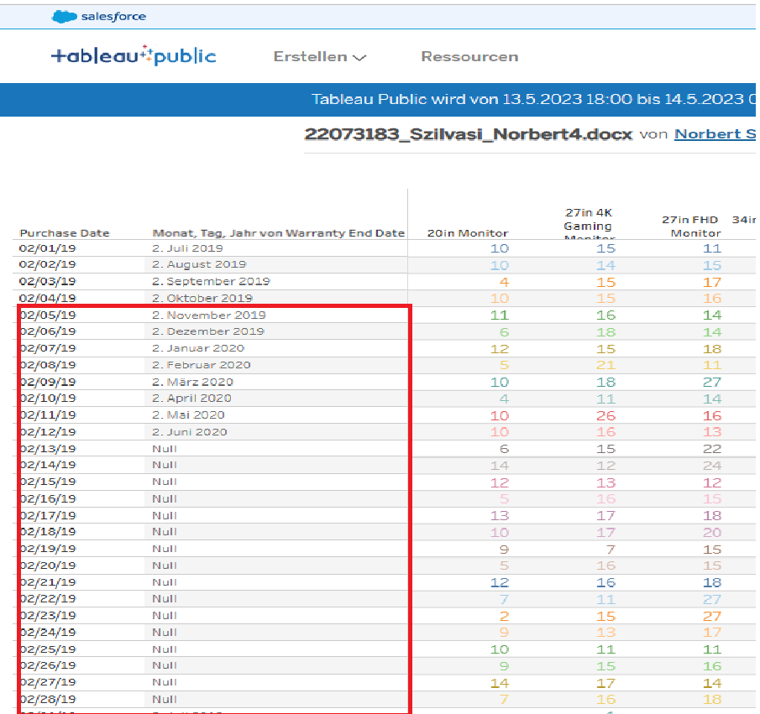

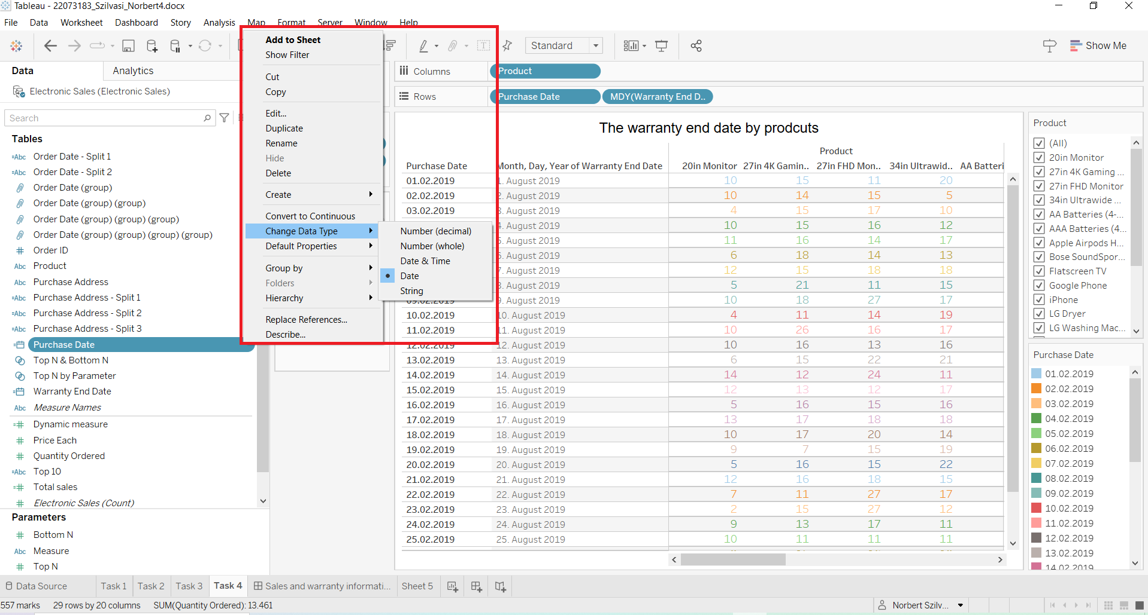

## 

## 

## **2****.5. Task 5**

Available here:

[22073183_Szilvasi_Norbert5.docx | Tableau Public](https://public.tableau.com/app/profile/norbert.szilv.si/viz/22073183_Szilvasi_Norbert5_docx/Salesandwarrantyinformation?publish=yes)

1.step: By clicking on the dashboard button at the bottom part beside the worksheets, the dashboard can be created by adding all the sheets

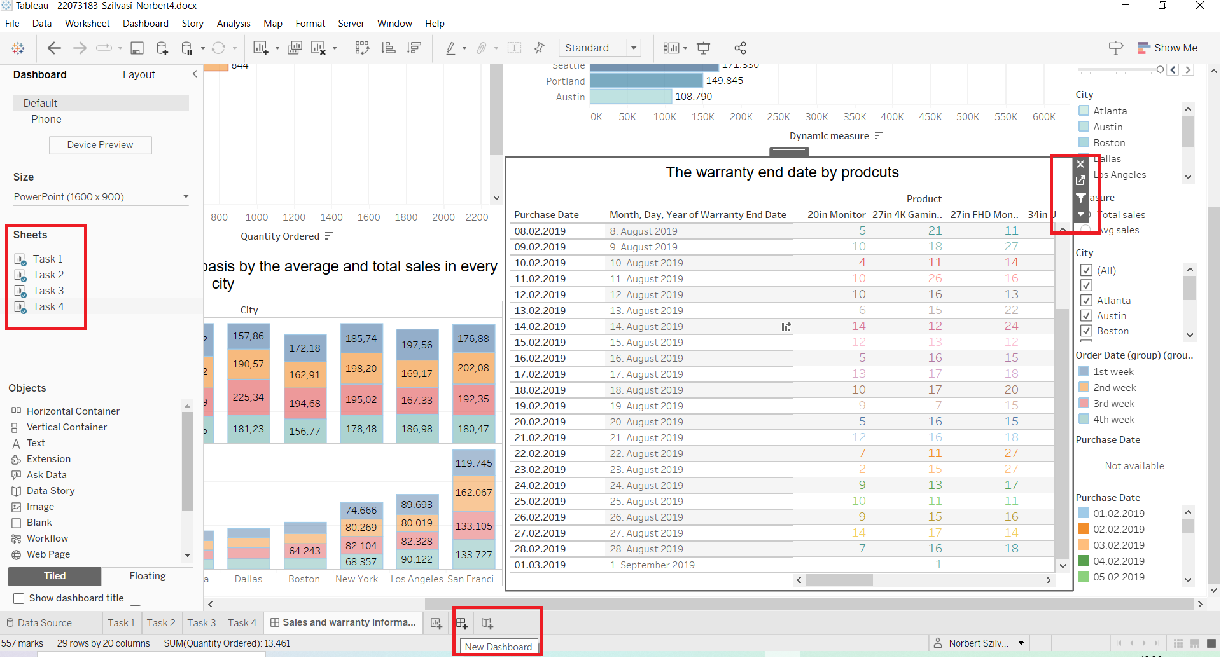

2. step: After adding all the worksheets, interactivity can be created by clicking on the filter in every worksheet field on the up left side. In order to create interactivity between all the tables filter buttons must be switched in every case

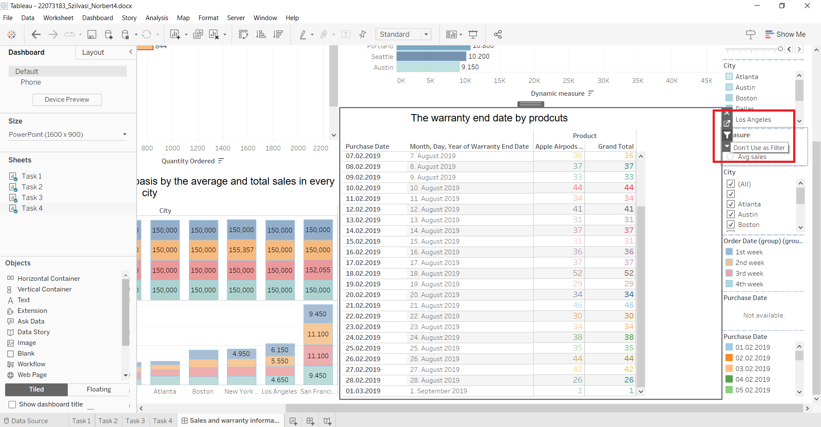

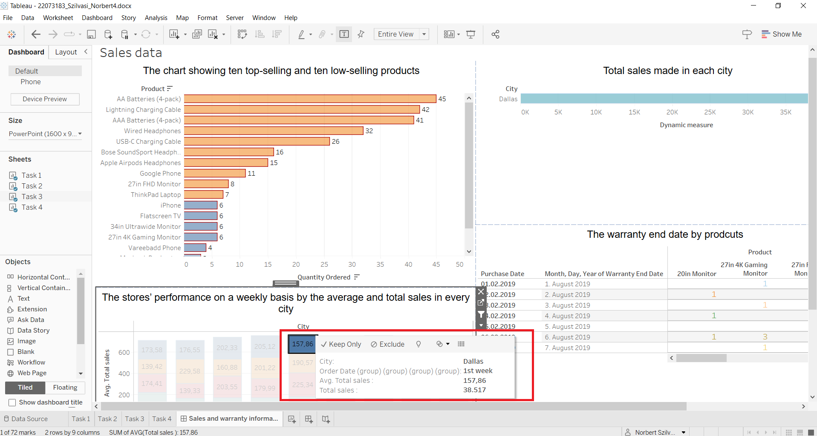

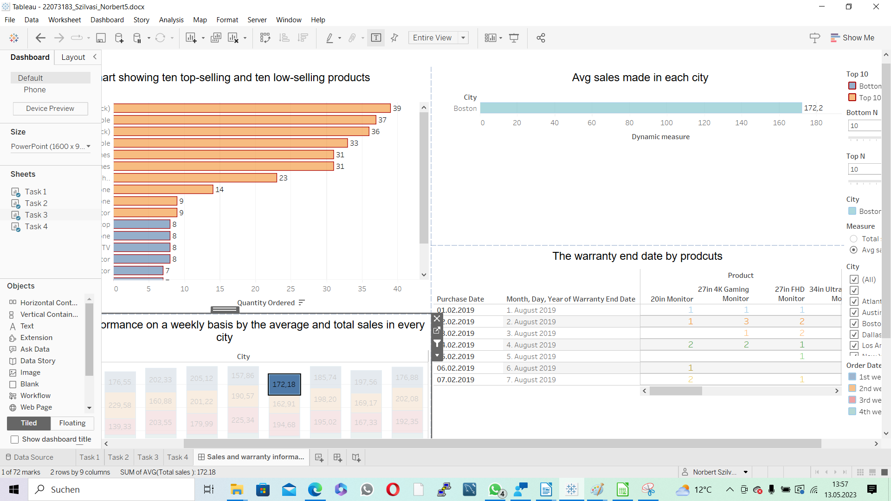

## Appendix:

https://colab.research.google.com/drive/1k8LLAXU2NgFHu8iCImQdfyS2iVB2eGzp?usp=sharing

## References

Abdalla, H.B., (2022). A brief survey on big data: technologies, terminologies and data-intensive applications. *Journal of Big Data*, *9*(1), pp.1-36.

Ajah, I.A. and Nweke, H.F., (2019). Big data and business analytics: Trends, platforms, success factors and applications. *Big Data and Cognitive Computing*, *3*(2), p.32.

Alexopoulos, E. C. (2010). Introduction to multivariate regression analysis. *Hippokratia*, *14*(Suppl 1), 23.

Ali, A., Abd Razak, S., Othman, S. H., Eisa, T. A. E., Al-Dhaqm, A., Nasser, M., and Saif, A. (2022). Financial Fraud Detection Based on Machine Learning: A Systematic Literature Review. *Applied Sciences*, *12*(19), 9637.

Bagchi, S. and Svejnar, J., (2013). Does Wealth Inequality Matter for Growth? The Effect of Billionaires. *Wealth, Income Distribution, and Poverty*.

Berisha, B., Mëziu, E. and Shabani, I., (2022). Big data analytics in Cloud computing: an overview. *Journal of Cloud Computing*, *11*(1), p.24.

Freund, C., and Oliver, S. (2016). The origins of the superrich: the billionaire characteristics database. *Peterson Institute for International Economics Working Paper*, (16-1).

Gandhi, A. and Walton, M., (2012). Where do India's billionaires get their wealth?. *Economic and Political Weekly*, pp.10-14.

Gunawan, F. E., and Riansah, F. (2021). Redistribution of Wealth: An Agent-based Simulation. In *2021 3rd International Symposium on Material and Electrical Engineering Conference (ISMEE)* (pp. 21-25). IEEE.

Gupta, E.A., Gupta, E.A. and Mishra, E.A., (2011). Research paper on cluster techniques of data variations. *International Journal of Advance Technology and Engineering Research*, *1*(1), pp.39-47.

Guriev, S. and Rachinsky, A., (2005). The role of oligarchs in Russian capitalism. *Journal of Economic Perspectives*, *19*(1), pp.131-150.

Hurst, E., Luoh, M.C., Stafford, F.P. and Gale, W.G., (1998). The wealth dynamics of American families, 1984-94. *Brookings papers on Economic activity*, *1998*(1), pp.267-337.

IBM (n.d.). *What is Exploratory Data Analysis? | IBM*. [online] [www.ibm.com.A](http://www.ibm.com.A/)vailable at:<https://www.ibm.com/topics/exploratory-data-analysis>.

Kaplan, S.N. and Rauh, J., (2013). It's the market: The broad-based rise in the return to top talent. *Journal of Economic Perspectives*, *27*(3), pp.35-56.

Karagiannaki, E., (2015). Recent trends in the size and the distribution of inherited wealth in the UK. *Fiscal Studies*, *36*(2), pp.181-213.

Khurana, D., Koli, A., Khatter, K., and Singh, S. (2023). Natural language processing: State of the art, current trends and challenges. *Multimedia tools and applications*, *82*(3), 3713-3744.

Klevmarken, N.A., Lupton, J.P. and Stafford, F.P., (2003). Wealth Dynamics in the 1980s and 1990s Sweden and the United States. *Journal of Human Resources*, *38*(2), pp.322-353.

Leckelt, M., König, J., Richter, D., Back, M.D. and Schröder, C., (2022). The personality traits of self-made and inherited millionaires. *Humanities and Social Sciences Communications*, *9*(1), pp.1-12.

Piketty, T., (2014). Capital in the Twenty-First Century: a multidimensional approach to the history of capital and social classes. *The British journal of sociology*, *65*(4), pp.736-747.

Piketty, T., and Zucman, G. (2015). ‘Wealth and Inheritance in the Long Run’, Handbook of Income Distribution, 2, 1303-1368.

Salas-Rojo, P. and Rodríguez, J.G., (2022). Inheritances and wealth inequality: a machine learning approach. *The Journal of Economic Inequality*, *20*(1), pp.27-51.

Sharma, R., (2012). *Breakout nations: In pursuit of the next economic miracles*. WW Norton and Company.

Soni, V.K. and Selot, S., (2020). Big Data for Natural Language Processing: A Survey Report.

Tableau (2023). *Big Data Analytics: Transform terabytes into insights*. [online] Tableau. Available at:<https://www.tableau.com/learn/articles/big-data-analytics>.

Zucman, G. (2019). ‘The Triumph of Injustice: How the Rich Dodge Taxes and How to Make Them Pay’, Norton and Company, New York.